## Acknowledgments

This project was supported by funding from the Fisheries Research Development Corporation on behalf of the Australian Government and was co-funded by the Institute of Marine and Antarctic Sciences (IMAS), University of Tasmania. This project received financial support from Natural Resources and Environment Tasmania (NRET), and from the Tasmanian Abalone Council Limited (TACL) to fund local development of GPS and depth data loggers to IMAS specifications. Luisa Forbes managed data logger allocation and retrieval to/from divers for the program from 2019. Luisa Forbes also provided critical support in the development, field testing, and finally deploying the next generation loggers. SciElex has accommodated and facilitated many of our requested changes in the firmware and helped to make this program a success.

## Executive Summary

Capture of high-resolution abalone fisheries data through the combination of passive GPS and depth data has been pioneered in Tasmania, with a 12 year time-series of mandatory use of the data logging hardware in Tasmania, covering around 90% of fishing activity. This project has exploited that time-series to address key challenges in assessment of abalone fisheries, particularly the global dilemma of quantifying catch rate hyperstability. The high-resolution spatial fisheries data have multiple applications, including the generation of new spatial performance measures, quantifying the spatial structure of our fisheries, as well as providing insights to the natural dynamics of dive fishery fleets.

##### Background

This project is the third in a series of projects aimed at developing the logic and data analysis workflow for electronic high-resolution data in abalone fisheries. The first project ([FRDC 2006/029](https://www.frdc.com.au/project/2006-029)) established a database backend/frontend for managing the deployment/retrieval of loggers to/from fishers, basic principles of handling and processing the electronic data stream in R, and structural components of two processed data formats. The second project ([FRDC 2011/201](https://www.frdc.com.au/project/2011-201)) further refined the methods for processing the electronic data streams and examined basic properties of the spatial data (Chapters 5 and 6), as well as exploring a range of analytical applications to maximise the potential of the high-resolution data streams (Chapters 7 to 12).

##### Aims/objectives

Among the Australian states with a wild-harvest abalone fishery, Tasmania has the longest time-series of data collected from a GPS and depth data logger program (12 years at the completion of this project). Prior to incorporating this data in Fishery Assessments, there were two specific challenges to be addressed: 1. identify a statistical solution to quantify hyperstability in catch rates, and 2. develop a framework for incorporating spatial data into catch-rate standardisation. This project was focused on these two tasks, in addition to further exploration of questions that might be addressed using the electronic spatial data, in addition to refining our estimates of catch-rates.

There were four primary objectives identified: 1. Characterise the statistical properties, consistency, inter- pretability and assumptions of spatial and classic indicators of fishery performance. 2. Develop methods for inclusion of fine-scale spatial data in CPUE standardisations. 3. Identify methods for detecting hyperstability in CPUE. 4. Determine feasibility of spatial data based stock status determination in spatially structured fisheries.

##### Methodology

This project focused primarily on the dive polygon derived by extracting the 75th percentile isopleth from a bivariate Kernel Utilisation Distribution (KUD) applied to each discrete dive event. The area and maximum linear extent of the KUD polygon were extracted as candidate performance measures, while the centroid of each KUD was used to represent the spatial location of each dive event. The majority of work was focused around these two measures - polygon area, and polygon length. Data from 2012 to 2021 have been utilised in this report, with the most recent years excluded to protect time-sensitive recent fishing data.

Broader consideration of the spatial structure and dynamic of the fishery and the fleet, and possible new approaches, were examined using the Hexgrid product - where each hexagon contains the total catch and effort across all divers for each year in the time-series (see section 6.4 in Mundy 2012). For those unfamiliar with data products derived from the Tasmanian abalone GPS logger program, a detailed description is provided in Chapters 5 and 6 of Mundy, Jones, and Worthington (2018). For brevity, the detail of those basic methods and data descriptions are not repeated here.

This project spanned the COVID era, with work conducted through remote collaboration, and when permissible, face to face sessions. The project team was a collaboration between fisheries ecologists, statisticians and fisheries assessment scientists, combining local knowledge of the species, fisheries and data collection program with statistical and assessment expertise. We focused on a small number of regions within the Tasmanian Abalone fishery, particularly the North-West and central east coast as they provided contrasting temporal trends, and magnitude of change over time.

Selection of predictor variables was a key first step, with extensive investigation of environmental variables such as SST (sea surface temperature), wind speed and wave power, along with predictors that represent sub-units of statistical reporting areas. A further consideration once predictors are finalised is whether each term should be considered random or fixed, and the inclusion or not, of interaction terms (Bolker et al. 2009; Brown 2021; T. S. Clark and Linzer 2015; Silk, Harrison, and Hodgson 2020). Most abalone catch-rate data is log-normally distributed, thus the question of whether to model the data as a gamma or log-normal with bias-correction on predicted means was an important consideration. While this made no difference to the outcome, the gamma approach while preferable in terms of simplicity, failed in several of the R packages available for mixed effect linear models.

All statistical analyses were conducted using R (R Core Team 2023) and several packages for mixed-effect models (lme4 Bates et al. 2015; glmmTMB Brooks et al. 2017; sdmTMB Anderson et al. 2022). This report is produced using Quarto within Rstudio (Allaire 2023).

##### Results/key findings

This project makes several important key findings. Firstly that, using passive GPS and depth data logging hardware, we are able to demonstrate that the effort component of the Tasmanian Abalone Fishery Docket returns are comparable to effort values determined from the GPS and depth data loggers. Given that daily catch is accurately weighed and reported, validation of the fishing effort component gives confidence in the long time-series of commercial catch and effort data currently utilised in the Tasmanian Abalone Fishery assessment. We were also able to demonstrate and quantify the existence of hyperstability in catch rate data, and, that

hyperstability occurs when the stock is low and declining, but also when the stock is improving. While it has long been assumed that hyperstable catch rates are problematic in abalone fisheries, it has previously been unquantifiable and therefore difficult to address in Harvest Strategies. The current Tasmanian Empirical Harvest Strategy includes an asymmetric control rule as a precautionary approach to account for hyperstable catch rates when stocks are in decline. The findings from this project validate the inclusion of that measure and provide support for ongoing retention of an asymmetric control rule.

This project demonstrates that dive polygon area, rather than dive time, is a much more appropriate measure of effort. Consequently, future utilisation of the GPS program derived spatial fisheries data will utilise area in all calculations of catch rates, rather than as a predictor in the standardisation model. At the commencement of this project, we were intent on exploring how to incorporate spatial performance measure in catch rate standardisations. Other candidate spatial performance measures such as the number of dives per day were less useful, and appear likely to have a non-linear relationship with stock abundance.

An exhaustive investigation of the value of including environmental predictors (appendices 13 - 15) in catch rate standardisations found little evidence at the scale of zones to support their inclusion. While sea temperature was not expected to be an important predictor of catch rates, wind speed and wave power were. There was however little direct evidence of an effect of these variables on mean annual catch rates, possibly because of the opportunity on any given day of fishing to find relatively sheltered locations to fish. Thus, these two variables are likely to have an upper threshold, beyond which fishing is not practical (or safe) rather than as a direct determinant of catch rate. Further investigation of environmental influences on fleet dynamics is under way as part of a PhD project independent of this project.

Explicit inclusion of dive location in statistical catch rate standardisations appeared to have no material conse- quence on estimated annual mean catch rate. While spatial heterogeneity in abalone fisheries is well known, it was uncertain as to whether this mattered in the context of calculating catch rates. This finding simplifies the statistical modelling runs, as inclusion of spatial explicit terms either as a spline in a GAMM or as a spatial term in sdmTMB, has very high computing overheads. However, as a secondary indicator, examination of the spatial distribution of residuals from spatially explicit Linear Mixed Effect Models provides valuable insights to the spatio-temporal dynamic within a Spatial Assessment Unit (SAU).

Inclusion of a rule-based process to identify distinct fishing grounds was trialled with some success. Abalone fish- eries historically have used broad scale reporting areas (Blocks, Spatial Assessment Units, Spatial Management Units, Reef Area). Over the past few decades, the realisation that there is considerable value in reporting at smaller scales has seen all abalone fisheries include finer scale statistical reporting areas, within which fishers must report daily catch and effort. These smaller areas (subblocks, mapcodes, reefcodes) are arbitrarily determined based on local knowledge, but often dissect contiguous rocky reef. An additional benefit of the GPS logger program is the ability to apply spatial clustering methods to identify discrete fishing grounds, resulting in a large number (mostly) of more appropriately bounded, small spatial units to capture structure within larger reporting areas.

##### Implications for relevant stakeholders

Development and validation of spatial performance measures from the Tasmanian GPS logger program has only been possible by the foresight of both the Tasmanian Government and the Tasmanian abalone fishery

to establish GPS based data collection as a mandatory reporting requirement in 2012. This program, now in its 12th year has underpinned the success of this project. Other states wishing to capitalise on these findings are likely to be able to make use of a GPS data program within a shorter time-period, on the assumption that fishing operations and species are largely similar across states.

For Tasmania, this project provides the confidence to expand the Tasmanian Empirical Harvest Strategy to include catch rates based on area, and when using GPS logger data, to replace subblock terms with cluster ID to account for within SAU structure in catch rate standardisations. There remain challenges in terms of identifying Target reference Points (TRP) and Limit Reference Points (LRP) for catch rates calculated using *area* as the measure of effort. Proxy TRPs and LRPs may be defined by empirical relationships between dive time and dive area, and will be explored further as the time-series expands.

Docket book derived fishing effort for calculation of catch rates will remain a key component of Harvest Strategies across all jurisdictions, in order to capitalise on the long time-series of commercial Docket book data. It is essential that each jurisdiction include a mechanism to account for the presence of hyperstable catch rates in the mechanics of their harvest strategies, as has been done in Tasmania.

##### Keywords

Stock status, Blacklip Abalone, *Haliotis rubra*, Tasmania, GPS, spatial regression, hyperstability, fleet dynamics

## Objectives

1. Characterise the statistical properties, consistency, interpretability and assumptions of spatial and classic indicators of fishery performance.
2. Develop methods for inclusion of fine-scale spatial data in CPUE standardisations.
3. Identify methods for detecting hyper-stability in CPUE.
4. Determine feasibility of spatial data based stock status determination in spatially structured fisheries.

## Introduction

Abalone stock status assessment is intrinsically difficult because stocks are typically spatially structured, the fishery utilises small vessels, the target species is sedentary, and the stock is prone to serial depletion of the many sub-populations. Fisheries with these characteristics have been termed S-fisheries by Orensanz et al (2005). Larval dispersal in the Blacklip Abalone *Haliotis rubra* is highly localised adding an additional spatial complexity. Obtaining representative biological data (growth, recruitment, mortality, emigration etc.) remains cost-prohibitive because abalone stocks live across extensive coastlines with substantial spatial structuring, requiring large numbers of sampling locations to capture the extent of variability. Local productivity of Blacklip is largely dependent on local abundance of reproductive individuals, and recovery from localised depletion is reliant on the remnant population as few external recruits will arrive to assist with population recovery (Miller, Maynard, and Mundy 2009). All of these features present significant challenges when assessing stock status.

Determining ‘global’ stock status requires some knowledge of the collective status of local populations within a stock. Accurately accounting for local dynamics (recruitment, growth, mortality) remains a challenge for model based abalone fishery assessments because it is unlikely that all local populations in a stock will share a global parameter set (see Mundy, Haddon, and McAllister 2023 for a more extensive discussion). Abalone assessments in many jurisdictions rely heavily on commercial catch-per-unit-effort (CPUE) data utlising fisher returns of catch and effort. Some jurisdictions have maintained a Fishery Independent Survey program, which can provide extra performance measures in those jurisdictions. These programs are costly, and difficult to maintain representative coverage of the fished area. Given the micro-stock structure of abalone fisheries, use of fishery-dependent data to determine stock status is problematic because catch-rates are applicable only to the local population fished and are not indicative of ‘global’ stock levels (Parma et al. 2003). When there are sufficient fishing events, time-series of sample parameters (mean, distribution shape) appear to be a useful indicator of fishery performance sufficient to make Total Allowable Commercial Catch (TACC) decisions. However, without data on the spatial extent of the fishery and how the area of reef utilised by the fishery varies through time, it remains uncertain whether CPUE can provide a meaningful indicator of relative stock biomass, changes in fishing mortality that might indicate increasing levels of over fishing, or the effectiveness of management interventions. For this reason, substantial effort has been invested in the development of spatial indicators, and theoretically, fine-scale fishery-dependent spatial data could be used in the development of a ‘global’ stock status indicator for abalone fisheries.

The introduction of the Status of Australian Fish Stocks (SAFS) process is generally considered to be an valuable initiative. However, the common reporting template is based on equilibrium concepts such as current biomass relative to unfished biomass (B0), and relies on fisheries conforming to Dynamic Pool assumptions, which includes an assumption of a single homogeneous stock. Sedentary and sessile target species are unlikely to conform to Dynamic Pool concepts (Seijo, Pérez, and Caddy 2004), and this is particularly applicable to abalone fisheries. The issue of lack of adherence to Dynamic Pool assumptions is an issue that both abalone scientists and abalone fishery managers have avoided, noting the challenges of factoring this understanding into both

assessment and management of abalone fisheries. Within SAFS, the lack of consideration in abalone and similar fisheries of just what a catch-rate indicator means in terms of stock status has created a significant stumbling block for scientists attempting to classify their fisheries as Sustainable, Depleting, Recovering, or Depleted. Collectively, our attempts to find a solution to the key issue - determining when a fishery has crossed a threshold from one category to another - have created tension, confusion, stress, and high levels of frustration across industry, management, research and FRDC.

Fishery-dependent data remain an important component of harvest control rules in Australian and New Zealand abalone fisheries (primarily catch-rates as Kg/Hr). However, with abalone, stable catch-rates may not indicate stable biomass and/or stable density. Catch-rates are frequently criticised because the effort (diving time) needed to take a quantity of catch may be influenced by density independent factors such as conditions at the time of fishing, experience, and the ability of fishers to adjust their fishing strategy to maintain catch rates (diver behaviour driven hyperstability). While there are many issues with the assumption that CPUE is a reliable proxy for abundance, it is assumed to be so despite the absence of robust data to validate use of CPUE in this way. In some jurisdictions CPUE is supplemented by sparse fishery-independent size and density data. Therefore, there is a need to review common assumptions, methods and interpretations of CPUE as a primary indicator, and to determine whether inclusion of spatial fishery data could provide a ‘global’ indicator of stock status for abalone fisheries.

This report examines the potential contribution to fishery assessments of using spatially explicit abalone fishing data. The project utilises spatial data collected by the Tasmanian abalone fishery GPS logger data program, along with catch and effort data from fisher docket returns. In particular we address the issue of hyperstability, which was the prime motivator of developing the passive GPS and depth data logger program in Tasmania in 2005. We also explore the potential of spatially explicit abalone fishing data to highlight spatio-temporal dynamics of fishing.

Part I

# Performance Measure Properties

## Properties of candidate spatial performance measures

##### Introduction

* + 1. Review of classic and spatial effort variables

One of the primary motivations for pursuing the passive GPS and depth data logger concept was to examine the consistency and quality of how fishing effort is captured and improve this if possible. Weather conditions are a strong determinant of where fishers choose to dive, and only rarely are conditions perfect. There may also be multiple dives over a section of coast, making the fishers task of estimating total diving effort at the end of the day challenging. In addition, different divers have different ideas of what counts as fishing effort. Thus, we expect effort recorded in divers’ fishing docket books to be an approximation. The GPS logger program provides two forms of effort:

* Diving time, accurately measured by the automatic depth data logger
* Area, as measured by the area of the vessel footprint for each dive

Of interest is whether these variables are correlated with the measure of effort (hours fished) recorded by fishers on the docket returns. Understanding the degree of correlation will provide insights into whether earlier estimates of catch-rates might potentially be biased in a particular manner.

This chapter links to Objective 1: **Characterise the statistical properties, consistency, interpretability and assumptions of spatial and classic indicators of fishery performance.**

##### Methods

Two reporting blocks in the Tasmanian abalone fishery are used as contrasting case studies - Block 6 in the north-west, and Block 21 in the south-east. The fishery in Block 6 has declined rapidly over the past 10 years, although with ~90% reductions in TACC, the fishery has recently shown increases in catch-rates suggesting a degree of rebuilding. Block 21 in the south-east was rebuilding at the start of the time-series, however its fishery was substantially impacted by two external events in 2016; the first was the most significant marine heat wave recorded in recent times (Oliver et al. 2017), and the second was a significant storm generating the largest easterly swells on record. Nevertheless, from 2017, stocks appeared to continue rebuilding through to 2021. These two blocks provide contrasting trends in fishery performance as a way to examine the behaviour of the modelling approach under different circumstances.

A simple graphical comparison of the distribution of daily effort (dive time) derived from docket books and GPS/depth data loggers is used to illustrate the relationship, and examine how each form of effort estimate relates to other variables such as area and maximum extent of the dive polygon, and to daily catch.

##### Results

* + 1. How accurate are Tasmanian abalone fisher Docket book effort records?

Calculations of the percent difference between Docket book estimates of effort recorded by divers and precise estimates of effort recorded by passive depth data loggers, suggests that Tasmanian commercial abalone divers provide surprisingly accurate estimates of actual fishing effort given the difficulties of working from small runabout fishing vessels (Figure 1.1). The proportion of docket records with ± 25% of the GPS estimates is over 80% in both blocks (Table 1.1), giving a degree of confidence in the Docket book estimates of fishing effort. The discrepancy between docket and logger estimates of effort are used to filter data before final use for spatial Performance Measures. Where both GPS and depth data logger data are available and electronic measure of effort is consistent with the docket record of effort, those records are retained. Where GPS data is present and depth data are absent, those GPS data are processed with a track classification algorithm to create a virtual depth data stream, and appended to the full data set. Where GPS data are missing but depth data are present, those data are removed from further analyses.

Data loss can exert a potential bias depending on whether the origins are human failure or hardware failure. Where there is a hardware failure, logger sets were replaced and the faulty units repaired and returned to a pool of spare units. Where there is human failure such as consistently forgetting to turn loggers on or forgetting to charge units prior to fishing days, there is the potential for bias in capture of fishing effort where we will achieve a lower coverage of data from fishers that are less diligent. There are multiple triggers for correct use of loggers, including reporting the serial ID of the logger hardware being used on the daily fisher returns, and a question in the pre-fishing phone report that asks the fishers to confirm that the loggers are charged and turned on. Hardware failure is the dominant cause of data loss, and we expect that to be unbiased with respect to fisher and region.

Marginal plots of the relationship between Docket book effort and logger effort provide support for a relatively close relationship between Docket Book and logger forms of fishing effort (time) in both Block 6 and Block 21 (Figure 1.2, Figure 1.3). The scatter of points well below the line (in sub-plot ‘a’ in both cases) indicates days where there is proportionally short logger time compared to Docket Book time. These are primarily due to low battery or hardware failure, although are relatively minor occurrences (e.g. Figure 1.2 a).

Fishing effort recorded in docket returns is often rounded to the nearest half hour or hour, and occurs across the full range of daily fishing effort (Figure 1.2 (a), Figure 1.3 (a)), regardless of whether the fishing day was short or long. The relationship between area and time is non-linear, with increasing variance as area or effort increase (Figure 1.2 (c), Figure 1.3 (c)). The area of the dive polygon is linearly correlated with the maximum linear extent, indicating that either of these two variables would have a similar effect in a statistical model (Figure 1.2 (d), Figure 1.3 (d)).

200

6

21

blocknoF

count

 6

21

100

0

50 100 150 200 50 100 150 200

pctimediff

Figure 1.1: Distribution of percent time differences between daily effort reported from divers Docket books and the GPS/depth dataloggers. Orange vertical lines indicate region of 75% and 125% differences.

Table 1.1: Distribution of differences between daily effort reported from divers Docket books and the GPS/depth dataloggers. Notes: allrecs = all matching records; Recs25 = proportion of records where logger time was within 25% of the docket time; pc25 = Recs25 as a fraction of total records.

blockno allRecs Recs25 pc25

6 1560 1273 81.6%

21 914 766 83.8%

### a b

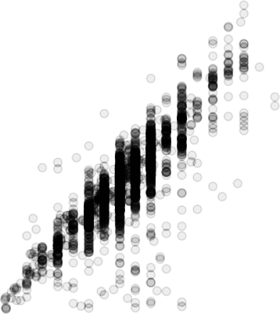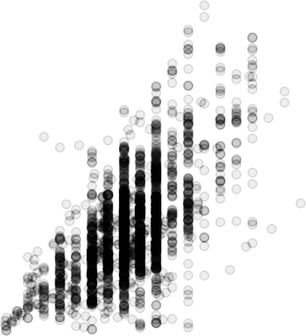

600

75000

400

logrtime

lograrea

50000

200

25000

0

### c

600

0 200 400

docktime

0

0 200 400

docktime

### d

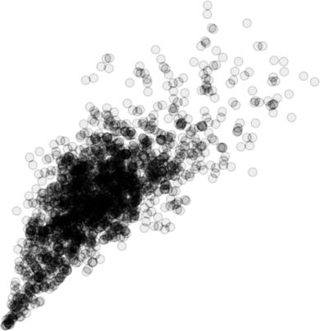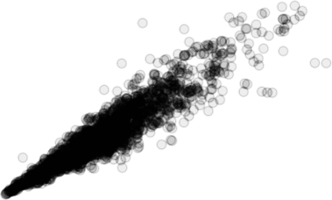

400

logrdist

4000

200

logrtime

2000

0

0 25000 50000 75000

lograrea

0

0 25000 50000 75000

lograrea

Figure 1.2: Relationship between different measures of effort for Block 6, Tasmanian Northern Zone. a) docktime vs logrtime - relationship between daily effort (minutes) from docket and logger; b) docktime vs lograrea - relationship between docket effort and dive polygon area; c) lograrea vs logrtime - relationship between logger area and logger time; d) lograrea vs logrdist - relationship between logger area and logger distance.

### a b

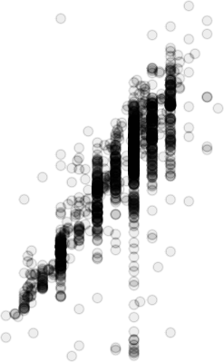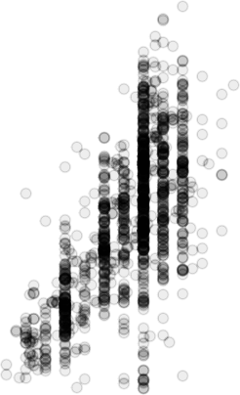

400

300

40000

200

logrtime

lograrea

20000

100

0

### c

400

0 200 400

docktime

0

100 200 300 400 500

docktime

### d

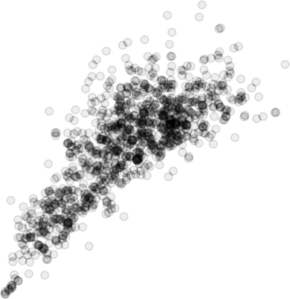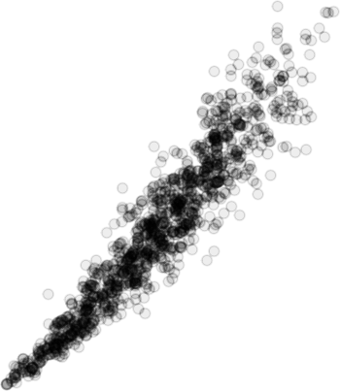

2000

300

1500

logrtime

logrdist

200

1000

100

500

0

0 20000 40000

lograrea

0

0 20000 40000

lograrea

Figure 1.3: Relationship between different measures of effort for Block 21, Tasmanian Eastern Zone. a) docktime vs logrtime - relationship between daily effort (minutes) from docket and logger; b) docktime vs lograrea - relationship between docket effort and dive polygon area; c) lograrea vs logrtime - relationship between logger area and logger time; d) lograrea vs logrdist - relationship between logger area and logger distance.

* + - 1. Relationship between catch and time by data type

Catch broadly increases with fishing time (logger) in both blocks (Figure 1.4, Figure 1.5). Banding of the fishing time from Docket books can be seen in plot b) again for both blocks (Figure 1.4, Figure 1.5), whereas catch appears as a continuous variable with no categorisation. This is expected given that catch is weighed to the nearest kilogram at the boat ramp (or jetty), during the transfer process from diver to processor. Although, all catch weight values in this study (and in the annual fishery assessment) are estimated weights, the fishers are much more adept and highly accurate at estimating weight of catch from each sub-block visited over the fishing day.

### a b

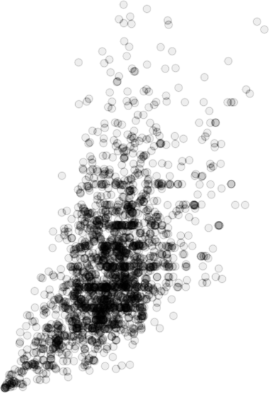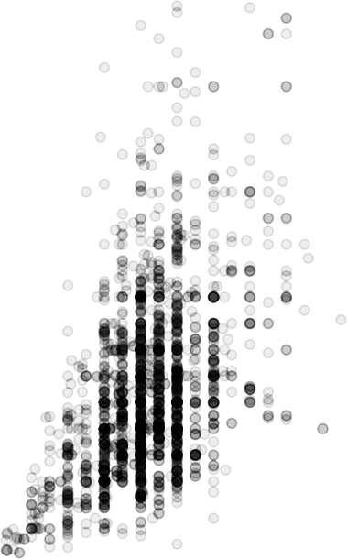

1500

1500

1000

1000

500

logrcatch

dockcatch

500

0 0

0 200 400 600

logrtime

0 200 400

docktime

Figure 1.4: Relationship between catch and effort (logger time and docket time) for Block 6, Northern Zone; a) logger effort (minutes) and catch (kilograms), b) Docket book effort (minutes) and catch (Kilograms). Note: daily catches > 1550Kg removed.

### a b

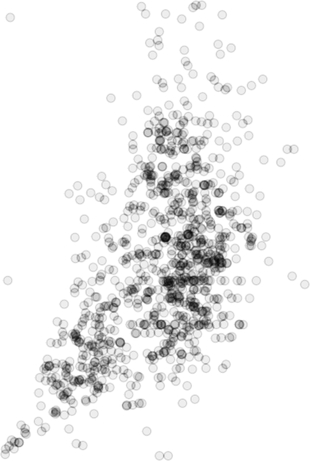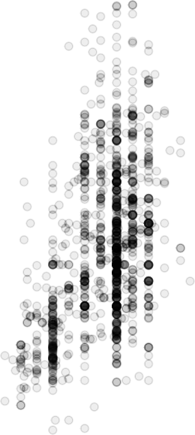

800 800

600 600

400 400

logrcatch

dockcatch

200 200

0 0

0 100 200 300 400

logrtime

100 200 300 400 500

docktime

Figure 1.5: Relationship between catch and effort (logger time and docket time) for Block 21, Eastern Zone; a) logger effort (minutes) and catch (kilograms), b) Docket book effort (minutes) and catch (Kilograms

* + - 1. Relationship between catch and area

There is considerable variation in the catch-dive area relationship in both block 6 and block 21 (Figure 1.6). This reflects high levels of variation among locations, fishing days, fishers, and state of the fishery at the time of fishing.

### a b

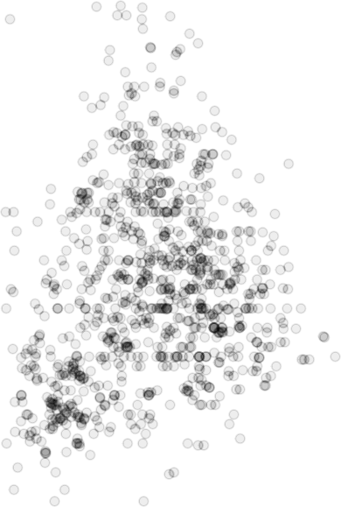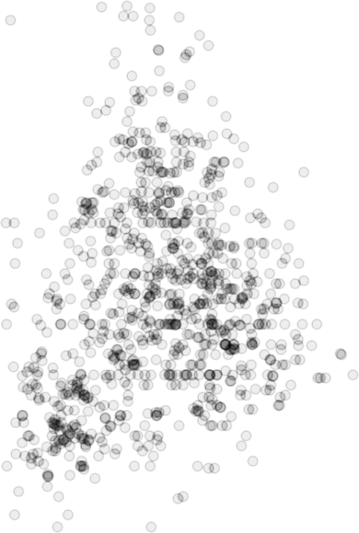

800 800

600 600

400 400

dockcatch

dockcatch

200 200

0 0

0 20000 40000

lograrea

0 20000 40000

lograrea

Figure 1.6: Relationship between reported Docketbook daily catch (dockcatch) and daily area from GPS loggers (lograrea) for Blocks 6 and 21; a) Block 6 logger area (square metres) and daily catch (kilograms), b) Block 21 logger area (square meters) and catch (Kilograms). Note: daily catches > 1550Kg removed.

##### Discussion

The Tasmanian abalone divers on the whole are providing relatively accurate estimates of fishing effort when recording hours fished on their daily Docket returns. Being mindful of the challenges of remembering how much time was spent underwater on each dive, and in each sub-block at the end of the day, the differences between the fisher memory (docket) and automatic logger (depth logger) estimates of fishing time were much less than thought likely. There is a risk that this high level of agreement (excluding biased records due to logger failure) is influenced by the knowledge that effort is being recorded electronically, leading fishers to be more careful with estimating their effort. Most Tasmanian abalone fishers have been using dive computers for the past two decades, and in most instances it assists them with estimating total hours in the water for their Docket

returns. Thus, there is a level of confidence that we can infer a level of accuracy in effort reporting for the period prior to the introduction of GPS and depth datalogger hardware.

The agreement between diver and logger estimates of effort, despite clear patterns of rounding, provides confidence that the Docket returns from fishers contain meaningful estimates of their fishing effort. This is an important conclusion from this study in that there is now greater confidence in the longer time-series of catch and effort data available from the Docket records, while a time-series of logger based measures of effort is developed. It is also clear that relationships between several variables (fishing time, area, distance, catch) are either non-linear, and with increasing variance with increasing magnitude of the variables. This is a clear indication that there are other factors that influence daily catch in addition to effort. These will include human variables such as knowledge of the coast, experience of the deckhand, and also, physical conditions such as sea conditions, wind, etc). There is also likely to be a contribution from small- and regional-scale variation in abundance, and prior fishing activity at the dive site. These issues are explored further in the remaining chapters.

Part II

# Optimising use of spatial dive event data

This section of the report is focused on identifying a base catch rate standardisation model, advantages of choosing different scales of aggregation, and finally on characterising and describing spatial performance measures derived from bivariate kernel utilisation distribution polygons of individual fishing events (KUD). Here we directly explore the potential to replace time as a unit of effort with dive polygon area.

## Catch-rate standardisation strategy

##### Introduction

Central to any assessment of fishery performance is the availability of a valid time-series of an index of relative abundance. All Australian abalone fisheries assume that commercial catch-rates provide such an index, although in some cases, this assumption should have caveats relating to hyperstability, a lack of contrast through time following the introduction of quota systems, and the inherent variation expected with abalone fishery statistics.

Before use in an assessment, ideally, catch-rates should be standardised. Statistical standardisation of catch- rates seek to identify and account for variation in the available data that is not a feature of the temporal trend in abalone abundance, and may include variables relating to gear types, fisher identity or spatial and environmental variables that may exert an influence on catch-rate trends (Hsu, Chang, and Ducharme-Barth 2022; Maunder and Punt 2004; Tanaka et al. 2022a; Thorson et al. 2023). Given the wildly different character of different commercial fisheries, there is no single best approach to such standardisation. For example, there are many different views on what predictor variables should be used, whether variables should be considered fixed, continuous or random, and the extent of any interactions between terms in the model. In the literature, that discussion appears never-ending and at least partly reflects the many different situations exhibited by different fisheries. Whether such discussion has value in practical terms is also debatable. For example, in many cases, providing the statistical model is constructed validly, the choice of whether to include a term as a random or fixed effect often makes relatively little difference. Although, also ideally, any statistical model that is used should also have a sensible biological interpretation and reflect other aspects of reality.

This chapter establishes a common base statistical mixed effects model to be applied to both docket- and logger-based datasets. Additional predictor variables may be added to the base model to address questions of specific interest, or for specific regions, or even individual assessment areas within the fishery.

This chapter links to two objectives:

Objective 1: **Characterise the statistical properties, consistency, interpretability and assumptions of spatial and classic indicators of fishery performance.**

Objective 2: **Develop methods for inclusion of fine-scale spatial data in CPUE standardisations.**

* + 1. Statistical Models

The traditional performance measure in abalone fisheries is catch per unit effort (CPUE), with Effort represented by time (in water dive time) and Catch as kilograms of abalone landed, summed across all dives for a day.

*“The Trouble with Ratios: an Overview*

*Unless there is reason to believe that the regression passes through the origin, the ratio is of dubious value. It may do for rough work, but careful experimentation deserves a more efficient statistical method.”*1

While we use the ratio CPUE religiously in abalone fisheries, it might be argued that the actual metric of interest is, how much catch can be achieved for a given unit of effort rather than the ratio of catch and effort. A more relevant question to ask of the data is, has the level of catch achieved per unit of effort changed over time. In the Tasmanian abalone fishery divers usually set out for the day with a known amount of catch to achieve and make decisions on where to fish based on their prior knowledge of where they are likely, or hopeful, of achieving that catch within the dive time allowed (or in sufficient time to meet the processor truck at the boat ramp at the pre-agreed time). Divers will also count as they fish, knowing that for every minute they spend in the water they need to achieve a certain level of catch. Divers, however, are familiar with and understand the ratio CPUE, perhaps largely because we have trained them over the past four decades to think this is the best way to examine performance of an abalone fishery.

The classic approach for statistical modelling of catch-rates is to use the ratio of catch per unit effort (CPUE) as the dependent (Mod0), with a number of explanatory or independent variables which may be categorical or continuous, and fixed or random depending on one’s philosophical leaning. Abalone fisheries are well known for high levels of spatial variation in productivity and catch-rates, and this is addressed by including a within SAU predictor, in this case sub-block (‘subblockno’). Fishers also have different strategies and diving behaviour, while in most locations we expect catch-rates to be influenced by season, for example higher levels of seaweed biomass during summer months affects catchability. We expect “among diver” and “among season” to contribute substantially to overall variation, and predictors are included for both these factors. Previously, the typical abalone standardisation model for example was:

Mod0 <- CPUE ~

fishyear + subblockno + diver_id + fishmonth

Where all predictors are treated as fixed effects.

As most of our predictors are included to account for variability other than the effect of year, we should consider whether our additional predictors should be included as random effects. Where the number of levels in a random predictor is small (i.e. < 5) the practical difference between treating subbockno as either fixed or random will be small. The estimated values of a random effect are known as ‘BLUP’s (Best Linear Unbiased Predictions), and can be considered equivalent to parameter estimates for a fixed effect. The major difference between treating a predictor as a random or fixed effects is that the BLUPs are penalised, and provide some protection for levels of a factor that might be quite disparate to other levels, particularly where the number of samples in that level are marginal. Overall, treating a predictor such as subblockno as random takes advantage of a phenomenon known as ’borrowing strength’, by assuming some similarity between individual levels (see for example, common trends among sub-blocks below in Figure 2.2). This provides a desirable feature for many of the SAUs where there is considerable heterogeneity in where fishers are active among seasons or among years, and often with small numbers of fishers with extensive local knowledge.

1George Snedecor (in: Curran-Everett (2013) p. 213)

Rather than use the CPUE as a ratio response variable, an alternative option is to model catch as the response variable and specify effort as an offset in the right-hand side of the equation. This provides an identical outcome to using the catch-rate ratio as the response variable, but provides more flexibility when back-casting to predict annual mean catch-rate as part of the standardisation process. Rather than producing a time-series of annual mean CPUE, we can instead examine a time-series of the relative change in catch achieved for a given unit of effort (e.g. 1 hour), where log(effort) is included as an offset in the linear model. When we back-cast to estimate the catch achieved for 1 hour of effort, the output of this formula structure is identical to that from a model with the ratio CPUE as the dependent (i.e. Mod0). Combining these two alternative approaches (mixed effects, offset(log(catch))), we have a model form such as (Mod1).

Mod1 <- log(catch) ~ offset(log(time)) + fishyear +

(1 | subblockno) +

(1 | subblockno:fishyear) + (1 | diver_id) +

(1 | fishmonth)

##### Methods

All mixed effect model and spatial analyses were conducted using R statistical software (R Core Team 2023). The sf package (Pebesma and Bivand 2023) was used to manage spatial objects within R throughout. A mixed-effects model (Mod1) was applied to the GPS logger time-series, with data aggregated by diver fishing day within the smallest scale reported on docket books (i.e. sub-blocks). A Log-normal model is used throughout, implemented using the r package glmmTMB (Brooks et al. 2017). The performance package (Lüdecke et al. 2021) was used to obtain diagnostics and Conditional and Marginal R2 values, and Intra-class correlation coefficients for the fitted models. The mixedup package (M. Clark 2023) was used to extract variance components for random effects. Standardised catch-rates are plotted with the ggplot package (Wickham 2016), and multi-plot arrangements were composed with ‘patchwork’ (Pedersen 2023). General functions within the tidyverse (Wickham et al. 2019) as well as base R were used to coerce and re-shape data as required. Tables were produced using the flextable package (Gohel and Skintzos 2023). Data were batch processed using custom functions and the purrr package (Wickham and Henry 2023).

An informal proportionality check (IPC) of catch and effort variables can be calculated with a minor re-arrangement of model terms, with offset(log(catch) replaced with log(catch) such that log(catch) becomes a continuous term in the model rather than as an offset. The IPC is the coefficient for log(catch), with an expected value of 1, which would confirm that a unit increase in effort achieves a unit increase in catch (Venables, pers comm). Marginal and conditional R2 values are also calculated to provide an indicator of how well the model captures variation in the dataset. Marginal R^2 indicate the variance accounted for by the fixed effects in the model and the Conditional R2 indicate the variance accounted for by the full model (fixed and random). Standard Residual and QQ plots are used to test whether assumptions of normality and variance are met adequately.

Statistical properties and diagnostics are explored in detail for a subset of Spatial Assessment Units (SAU). The IPC, R2 values, and contribution of random effects are conducted on a selection of SAUs, while more detailed

analyses are done for two SAUs - SAU5 and SAU11. The following base model formula was applied to each of the example SAUs:

log(catch_est) ~ offset(log(logrtime)) + fishyear + (1 | subblockno) + , (1 | subblockno:fishyear) + (1 | diver_id) + (1 | fishmonth)

A consideration of a range of standardisation approaches and the contribution of several environmental variables are detailed in the Appendix (Chapters 10-12).

##### Results

* + 1. Informal proportionality check

IPC values for all SAUs examined here are close to the expected value of 1. Two notable exceptions are SAU21 and SAU49 where the IPC is 0.94 and 0.91 respectively (Table 2.1). This simple check provides confidence that the data conform to the expectation that catch is proportional to effort.

Table 2.1: Logger data: Informal proportionality check for three Spatial Assessment Units (SAUs) in the Tasmanian abalone fishery.

|  |  |
| --- | --- |
| SAU | ipc |
| SAU11 | 0.98 |
| SAU12IN | 0.98 |
| SAU13 | 1.00 |
| SAU21 | 0.94 |
| SAU49BS | 0.91 |
| SAU5 | 1.03 |
| SAU53 | 1.00 |
| SAU7 | 1.03 |

Table 2.2: Docket book data: Informal proportionality check for three Spatial Assessment Units (SAUs) in the Tasmanian abalone fishery.

|  |  |
| --- | --- |
| SAU | ipc |
| SAU11 | 0.97 |
| SAU12IN | 0.95 |
| SAU13 | 0.91 |

|  |  |
| --- | --- |
| SAU | ipc |
| SAU21 | 0.84 |
| SAU49BS | 0.65 |
| SAU5 | 0.91 |
| SAU53 | 0.93 |
| SAU7 | 1.01 |

* + 1. Marginal and Conditional R2

Marginal R2 (~ fixed effects) was low for all SAUs examined (Table 2.3). In the base model, the only fixed effect is Year (fishyear), with random effect terms accounting for much of the variation. The Conditional R2 (both fixed and random effects) ranged from 0.30 to 0.70 for the SAUs examined. The relatively low level of variance explained suggests there are drivers not included in the model contributing to variation in the dataset. These may include spatial or environmental drivers, or, may reflect the high levels of variation commonly observed in commercial fisheries data (See(Figure 3.2 in Chapter 3 for an expansion of this issue).

Table 2.3: Marginal (R2_M) and Conditional(R2_C) R2 for three Spatial Assessment Units (SAUs) in the Tasmanian abalone fishery using Mod1.

|  |  |  |
| --- | --- | --- |
| SAU | R2_marginal | R2_conditional |
| SAU11 | 0.07 | 0.30 |
| SAU12IN | 0.06 | 0.35 |
| SAU13 | 0.10 | 0.46 |
| SAU21 | 0.15 | 0.55 |
| SAU49BS | 0.07 | 0.70 |
| SAU5 | 0.21 | 0.45 |
| SAU53 | 0.12 | 0.59 |
| SAU7 | 0.09 | 0.47 |

* + 1. Intra-class correlation coefficient

Of interest is whether replicates within a grouping variable (random effect) resemble each other. The Intra-class correlation coefficient (ICC) provides a measure of within-group repeatability i.e. are records within a level within a group more similar to each other than to records in another level within the same group. Notably, our model term for seasonality (fishmonth) suggests there is very little repeatability within months (Table 2.4). ICC values close to zero suggest there might be little benefit in setting that model term as a random effect. Only two terms - diver_id and subblockno show moderate levels of repeatability, but the patterns are not consistent across SAUs.

Table 2.4: Intra-class correlation coefficient of individual random effects in the model.

|  |  |  |  |  |
| --- | --- | --- | --- | --- |
| SAU | diver_id | fishmonth | subblockno | subblockno:fishyear |
| SAU11 | 0.19 | 0.02 | 0.00 | 0.03 |
| SAU12IN | 0.20 | 0.01 | 0.08 | 0.02 |
| SAU13 | 0.28 | 0.11 | 0.00 | 0.01 |
| SAU21 | 0.40 | 0.01 | 0.03 | 0.03 |
| SAU49BS | 0.03 | 0.01 | 0.58 | 0.04 |
| SAU5 | 0.13 | 0.02 | 0.11 | 0.05 |
| SAU53 | 0.05 | 0.06 | 0.37 | 0.06 |
| SAU7 | 0.14 | 0.01 | 0.17 | 0.09 |

* + 1. Contribution of individual random effects to the model

For most SAUs diver identity was the most important random effect in the model, whereas the sub-block effect (representing areas within each SAU) was relatively unimportant. Whereas for SAU49 and SAU53, the relative importance of these two random effects were reversed (Table 2.5). Month of year was of negligible importance across all the SAUs examined here, with SAUs representing western, eastern, northern, and Bass Strait regions of the Tasmanian Abalone fishery. The relative contribution of random effects are almost identical to the ICC values.

Table 2.5: Contribution (% explained) of individual random effects to the model.

|  |  |  |  |  |  |
| --- | --- | --- | --- | --- | --- |
| SAU | diver_id | subblockno:fishyear | fishmonth | subblockno | Residual |
| SAU11 | 0.192 | 0.027 | 0.024 | 0.000 | 0.756 |
| SAU12IN | 0.203 | 0.021 | 0.014 | 0.076 | 0.686 |
| SAU13 | 0.277 | 0.009 | 0.110 | 0.001 | 0.603 |
| SAU21 | 0.400 | 0.029 | 0.014 | 0.029 | 0.527 |
| SAU49BS | 0.033 | 0.041 | 0.013 | 0.585 | 0.328 |
| SAU5 | 0.130 | 0.054 | 0.016 | 0.106 | 0.694 |
| SAU53 | 0.047 | 0.057 | 0.064 | 0.367 | 0.465 |
| SAU7 | 0.143 | 0.087 | 0.012 | 0.172 | 0.586 |

* + 1. Case Study: SAU5 Northern Zone (Blocks 5 & 6)

Model diagnostics for the SAU5 dataset indicate reasonable adherence to assumptions required of data analysed with linear mixed-effect model. Normality of the residuals is perhaps the most concerning (Figure 2.1), although typical of fisheries data where the density of data points is sparse at the lower end and to a lesser extent at the upper end. Noting that a log-normal model is applied, the diagnostics for this linear mixed-effect model don’t suggest any cause for concern that might require action.

Posterior Predictive Check

Model−predicted lines should resemble observed data line 0.003

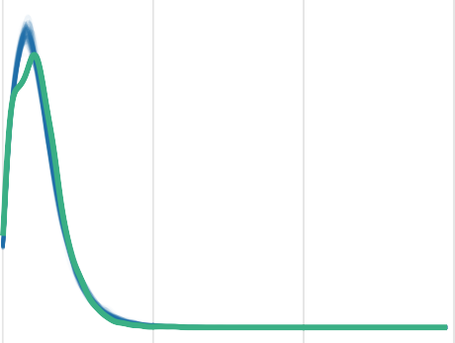

Linearity

Reference line should be flat and horizontal

1

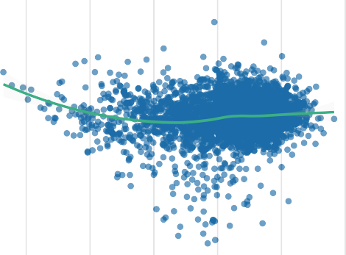

0.002

Density

Residuals

0

0.001 −1

0.000

−2

0 1000 2000 3000

log(catch_est)

Observed data Model−predicted data

2 3 4 5 6 7

Fitted values

Homogeneity of Variance

Reference line should be flat and horizontal 2.5

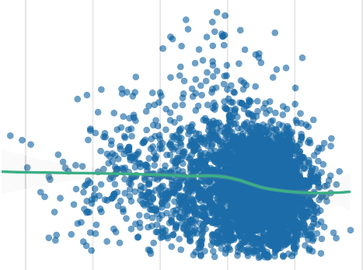

2.0

Normality of Residuals

Dots should fall along the line

|  |  |  |  |  |  |  |  |  |  |  |  |
| --- | --- | --- | --- | --- | --- | --- | --- | --- | --- | --- | --- |
|  |  |  |  |  |  |  |  |  |  |  |  |
|  |  |  |  |  |  |  |  |  |  |  |  |
|  |  |  |  |  |  |  |  |  |  |  |  |
|  |  |  |  |  |  |  |  |  |  |  |  |
|  |  |  |  |  |  |  |  |  |  |  |  |
|  |  |  |  |  |  |  |  |  |  |  |  |
|  |  |  |  |  |  |  |  |  |  |  |  |
|  |  |  |  |  |  |  |  |  |  |  |  |
|  |  |  |  |  |  |  |  |  |  |  |  |

1

Sample Quantile Deviations

1.5

|Std. residuals|

1.0

0.5

0.0

2 3 4 5 6 7

Fitted values

0

−1

−2

−1.0 −0.5 0.0 0.5 1.0

Standard Normal Distribution Quantiles

Normality of Random Effects (subblockno:fishyear)

Dots should be plotted along the line 0.3

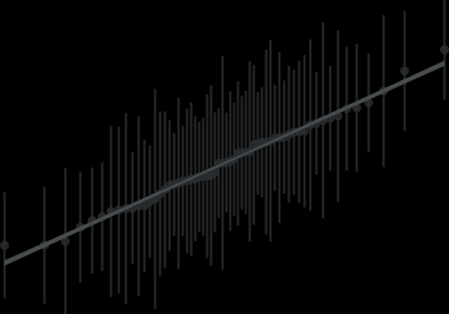

0.2

Normality of Random Effects (fishmonth)

Dots should be plotted along the line 0.1

RE Quantiles

0.1

RE Quantiles

0.0

0.0

−0.1

−0.2

−0.1

−2 −1 0 1 2

Theoretical Quantiles

−1 0 1

Theoretical Quantiles

Figure 2.1: SAU5: Model diagnostics)

* + - 1. Standardised catch per 1 hour of diving effort

An advantage of the base statistical model is that the SAU wide trend can be presented, while accounting for variation among sub-blocks within the SAU. Additionally, via the partial interaction term (1 | subblock:fishyear) we can also examine the trends of individual sub-blocks across the same time-series (Figure 2.2). Sub-block 5A, while one of the top two sub-blocks in this SAU in terms of production, has always had a substantially lower

catch-rate (Figure 2.2, Figure 2.3). Despite this, the trend in catch per 1 hour of effort is very similar across all subblocks.

Lognormal model (independence)

90

70

CPUE

50

2012 2014 2016 2018 2020

year



subblockno

05A 

05B

05C 

06A

06B

06C

Figure 2.2: SAU5: glmmTMB - Log-normal CPUE standardisation (including bias correction). Response variable is log(catch), with log(effort) included as an offset. Black line indicates SAU mean catch-rate, and the coloured lines relate to the trend in each specific subblock, and the coloured lines relate to the trend in each specific subblock.

Lognormal model (independence)

90

05A

05B

70

50

90

05C

06A

70

CPUE

50

90

06B

06C

70

50

2012 2014 2016 2018 2020 2012 2014 2016 2018 2020

year

Figure 2.3: SAU5: glmmTMB - Log-normal CPUE standardisation (including bias correction) - facet plot. Black line indicates SAU mean catch-rate, and the coloured lines relate to the trend in each specific subblock, and the coloured lines relate to the trend in each specific subblock.

Posterior Predictive Check

Model−predicted lines should resemble observed data line 0.0020

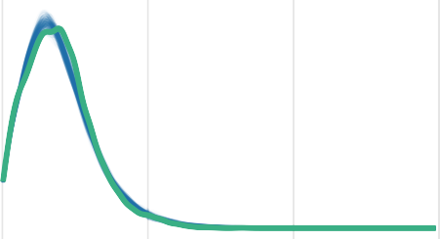

0.0015

Density

0.0010

0.0005

0.0000

0 1000 2000 3000

log(catch_est)

Observed data Model−predicted data

Homogeneity of Variance

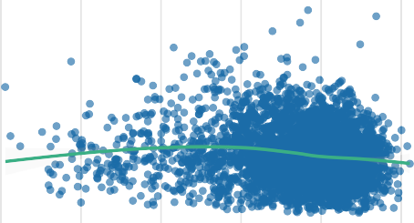Reference line should be flat and horizontal

|  |  |  |  |  |  |
| --- | --- | --- | --- | --- | --- |
|  |  |  |  |  |  |
|  |  |  |  |  |  |
|  |  |  |  |  |  |
|  |  |  |  |  |  |
|  |  |  |  |  |  |
|  |  |  |  |  |  |

2

|Std. residuals|

1

Linearity

Reference line should be flat and horizontal 1

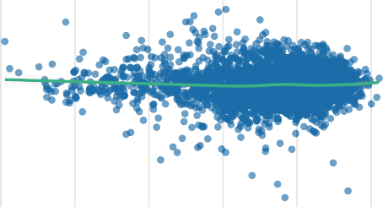

Residuals

0

−1

−2

2 3 4 5 6 7

Fitted values

Normality of Residuals

Dots should fall along the line 1



Sample Quantile Deviations

0

−1

0

2 3 4 5 6 7

Fitted values

−2

−1.0 −0.5 0.0 0.5 1.0

Standard Normal Distribution Quantiles

Normality of Random Effects (subblockno:fishyear)

Dots should be plotted along the line

Normality of Random Effects (fishmonth)

Dots should be plotted along the line

0.1

RE Quantiles

0.0

−0.1

−2 −1 0 1 2

Theoretical Quantiles

0.10

0.05



RE Quantiles

0.00

−0.05

−0.10

−1 0 1

Theoretical Quantiles

Figure 2.4: SAU11: Model diagnostics)

* + 1. Case Study: SAU11 Western Zone (Block 11)

Diagnostics for SAU11 are similar to those for SAU5, even though SAU11 has a much greater level of fishing activity (SAU11 4116 records; SAU5 3237 records). Non-Normality of the residuals in SAU11 follows a similar pattern to SAU5. As for SAU5, most subblock catch rates follow a similar trend to the SAU wide trend. This may explain why the ICC and % variance explained for subblocks is consistently low - i.e the subblocks are essentially correlated. For SAU11 however, two subblocks however show different trends over the time series; subblock 11D had the lowest catch per unit effort at the start of the time-series, but the second highest by the end of the time-series, while subblock 11A had the highest catch per unit effort in 2012, and the lowest by 2019. While these two subblocks have slightly different trajectories, they remain largely in parallel.

Lognormal model (independence)

120

110

100

CPUE

90

80

2012 2014 2016 2018 2020

year

subblockno  11A  11B  11C  11D  11E

Figure 2.5: SAU11: glmmTMB - Log-normal CPUE standardisation (including bias correction). Response variable is log(catch), with log(effort) included as an offset. Black line indicates SAU mean catch-rate, and the coloured lines relate to the trend in each specific subblock, and the coloured lines relate to the trend in each specific subblock.

Lognormal model (independence)

120

11A

11B

110

100

90

80

120

11C

11D

110

100

CPUE

90

80

2012 2014 2016 2018 2020

11E

120

110

100

90

80

2012 2014 2016 2018 2020

year

Figure 2.6: SAU11: glmmTMB - Log-normal CPUE standardisation (including bias correction) - facet plot. Black line indicates SAU mean catch-rate.

##### Discussion

A log-normal model was fitted using two R packages - glmmTMB (Brooks et al. 2017) and lme4 (Bates et al. 2015). The lme4 package has been chosen as for statistical standardisation of Tasmanian abalone catch-rates, largely due to the ease of prediction methods for back-casting to obtain a standardised catch rate. When attempting to fit a log-normal model using lme4 (Bates et al. 2015) or a gamma model using either lme4 or glmmTMB packages, convergence warnings were common, primarily for singularity, and always driven by the subblock factor having negligible or zero variance. An automated switch was applied such that for SAUs with less than four subblock levels, the subblockno and subblockno:fishyear terms were removed from the model. Implementation of the filter resolved the majority of convergence warnings when using the lme4 package.

The base statistical model outlined here for statistical standardisation of Tasmanian abalone catch-rates provides a number of benefits in terms of flexibility, while accounting for key factors affecting fishing performance. The minimal contribution however, of the sub-block factor to model variance in most SAUs was unexpected (this is explored further in Chapter 3). When using the fishery docket data some of level of inaccuracy in reporting at the sub-block scale is expected, but that does not apply in the GPS logger program examples provided here. GPS logger program data maps sub-block onto the dataset using a spatial join between each dive polygon and a zone polygon with zone, region, SAU, block, and sub-block attributes.

An emerging characteristic of the Tasmanian GPS logger program data is that different parts of the fishery have different drivers in terms of the spatial structure of effort. For this reason, a relatively simple base model, optimised for each SAU with additional variables where available is a better approach than attempting to apply a more complex model throughout. The model residual term accounted for the majority of data variance for all SAUs. Whether this is because other factors are more important than those included in the base model, or that there is a high level of noise in fisheries catch rate data is examined in the next chapter (Chapter 3).

## The Importance of Scale

##### Introduction

Read (Barnett, Ward, and Anderson 2021)

Adapt and run this code <https://pbs-assess.github.io/sdmTMB/articles/web_only/index-standardization.html>

Catch and effort data in most fisheries are most often noisy and variable. This is perhaps unsurprising in that they often reported from large geographic distances, often with highly heterogeneous environments. Fishing takes place across a range of sea conditions, and effort is often only a rough guide rather than a precisely measured unit of time. We observed in Chapter 1 considerable levels of variation in the relationship between catch and effort. In Chapter 2 we observed moderate Conditional R2 (~ 0.4 - 0.5) for many of the Spatial Assessment Units (SAUs) examined, indicating the terms included in the statistical model for catch rate standardisation are failing to capture a substantial proportion of the observed variance in the datasets. While we have included a within-SAU spatial structure (subblock), this term contributed very little to the model outcomes (Table 2.5). This would suggest either a level of homogeneity among subblocks within an SAU, or, that high levels of variation occur at a scale much smaller than the scale of a subblock. Alternatively, there are other factors not included in the model that contribute to high variability in daily diver catch rates.

A perceived advantage of the fine-scale fisheries collected through the GPS logger program is the potential to account for the high levels of variability in abalone fisheries catch rate data. Utilising the precise location of each fishing event, we can either dissect each SAU into smaller rule-based spatial units (rather than the arbitrarily imposed subblock boundary divisions), or go further and account for the exact spatial location in our linear model.

Abalone fishery catch rates are always perceived as highly variable and unreliable, yet illustrations of the extent of variability in catch rates within a Spatial Assessment Unit (SAU) are rarely provided. In order to better understand the challenges with obtaining a mean annual catch rate for an SAU, catch rates are calculated at a range of time steps, from daily (mean of all fishing events in an SAU per day) to mean catch rate within a moving window of 5, 10, 30 and 90 days.

This chapter links to two objectives:

Objective 1: **Characterise the statistical properties, consistency, interpretability and assumptions of spatial and classic indicators of fishery performance.**

Objective 2: **Develop methods for inclusion of fine-scale spatial data in CPUE standardisations.** ## Methods

##### Methods

Input data are those spatial records that meet criteria outlined in Chapter 1. Noting that data capture is between 80% and 90% depending on the year, this opens a potential bias

* + 1. Statistical Models

All lmer analyses here use the KUD dataset either pooled by diver/day, or by individual dive. The response is always log(catch) and modelled against log(effort) where effort is logger time in minutes.

* + - 1. Modelling response variable at different scales

While the GPS logger program records the duration (in minutes) for each fishing event, catch is reported as a daily total catch for each subblock visited. Catch per dive is achieved by pro-rata assignment of total catch to each dive based on duration of each dive. While we recognise this would have a smoothing effect on actual catch per dive especially where catch rate for dives through the day might vary due to depth or other environmental drivers. By modelling catch at the dive level, rather than by day, we may be able to account for some of the unexplained variation in the model identified in Chapter 2. This is achieved by modelling catch achieved for one hour of effort at the day, and dive scales using the base mixed effects model outlined in Chapter 2.

* + - 1. Including within SAU spatial structure in standardisation models

Dividing an SAU into multiple spatial clusters as an alternative to arbitrary subblock divisions may capture more of the unexplained variation (residual variance) evident in the examination of the contribution of effects to total variance in Chapter 2. This is achieved by applying spatial scan methods to the dive centroid, to create an empirical rule-based SAU subarea. Spatial density-based clustering methods require two parameter settings; a distance value (epsilon) to be used as the radius of the neighbourhood search, and the minimum number of points required for a unique cluster. Here we use the dbscan package (Hahsler and Piekenbrock 2022) to assign a unique spatial cluster identifier to every dive record, with epsilon set at 300m and the minimum points per cluster set at 15. The new cluster variable is substituted for the subblock variable in the base standardisation model (Figure 3.1).

40.90S

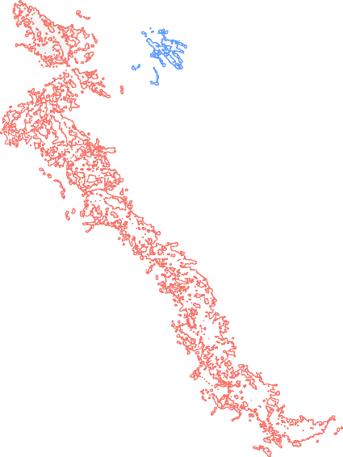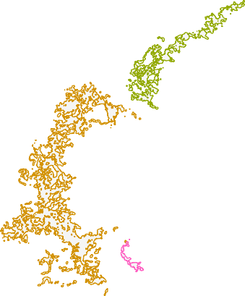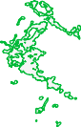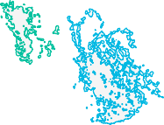

274

182

118

102

420

203

225

43

231

40.95S

y

cluster_id

43

102

118

182

203

225

231

274

420

41.00S

41.05S

144.60E144.61E144.62E144.63E144.64E144.65E

x

Figure 3.1: Spatial Clustering of all dive events within SAU5, Subblock 5C, Northern Zone (2012 - 2021) into discrete groups by distance. DBSCAN generated nine clusters using a setting of 300m separation between the centroid of fishing events, and a minimum of 15 points to form a cluster. This approach found nine distinct spatial clusters of fishing activity within the single Subblock 5C.

* + - 1. Using high resolution information on location of fishing

Much of the variation in catch rates is thought to be associated with high levels of patchiness in resource abundance. By modelling fishing data at the scale of individual dive, the centroid of the dive polygon representing the location of the fishing event can be used in a spatial regression approach. While several packages offer fixed effect spatial auto-regression capability, very few enable direct use of the spatial information in a mixed effect model.

Two mixed effect spatial regression approaches are utilised here:

* + - * 1. Coordinates (Easting and Northing) of the dive polygon centroid are included as a spline in a general additive mixed effect model (GAM) using the mgcv package (Wood 2011).
        2. A spatio-temporal LMM was used to examine the influence of spatial structure on the model fit to the case study dataset using the sdmTMB package (Anderson et al. 2022).

The approach using GAMs involved fitting the base CPUE standardisation model as a GAM, and then repeating the model with a term for a spline of easting and northing of the dive centroid. Model fits were examined using deviance explained and AIC. Scaled prediction plots using predicted annual mean catch per 1 hour of effort were used to examine the impact of inclusion of the spatial term.

Spatially explicit GLMMs seek to address spatial and or temporal autocorrelation in a dataset, and provide insights into the space and time influences on response variables. The first step is to create an SPDE mesh using the centroid of the dive polygon, with a cut-off value of 5, where cut-off refers to the minimum distance between knots (vertices) of the resulting mesh (Anderson et al. 2022). This step builds a mesh across the spatial extent of the input dataset. For the GLMM component, the base standardisation model was used, except the (1| subblock:fishyear) term was dropped as sdmTMB does not yet support interactions of this type. Three models were applied, spatial switched off (non-spatial) which should be equivalent to a GLMM from non-spatial modelling packages, spatial switched on (space) and, lastly, with switching both spatial and spatio-temporal modes on (space-time). The temporal component was intentionally coarse for this exercise, with the time resolution set to fishing year. To better understand the spatial scale of variation in the datasets, this exercise was run firstly with the coarse scale subarea term subblock, and then again with subblock replaced with the finer scale subarea term cluster_id. Model performance was compared using AIC. If fishing performance is relatively homogeneous within clusters, we would expect relatively little difference between the non-spatial and spatial model fits where the finer scale cluster term is used.

##### Results

* + 1. Variability in daily catch rate

Across all example SAUs, daily catch rates differ substantially over short time frames such as 10s of days (Figure 3.2). Daily catch rates appear to be lower and less variable during winter, but otherwise there is little evidence of a strong seasonal pattern. For example in SAU11, daily catch rate may vary by up to 150 Kg/Hr within as little as 30 days (Figure 3.2 SAU11 panel). Moving window mean catch rates of 5 and 10 days also show short-term oscillations of up to 80 Kg/Hr. Over longer time windows, the 30- and 90-day moving window mean

catch rates continue to show substantial oscillations of up to 50 kg/Hr. There are many potential explanations for this level of variability such as weather on the day of fishing, diver identity and knowledge, the subblock or location within the SAU, or high variability in the local abundance across fishing events. The contribution of environmental variables was examined in detail in appendices 10-12, with little evidence that weather imparts a strong influence on fishing performance in the majority of cases. The contribution of heterogeneity abalone abundance at fin spatial scales is the focus of the remainder of this chapter.

300

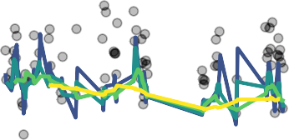

SAU11

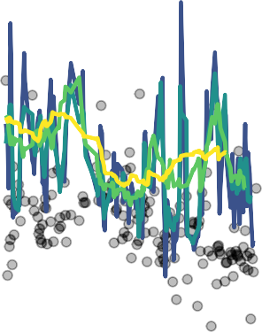

SAU13

100

200

100

mean CPUE (daily)

125

50

Mar 01 Jun 01 Sep 01 Dec 01 Mar 01 Jun 01 Sep 01 Dec 01

moving window

05day 10day 30day 90day

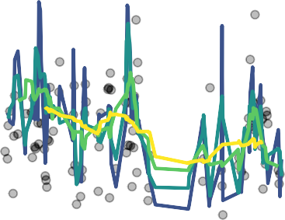

SAU5

100

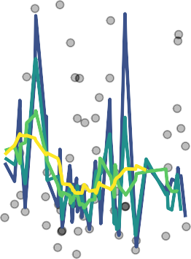

SAU21

100

75

50

50

0

Mar 01 Jun 01 Sep 01 Dec 01 Mar 01 Jun 01 Sep 01 Dec 01

Date

Figure 3.2: Mean daily catch rate (Kg/hr) by dive in 2013 for three case-study SAUs. Grey scale dots represent mean daily catch rate. Coloured lines represent a moving window mean catch rate calculated for window size: 5, 10, 30, and 90 days.

* + 1. Modelling response variable at different scales: day vs dive

Modelling the response variable (estimated catch) at the spatial resolution of individual dives rather than aggregated up to each fishing day, provides a number of opportunities for quantifying scales of spatial structure in our datasets. There was almost no difference in predicted mean catch per hour of effort when data were

modelled by day or disaggregated to the scale of each dive event (Figure 3.3). Mean expected catch only deviated in the final year of the time-series (2021), and is not likely due to the low sample size for 2021 in the study dataset.

90



80

70

Catch (per dive hour)

60

50

2012 2014 2016 2018 2020

Year

factor(method)  Crude  L_Time_Day  L_Time_Dive

Figure 3.3: Modelling the response variable (catch) at day vs dive scale for Northern Zone, SAU 5(subblocks 5A, 5B, 5C, 6A, 6C, 6D). Catch achieved is predicted for 1 hour of fishing effort. Crude = ratio CPUE.

* + 1. Accounting for within SAU spatial structure

Replacement of the coarse-scale (subblock) random effect predictor with a finer-scale (cluster_id) predictor to account for within SAU spatial structure returned mixed results. For some SAUs (SAU11, SAU21), replacing the coarse-scale subblock categorical predictor with the fine-scale cluster predictor, marginally increased the Conditional R2 (Table 3.1), indicating a small improvement in capture of variation within the dataset. However, the inverse was observed for SAU49 where inclusion of cluster_id decreased Conditional R2. This is supported by a corresponding increase in residual variance for SAU49 modelled with cluster_id (Table 3.2). While in most cases, the switch from coarse to fine for the sub-SAU term had little effect on the overall variance accounted for

by the model, there was an effect on the proportion of variance accounted for by the model random effects. With the exception of SAU49 and SAU7, shifting to the finer cluster term decreased the residual variance, although there was no real change in SAU13, which had only three distinct spatial clusters of fishing events. The trend in estimated mean catch per 1 hour fishing event using subblock or cluster terms was also very similar (Figure 3.4). The absence of a strong effect of the within SAU spatial structure term (subblock vs cluster) on either Conditional R2 or on estimated mean catch suggests, that in most SAUs they are not an effective mechanism to account for spatial structure in the dataset.

Table 3.1: Accounting for within SAU spatial structure with fine or coarse scale division. Marginal (R2_M) and Conditional(R2_C) R2 for five Spatial Assessment Units (SAUs) in the Tasmanian abalone fishery.

|  |  |  |  |
| --- | --- | --- | --- |
| structure | SAU | R2_marginal | R2_conditional |
| Sub-block |  |  |  |
|  | SAU11 | 0.07 | 0.41 |
|  | SAU13 | 0.10 | 0.52 |
|  | SAU21 | 0.17 | 0.58 |
|  | SAU49BS | 0.07 | 0.75 |
|  | SAU5 | 0.25 | 0.53 |
|  | SAU53 | 0.12 | 0.78 |
|  | SAU7 | 0.07 | 0.57 |
| Cluster |  |  |  |
|  | SAU11 | 0.07 | 0.50 |
|  | SAU13 | 0.12 | 0.56 |
|  | SAU21 | 0.19 | 0.62 |
|  | SAU49BS | 0.12 | 0.68 |
|  | SAU5 | 0.22 | 0.55 |
|  | SAU53 | 0.14 | 0.76 |
|  | SAU7 | 0.06 | 0.57 |

Table 3.2: Accounting for within SAU spatial structure with fine or coarse scale division. Contribution (% ex- plained) of individual random effects to the model.

90



80

70

Catch (per dive hour)

60

50

2012 2014 2016 2018 2020

Year

factor(method)  Crude  L_Time_Dive  L_Time_Dive_Clust

Figure 3.4: Modelling the response variable (catch) at the dive scale, with either subblock or cluster terms to account for within SAU spatial structure. Figure shows results for Northern Zone, SAU5 (subblocks 5A, 5B, 5C, 6A, 6C, 6D). Catch achieved is predicted for 1 hour of fishing effort.

* + 1. Including precise location of dive events in the standardisation model
       1. Using GAM with a spline to account for spatial structure

Inclusion of a spline term in a GAM model to account for precise location of each fishing event had minimal impact on the proportion of deviance explained by the model (Table 3.3), although there was a noticeable reduction in AIC with the inclusion of the spatial spline (Table 3.4). There appeared to be little corresponding impact on the temporal trend in the estimated annual mean catch rate (Figure 3.5), although the GAM model

suggests the fishery reached a low point in 2016, whereas the non-spatial glmmTMB model suggests the low point in the time-series occurred in 2018 (Figure 3.4).

Exploration of the residuals by year and spatial location identify high levels of local variation in residuals, with substantial change among years (Figure 3.6).

Table 3.3: Change in model deviance explained by accounting for spatial location of each dive event by adding a spline on easting and northing of the dive centroid. Data used in this analysis were from SAU5 in the Tasmanian abalone fishery.

Scale devExplained

non-spatial 0.84

spatial 0.87

Table 3.4: Change in model AIC with increasing spatial resolution.

|  |  |  |
| --- | --- | --- |
| model | df | AIC |
| dive | 117.8 | 6,822.9 |
| diveXY | 145.9 | 4,369.0 |

1.5



1.3

1.1

Catch per dive hour

0.9

0.7

2012 2014 2016 2018 2020

Year

factor(method)  Gam_Dive  Gam_DiveXY

Figure 3.5: GAM Modelling day vs dive scale catch and effort for SAU5, Northern Zone. Standardised CPUA (catch achieved for 0.5Ha of fishing area).

5426000

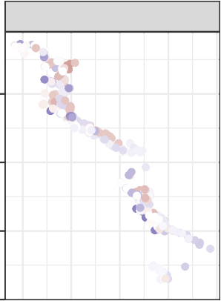

2012

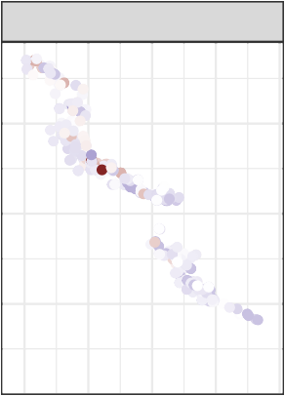

2013

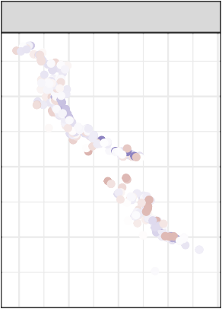

2014

5424000

5422000

5420000

5426000

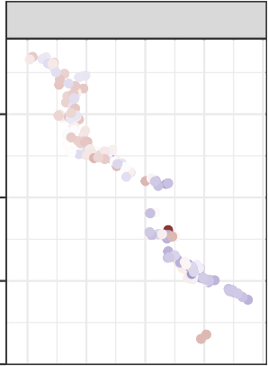

2015

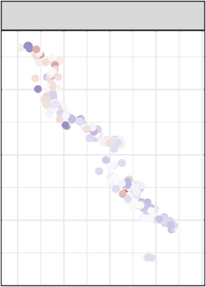

2016

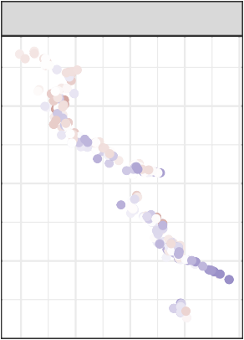

2017

5424000

5422000

5420000

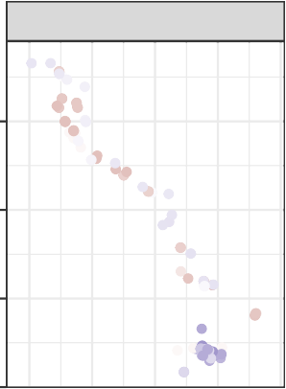

2018

northing

5426000

res_gam2

1.0



0.5

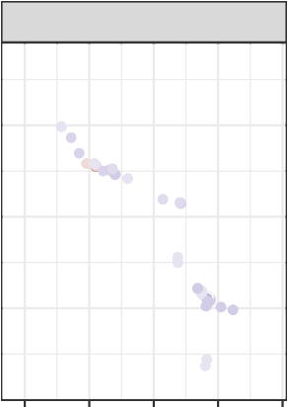

2020

0.0

−0.5

−1.0

5424000

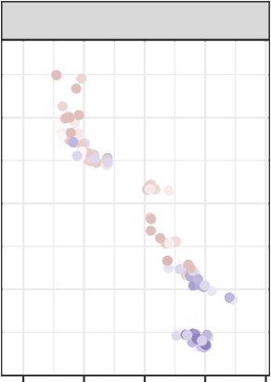

2019

5422000

5420000

308000309000310000311000312030008000309000310000311000312000

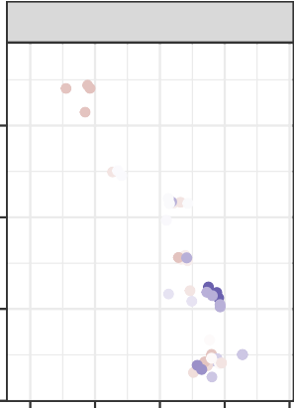

2021

5426000

5424000

5422000

5420000

308000309000310000311000312000

easting

Figure 3.6: Residual plots by year for SAU5, Northern Zone from model fitted with subblock term. Only data from subblock 6C are presented here for clarity. Spatial location included as a spline smooth in the GAM model using easting and northing of the dive centroid.

* + - 1. Using spatially explicit GLMMs to account for spatial structure

The basis of the spatially explicit linear mixed effects model is a SPDE (stochastic partial differential equation) mesh Figure 3.7. The resolution of the mesh can be configured from fine to coarse, with trade-offs between computation speed and spatial resolution.

Direct comparison between non-spatial and spatio-temporal model fits is not possible, although a comparison of the improved performance from using a different within-SAU term (subblock vs cluster) can provide insights into the improvements gained by addressing spatial structure directly in the model. For the non-spatial model, a marked reduction in model AIC was observed for the model using cluster_id as the within SAU term compared to using the coarser subblock term (Table 3.5). When spatial or spatio-temporal terms are included the improvement in AIC is negligible (Table 3.5).

Examination of the spatial structure in residuals through time suggests that the majority of variation in catch rates occurs at a very fine scale, although this does vary through time and some broad spatial structure is evident regardless of whether subblock or cluster is added as the within SAU term (Figure 3.8, Figure 3.9). The spatial map of residuals matches very closely to that returned from the GAM model (Figure 3.6) In 2012, there is considerable local variation in residuals across the fishing grounds in subblock 6C. In 2018 and 2019, when fishery performance was lowest (Figure 3.4), the residuals are largely negative across all of Subblock 6C (Figure 3.8, Figure 3.9). While there is a small level of deviation between the non-spatial model residuals and the spatio-temporal model residuals, there are no outstanding differences, or differences that are of concern (Figure 3.10, Figure 3.11).

The difference between non-spatial, spatial, and spatio-temporal standardised annual mean catch rate was negligible, for both the subblock and cluster term models (Figure 3.12, Figure 3.13). This is consistent with a lack of major shift in the residuals (Figure 3.10, Figure 3.11), and also consistent with the spatial and non-spatial GAM models.

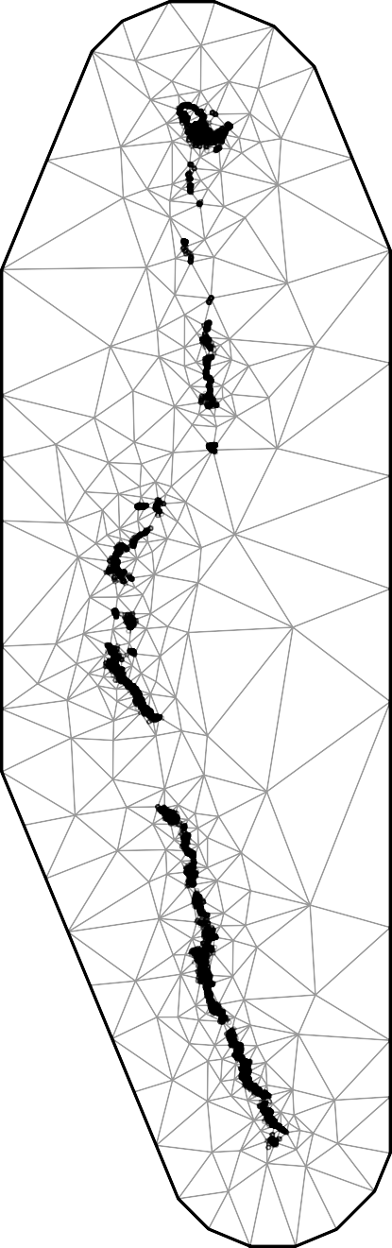

Figure 3.7: Spatial mesh for Block6 used as the basis for the spatially explicit lmm.

Table 3.5: Spatially explicit GLM modelling of abalone abundance. GLM formula was identical for all three models, with **subblock** and **cluster** used as alternative within SAU random effect terms.

|  |  |  |
| --- | --- | --- |
| structure withinSAU | df | AIC |
| subblock  non-spatial | 14 | 5,893.1 |
| cluster | 14 | 5,606.2 |
| subblock  spatial | 16 | 4,159.6 |
| cluster | 16 | 4,160.3 |
| subblock  space-time | 17 | 2,888.2 |
| cluster | 17 | 2,888.1 |

5426

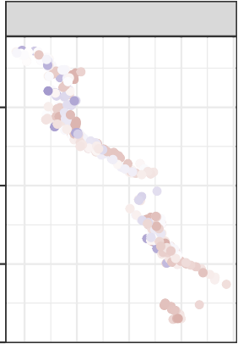

2012

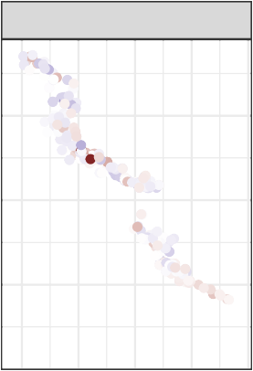

2013

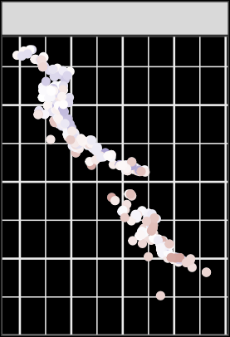

2014

5424

5422

5420

5426

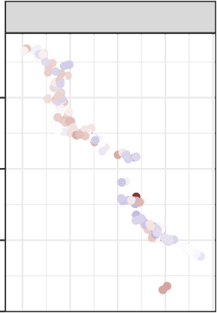

2015

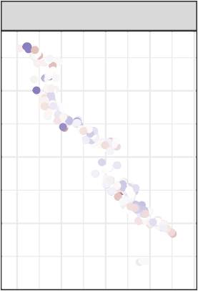

2016

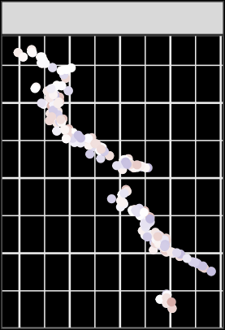

2017

5424

5422

sb_resids_space

2



5420

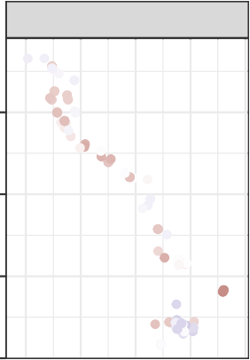

2018

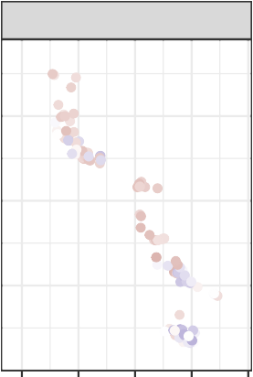

2019

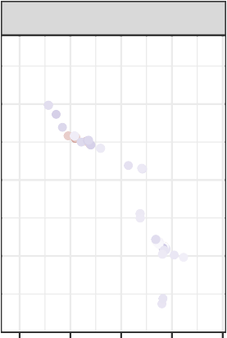

2020

0

y

−2

5426 −4

5424

5422

5420

308 309 310 311 312 308 309 310 311 312

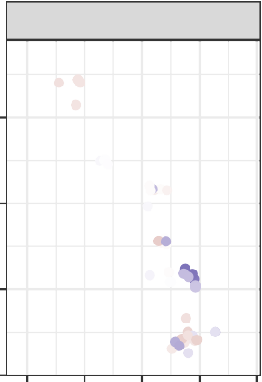

2021

5426

5424

5422

5420

308 309 310 311 312

x

Figure 3.8: Residual plots by year for SAU5, Northern Zone from model fitted with subblock term. Only data from subblock 6C are presented here for clarity. Spatial location included as a mesh to the sdmTMB model using easting and northing of the dive centroid.

5426

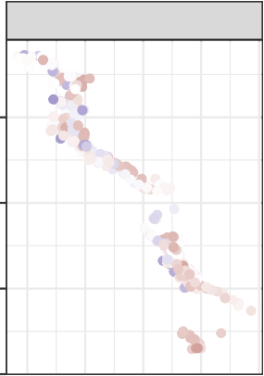

2012

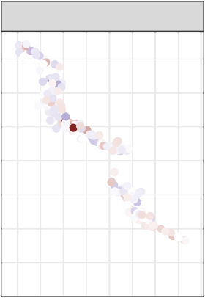

2013

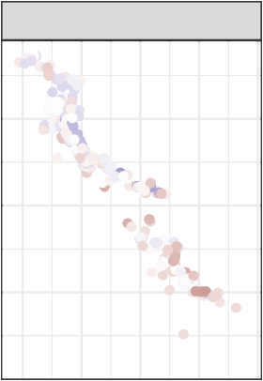

2014

5424

5422

5420

5426

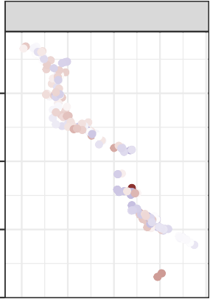

2015

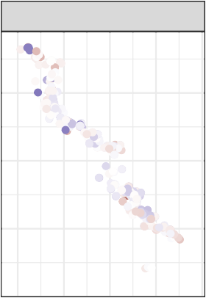

2016

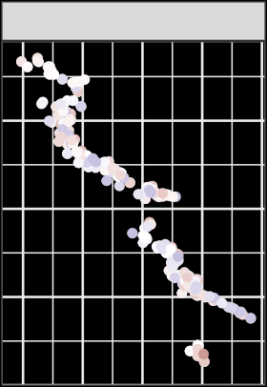

2017

5424

5422

cl_resids_space

2



5420

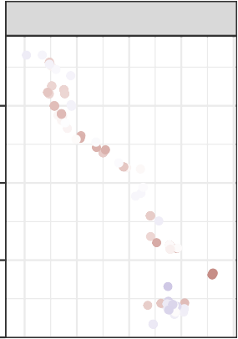

2018

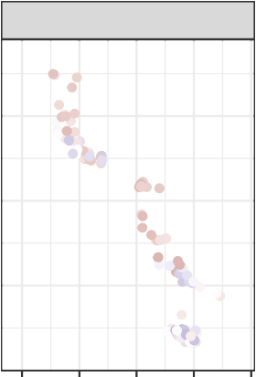

2019

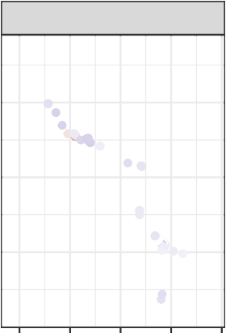

2020

0

y

−2

5426 −4

5424

5422

5420

308 309 310 311 312 308 309 310 311 312

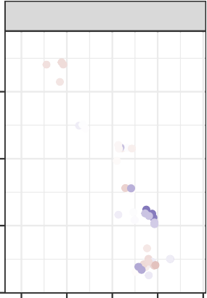

2021

5426

5424

5422

5420

308 309 310 311 312

x

Figure 3.9: Residual plots by year for SAU5, Northern Zone from model fitted with cluster term. Only data from subblock 6C are presented here for clarity. Spatial location included as a mesh to the sdmTMB model using easting and northing of the dive centroid.

5.0



2012



2013

2.5

0.0

−2.5

−5.0

−7.5

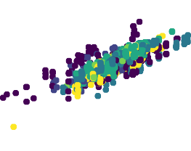

2015

5.0

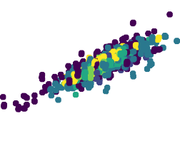

2014

2.5

0.0

−2.5

−5.0

−7.5

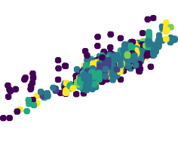

2016

5.0

sb_resids_spacetime

2.5

0.0

−2.5

−5.0

−7.5

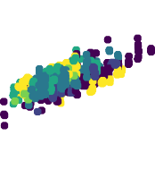

2018

5.0

2.5

0.0

−2.5

−5.0

−7.5

subblockno

05A

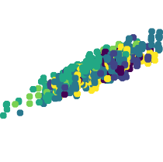

2017

05B

05C

06A

06B

06C

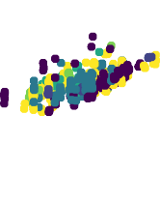

2019

5.0



2020



2021

2.5

0.0

−2.5

−5.0

−7.5

−8 −4 0 4 −8 −4 0 4

sb_resids

Figure 3.10: Plot of residuals for non-spatial vs spatiotemporal model for SAU5, Northern Zone from model fitted with subblock term. Spatial location included as a mesh to the sdmTMB model using easting and northing of the dive centroid. Date of fishing is included as a Spatiotemporal term.

5

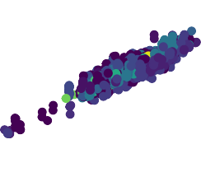

2012

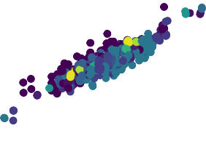

2013

0

−5

5



2014

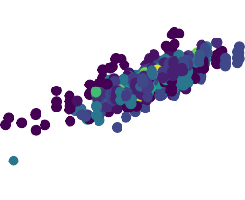

2015

0

cluster_id

−5

|  |  |  |
| --- | --- | --- |
| 28 |  | 183 |
| 29 |  | 203 |
| 31 |  | 225 |
| 32 |  | 227 |
| 33 |  | 228 |
| 43 |  | 231 |
| 102 |  | 274 |
| 118 |  | 287 |
| 123 |  | 288 |
| 127 |  | 289 |
| 157 |  | 320 |
| 182 |  | 420 |

5

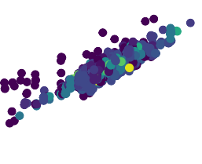

2016



2017

cl_resids_spacetime

0

−5

5



2018



2019

0

−5

5

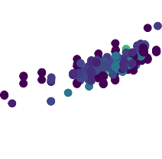

2020



2021

0

−5

−8 −4 0 4 −8 −4 0 4

cl_resids

Figure 3.11: Plot of residuals for non-spatial vs spatiotemporal model for SAU5, Northern Zone from model fitted with subblock term. Spatial location included as a mesh to the sdmTMB model using easting and northing of the dive centroid. Date of fishing is included as a Spatiotemporal term.

1.4

05A

05B

05C

1.2

1.0

0.8

1.4

06A

06B

06C

scaled

1.2

1.0

0.8

2012 2014 2016 2018 2020 2012 2014 2016 2018 2020 2012 2014 2016 2018 2020

year

method  non−spatial  spatial  spatiotemporal

Figure 3.12: Space-time modelling of the response variable (catch) for SAU5, Northern Zone from model fitted with subblock term. Spatial location included as a mesh to the sdmTMB model using easting and northing of the dive centroid. Date of fishing is included as a Spatiotemporal term.

1.4

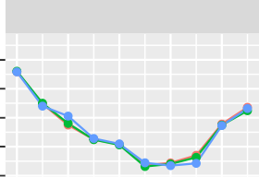

28

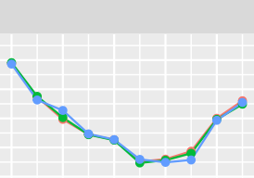

29

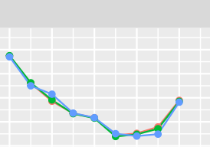

31

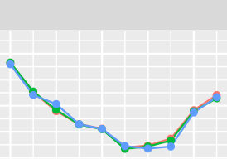

32

1.2

1.0

0.8

0.6

1.4

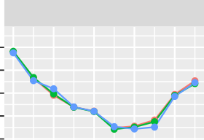

33

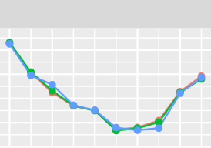

43

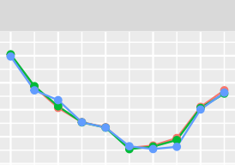

102

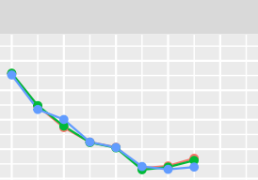

118

1.2

1.0

0.8

0.6

1.4

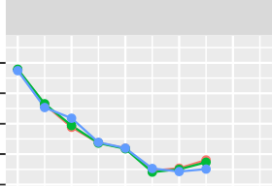

123

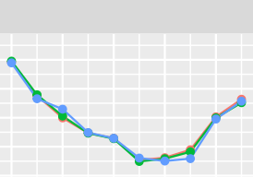

127

157

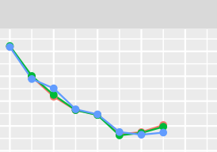

182

1.2

1.0

0.8

0.6

scaled

1.4

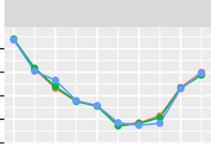

183

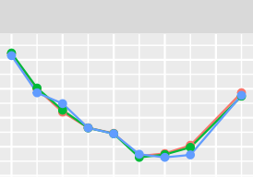

203

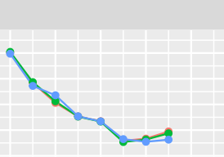

225

227

1.2

1.0

0.8

0.6

1.4

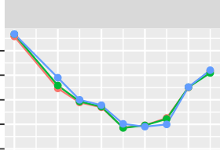

228

231

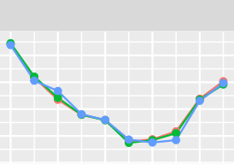

274

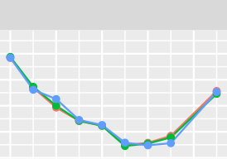

287

1.2

1.0

0.8

0.6

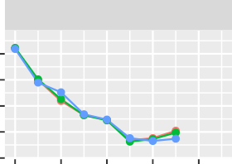

288

289

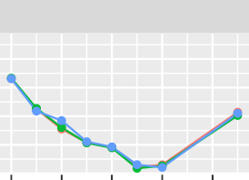

320

420

1.4

1.2

1.0

0.8

0.6

2012 2014 2016 2018 2020 2012 2014 2016 2018 2020 2012 2014 2016 2018 2020 2012 2014 2016 2018 2020

year

method non−spatial spatial spatiotemporal

Figure 3.13: Space-time modelling of the response variable (catch) for SAU5, Northern Zone from model fitted with cluster term. Spatial location included as a mesh to the sdmTMB model using easting and northing of the dive centroid. Date of fishing is included as a Spatiotemporal term.

##### Discussion

The suite of results presented here confirm that geo-referenced fishery dependent data can assist with ac- counting for and quantifying spatial structure in abalone fisheries data. That does not translate however, to major shifts in standardised mean annual catch rates. Mean catch per hour of effort was relatively robust to a range of modelling approaches with different spatial and temporal resolution of predictor terms. Surprisingly, aggregating response and predictor variables to the scale of fishing day did not have an adverse impact on the

estimated annual mean catch rate. In terms of impact on catch rate trends, there appears limited direct benefit in applying spatial regression methods to catch rate standardisation given the negligible improvement found in this study. There are however other benefits of application of spatial linear models which are discussed below.

Utilising high resolution data on fishing activity to build maps of discrete reef systems, and adding a reef identifier to the model as a random effect does appear to be advantageous. This appears to be a valuable use of the fine scale fisheries data, regardless of whether a spatial term is added to the mixed effects model. While it is desirable to capture information on fisher Docket returns about geographic structure within an SAU, the formal subblock (mapcode, reefcode) reporting areas often dissect contiguous rocky reef. Whereas empirical rule-based determination of reef systems based on centroids of dive polygons is a more defensible approach to addressing within SAU spatial structure. Typically, the number of discrete reef areas within an SAU is higher than the number of formal subblock divisions, and meets the normally accepted requirement for random effects to have more than five levels. A greater difference is evident among clusters in annual catch rate trends (Figure 3.13) than when a coarse grouping level such as subblock is used (Figure 3.12).

The relatively new spatially explicit GLMM tools are providing capability to incorporate spatial terms and capture spatial structure in CPUE standardisation and/or research surveys (Evans et al. 2021; Tanaka et al. 2022b; Thompson et al. 2023; Thorson et al. 2023; E. J. Ward et al. 2022; Zhou, Campbell, and Hoyle 2019). Application of mixed effect models for CPUE standardisation require a relatively high level of expertise, and there are many different views on their efficacy and their implementation. Adding spatial terms to GLMMs necessarily adds complexity, with many more traps for young players (Hodges and Reich 2010). At this stage, mixed effects models with random spatial terms are being actively developed, with rapid advances made in terms of speed of computation. Implementation of these types of models as well as informative diagnostics and capacity to make comparisons with non-spatial models are still their infancy. It is very clear from the experimental implementation of spatially explicit mixed effect models in this chapter, that the capacity to explore temporal shifts in the spatial structure of residuals can provide great insight into underlying changes within SAUs, that would be impossible to capture without a GPS and depth data logger program.

This chapter has skimmed the surface of the potential use of spatial GLMMS. As the new tools mature,

particularly those using TMB (Kristensen et al. 2016) and INLA (Krainski, Lindgren, and Rue 2023; Rue, Martino, and Chopin 2009 ) for the basis of CPU intensive spatial computations, the scope for application will broaden.

## Quantifying hyperstability in abalone catch and effort data

##### Introduction

Hyperstable catch rates are widely assumed to feature in most wild fisheries around the world (Harley, Myers, and Dunn 2001), and is often cited as a justification for interpreting catch rates with caution, or relying heavily on fishery independent survey (FIS) data sets. FIS data are largely collected systematically according to an experimental design which should eliminate some of the biases in fishery-dependent data. FIS data collection can also be subject to hyperstability associated with density-dependence of the target species (Kotwicki, Ianelli, and Punt 2014), but avoids the potential effect of diver and fleet behaviour that might create a bias in a fishery-dependent catch rate signal. Behaviour of the target species, for example aggregating behaviour (Rose and Kulka 1999) is another key driver of hyperstability. Changes in the way fishers operate can be difficult to quantify, although Hamilton et al. (2016) were able to combine FIS with fishery dependent data to quantify hyperstability in a tropical reef fishery. Classical serial depletion is another driver of hyperstable catch rates, for example switching to a new species as abundance of one species declines has been a feature in some fisheries, including the Californian abalone fishery (Karpov et al. 2000). Travelling further as fishing grounds close to port become depleted is another form of spatial serial depletion resulting in hyperstable catch rates (Cardinale, Nugroho, and Jonson 2011), though is relatively uncommon in mature fisheries.

While hyperstable catch rates are often acknowledged, and occasionally described (see Figure 1 in Harley, Myers, and Dunn 2001), hyperstable catch rates are rarely quantified in a commercial wild harvest fishery. Documentation of hyperstable catch rates however, is becoming more common in recreational fisheries (e.g. H. G. M. Ward, Askey, and Post 2013). When hyperstable catch rates are described typically it is in the form of a power curve that describes a non-linear relationship between the index of abundance (catch rate) and biomass (e.g. Figure 4.1). When fishery-dependent indices of abundance such as CPUE are used to estimate biomass, the effect is that lower catch rates over-estimate remaining biomass. The challenge of confirming the existence of, and quantifying hyperstability in fishery catch rates is problematic whether using catch rates as an index of relative abundance directly in Empirical Harvest Strategies, or, as an index of relative abundance when conditioning integrated assessment models. The solution for Empirical Harvest Strategies is to be more precautionary, while assessment models can include a hyperstability coefficient and, examine the impact of that coefficient on model fits.

In well-established abalone fisheries, rather than the typical form of hyperstability such as species switching, or serial depletion of fishing grounds, it is the capacity of divers to change their fishing behaviour to maintain a catch rate that is of greatest concern. Tasmanian abalone divers have long expressed frustration with reliance on time as a measure of effort, and frequently advised that they changed their fishing behaviour (usually swim

speed) to maintain catch rates. Aggregation of adult abalone will be a factor in some abalone fisheries, for example fishers in the Tasmanian Western Zone blacklip fishery target aggregations, whereas fishers in the Tasmanian Eastern Zone blacklip fishery are ‘skimming’ and picking up individual animals as they traverse the reef. Whether this is a habitat driven pattern, or a function of the relative health of these two blacklip fisheries remains unclear.

Traditionally, we measure effort as time and model CPUE (ratio of catch and time) as the response variable against a number of likely predictors. Divers frequently comment that while catch per unit effort (CPUE) remains stable, they are covering more reef area in the same dive time to get their target catch. This common description of change in fishing behaviour in response to declining abalone abundance should be detectable by considering the spatial extent of each dive event. The spatial data collected in the Tasmanian passive GPS data logger program allows us to estimate two spatial forms of effort - the first being the reef area covered by the vessel, and the second being the maximum extent (linear distance) covered by the vessel during a dive as proxies for the area being fished by the diver. Dive polygon area and dive polygon length are highly correlated (Chapter 1), and in these analyses result in almost identical trend lines. Here we use dive polygon area as a measure of effort to contrast with dive time as a measure of effort from both the GPS logger program and dive time recorded on the Docket book data.

This chapter links to objective two:

Objective 2: **Develop methods for inclusion of fine-scale spatial data in CPUE standardisations.** Objective 3:

**Identify methods for detecting hyperstability in CPUE.**

##### Methods

Three SAUs in the Tasmanian abalone fishery are used as contrasting case studies - SAU5 in the north-west, SAU21 in the East, and SAU13, the most productive SAU in the south- east. SAU5 is highly spatially structured with variable growth, and has declined rapidly in abundance over the past 10 years. With ~90% reductions in TACC, this fishery has recently shown indications of rebuilding. SAU21 in the south-east was rebuilding at the start of the time-series, declined sharply due to two external events in 2016; the most significant marine heat wave recorded in recent times (Oliver et al. 2017), and a significant storm generating the largest easterly swells on record. From 2017, stocks appeared to keep rebuilding through to the end of the time-series used here (2021). SAU13 is the most productive region (Actaeons) in the Tasmanian blacklip abalone region, and currently accounts for more than 60% of the Eastern Zone TACC. This SAU has been slowly rebuilding over this time-series. These three SAUs provide contrasting trends in fishery performance, which provides a way to examine consequences of using different forms of effort to estimate fishery performance.

In Chapter 2, we outlined our standardisation approach modelling catch as a function of effort (Mod1 below).

Mod1 <- log(catch) ~ offset(log(time)) + fishyear +

(1 | subblockno) +

(1 | subblockno:fishyear) + (1 | diver_id) +

(1 | fishmonth)

Assumed Hyperstable

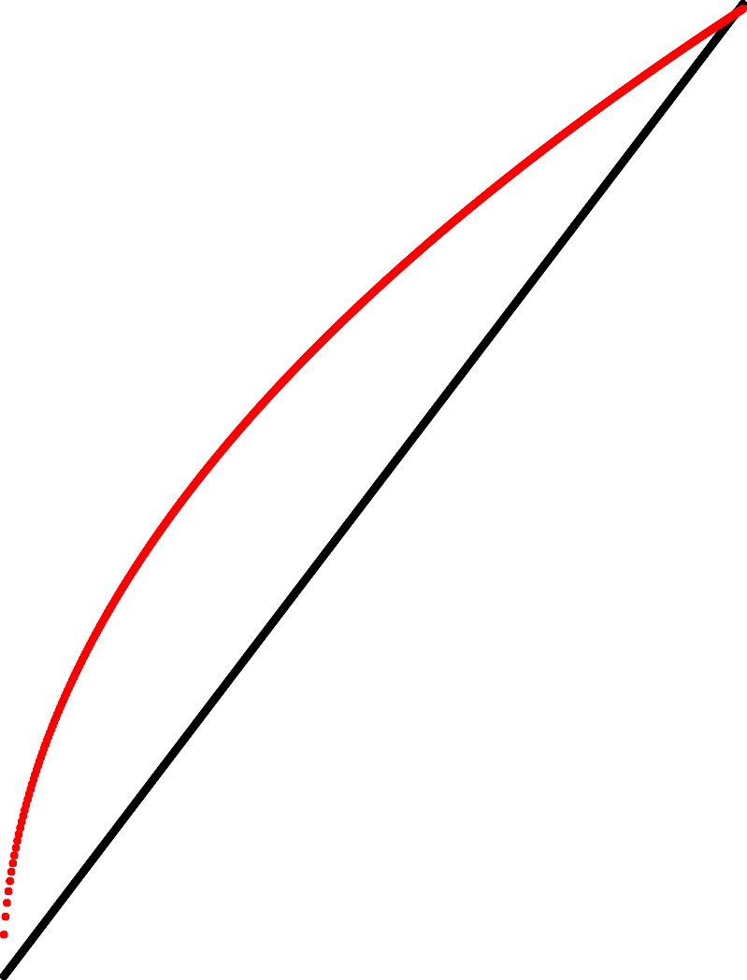

Catch Rate

#### Abundance/Biomass

Figure 4.1: Hypothetical relationship between Biomass and CPUE, where CPUE is assumed to be an index of relative abundance (e.g. Harley, Myers, and Dunn 2001, fig. 1)). The black line (Assumed) represents the assumed relationship where the index is proportional to abundance, while the red line (Hyperstable) represents a non-linear hyperstable relationship between the index and actual abundance.

To contrast the effort required to achieve a nominal amount of catch (100kg), the effort and catch terms are reversed in the statistical model. Using this approach we are able to ask the question, what is the change in effort through time required to achieve 100kg of catch? The statistical model is then given by Mod2.

Mod2 <- log(time) ~ offset(log(catch)) + fishyear +

(1 | subblockno) +

(1 | subblockno:fishyear) + (1 | diver_id) +

(1 | fishmonth)

To provide a comparison with traditional catch rate modelling, both Mod1 and Mod2 are applied to our case study SAUs. Mod1 is applied to both GPS logger and Docket book estimates of dive time (effort). Bias-corrected geometric mean catch-rates are usually presented when catch-rates are not standardised, but for simplicity here crude catch rate is calculated as total catch / total effort across all dives in each year, and included as a rough yardstick.

The first comparison, using Mod1, is simply time as effort from two different sources:

* diver Docket book time (minutes)
* GPS program time (minutes)

Secondly, we consider a comparison of effort represented as either dive area or dive time, and compared using mod2:

* GPS logger dive time (minutes)
* GPS dive polygon area (meters2)

The datasets were restricted to the years 2012-21 for both GPS and Docket book datasets. To provide a reasonable comparison, both spatial and docket datasets operate on a per diver/day basis. For spatial data, individual dive metrics (area, dive time, catch) are aggregated to the scale of day.

A log-normal model was fitted using R (R Core Team 2023) and the glmmTMB package (Brooks et al. 2017), and summary figures produced using the tidyverse suite of R packages (Wickham et al. 2019). Data were batch processed using custom analysis functions and the purrr package (Wickham and Henry 2023). We use predict functions to back-cast the mean change in effort required to achieve 100kg of catch in each year of the time-series.

##### Results

* + 1. Case study 1: SAU5

Fishery performance in SAU5 as assessed using the typical approach of catch as a function of effort (in this case 1 hour of dive time) identifies a sharp decline in catch rate from 2012 through 2018, and then a rebuilding catch rate from 2019 through 2021 (Figure 4.2A). Mean annual catch rates using time as a measure of effort from GPS logger and Docket book datasets are very similar (Figure 4.2A). Catch rates for both datasets decline by around

50% between 2012 and 2018. Crude catch rate follows a similar pattern to the standardised catch rates, with the greatest deviation when catch rates are low (2015-19).

Modelling effort as a function of catch (effort ~ catch) identifies an inverse pattern to mean catch rate trends (catch ~ offset(effort)). Substantial differences in estimated mean effort are required to achieve 100kg of catch by the two forms of effort - time, area (Figure 4.2B). As the fishery declines between 2012 and 2018, the dive time increases twofold, whereas over the same time-period the reef area required to catch 100kg is four times greater in 2018 compared to 2012 (Figure 4.2B). As the fishery improves between 2019 and 2021, the effort required to achieve 100kg of catch return to similar values observed in 2012, for both forms of effort.

A B

90

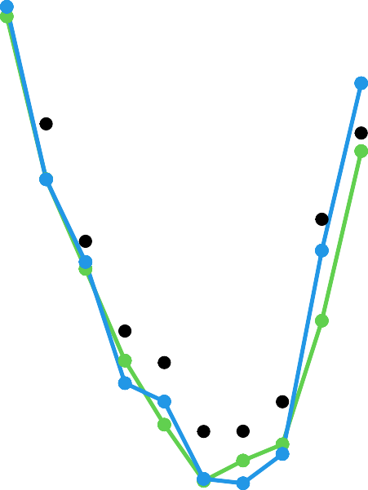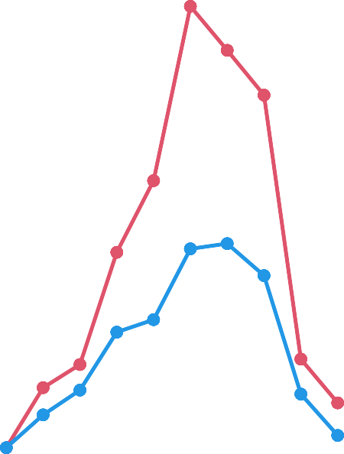

80 9

Relative change in effort

70

Catch (per dive hour)

6

60

50 3

2012 2014 2016 2018 2020

Year

2012 2014 2016 2018 2020

Year

factor(method)  Crude  D_Time  L_Time factor(method)  L_Area  L_Time

Figure 4.2: Modelling catch and effort for Northern Zone, SAU 5(subblocks 5A, 5B, 5C, 6A, 6C, 6D). A) Crude and standardised catch achieved for 1 hour of effort (docket and logger); B) Relative change in effort (logger area, logger time) required to achieve 100kg of catch.

* + 1. Case study 2: SAU21

In contrast to SAU5, abalone abundance in SAU21 is rebuilding between 2012 and 2021, with a downturn in catch rate associated with the Marine Heat Wave in 2016 (Figure 4.3A). The typical approach in abalone fisheries of modelling catch as a function of effort (in this case 1 hour of dive time) identifies a sharp decline in catch rate in 2016, followed by an immediate increase in 2017 which continues through 2021 (Figure 4.3A). The GPS logger and Docket book estimated annual mean catch rates using time as a measure of effort are very similar (Figure 4.3A), with minor difference in mean catch rate and a common temporal trend. Catch rates for both datasets nearly double over the time-series, despite the impact of the Marine Heat Wave in 2016. Crude

catch rate follows a similar pattern to the standardised catch rates, although there is some deviation in the first three years and again in the final year (Figure 4.3A). Crude catch rate is very similar to the catch ~ offset(effort) approach, although with some trend departure in the first (2012) and last (2021) years.

When modelling effort required to achieve 100kg of catch, a rather different pattern is apparent in SAU21 compared to SAU5. For SAU21, area as our measure of effort declines at a faster rate than when using time as our measure of effort (Figure 4.3B) i.e. the area required to achieve 100kg of catch reduces a greater rate with higher abalone abundance. This pattern is apparent in both rebuilding phases within the time-series - from 2012 to 2015, and then again from 2017 - 2021 (Figure 4.3B). The difference in the rate of relative change in effort required when catch rates are improving, is not as great as the rate of relative change when catch rates are declining (Figure 4.2B).

A B



4

100

3

Catch (per dive hour)

Relative change in effort

80

60 2

40

2012 2014 2016 2018 2020

Year

1

2012 2014 2016 2018 2020

Year

factor(method)  Crude  D_Time  L_Time factor(method)  L_Area  L_Time

Figure 4.3: Modelling catch and effort for Eastern Zone, SAU21 (subblocks 21A, 21B, 21C). A) Crude and stan- dardised catch achieved for 1 hour of effort; B) Relative change in effort required to achieve 100kg of catch.

* + 1. Case study 3: SAU13

Block 13 Catch rates (catch ~ offset(effort)) were stable in the first two years, with a dip in 2014, followed by improvements in catch rate through to 2021 (Figure 4.4A). In contrast to SAU5 and SAU21, the crude catch index also departs from the catch ~ offset(effort) standardised catch rate index for the middle phase of the time-series (2016-18) (Figure 4.4A). Mean catch rates for both Docket book and GPS logger estimates of time are almost identical for the entire time-series, using the catch ~ offset(effort) approach.

Estimates of mean effort required to achieve 100kg of catch over the time-series decline over the time-series, with the exception of 2014, where effort required increased sharply (Figure 4.4B). As observed for SAU21, when effort is measured as area of the dive polygon, the index of effort required declines faster than when time is our measure of effort.

A 125



B

3.0



100

2.5

Relative change in effort

75

Catch (per dive hour)

2.0

50

1.5

25

0

2012 2014 2016 2018 2020

Year

1.0

2012 2014 2016 2018 2020

Year

factor(method)  Crude  D_Time  L_Time factor(method)  L_Area  L_Time

Figure 4.4: Modelling catch and effort for Eastern Zone, SAU13. A) Crude and standardised catch achieved for 1 hour of effort; B) Relative change in effort required to achieve 100kg of catch.

##### Discussion

* + 1. Modelling relative change in effort

Divers routinely comment that they are covering much greater area per dive as abundance declines and by swimming faster as they search for abalone they are able to maintain catch rates (Kg/Hr). Through the GPS logger program, we have captured and quantified that spatial change in fishing activity. When area was used as our measure of effort, the relative change in effort required in SAU5 to harvest 100kg of catch increased markedly over time-based measures of effort (Figure 4.2B). Similarly, the relative change in area declined faster than the relative change in time required to harvest 100kg from 2018 onwards as catch rates begin to improve (Figure 4.2A). These results clearly demonstrate that reliance on time as our measure of fishing effort under-estimates the fishing effort required to harvest 100kg of abalone (i.e. catch rate indices using time as a measure of effort are hyperstable). Hyperstable catch rates in an experimental Paua fishery were also observed by Abraham and Neubauer (2015), although this finding was assigned to serial depletion over the course of the

experiment. This use of the GPS logger program is the first empirical confirmation of a change in fisher behaviour leading to hyperstable catch rates in an abalone fishery.

While the rate of change in area was greater than the change in time required to harvest 100kg of abalone in SAU 5, the magnitude of the change, over the time-series (2012-21), varied greatly among SAUs. One possible explanation is that the magnitude of the relative change in effort is linked to the level of depletion. In terms of productivity and stock health, we can order the three SAU case studies as SAU13 in the best health, followed by SAU21, and then SAU5 which is recovering from severe depletion. Respectively, the magnitude of relative change was smallest at SAU13 (Figure 4.4B) and largest at SAU5 (Figure 4.2B). Alternatively, the observed patterns in rate of change in effort required may be linked more strongly to the habitat type and reef complexity, with SAU5 having relatively low reef complexity in comparison to SAU21 and SAU13. However, SAU21 is much more complex in terms of reef structure than SAU13. The low topographic complexity of reef systems in SAU5 may have been a contributing factor to the extent of depletion, but is perhaps unlikely to be a key factor affecting the magnitude of change in relative effort observed in this study.

* + 1. Hypothetical relationship between CPUE and biomass revisited

As well as differential rates of change expressed using time and area as measures of effort in a declining fishery, we also found evidence of hyperstability in catch rate indices when catch rates are above average and improving. Patterns of relative change in effort for area and time in SAU21 and SAU13 (improving fisheries), demonstrate that time-based catch rate indices are also subject to hyperstability at the upper margins of catch rates when abalone abundance is improving. Thus,

hyperstability is not restricted to depleting stocks, and can affect catch rate indices at both ends of the catch rate range. In hypothetical terms, the non-linear relationship between catch rate index and biomass would be better described by Figure 4.5, than by Figure 4.1. Gaertner and Dreyfus-Leon (2004) alluded to the possibility of hyperstability occurring at upper and lower ranges of stock abundance in their simulations of a tuna purse-seine fishery (Gaertner and Dreyfus-Leon 2004, fig. 3). However, no empirical demonstration of hyperstability of an improving stock has been reported previously in the literature.

Assumed Hyper

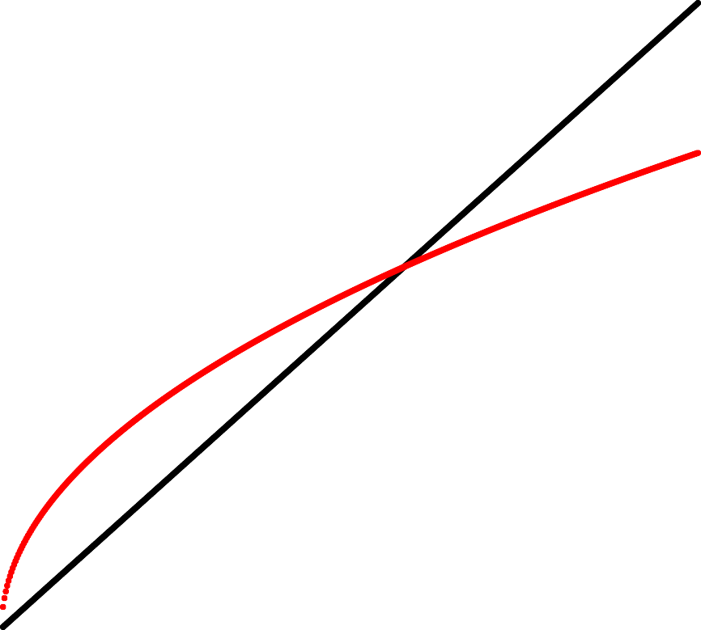

Catch Rate

###### Abundance/Biomass

Figure 4.5: Revised hypothetical relationship between Biomass and CPUE (where CPUE is assumed to be an index of abundance). The non-linear relationship between CPUE and abundance is modified to reflect the finding that time based CPUE overestimate abundance when low, and underestimate abundance when CPUE is high. The black line (Assumed) represents the assumed relationship where the index is proportional to abundance, while the red line (Hyperstable) represents a non-linear hyperstable relationship between the index and actual abundance.

Part III

# Quantifying spatial dynamics of reef use: exploiting the grid data

The previous chapters focused on characterising and describing spatial performance measures derived from bivariate kernel utilisation distribution polygons of individual fishing events (KUD). Those chapters directly explore the potential to replace time as a unit of effort with dive polygon area. In Chapter 3 we created maps of residuals which clearly demonstrate a spatio-temporal dynamic of fishing. The chapters in this section focus on how we might use the geo-referenced fishing data to determine the total area of reef utilised, and identify metrics that could provide performance measures for patterns in reef utilisation.

## Time integrated productivity index (TIP) data

##### Introduction

Fleet utilisation of fishing grounds in spatially structure fisheries is rarely described, and not well understood. In addition to choices made by fishers based on personal preference and restrictions imposed by weather conditions, patterns of exploitation may also be driven by fine-scale heterogeneity of stock productivity. Fishers often report a natural cycle of return times to specific fishing grounds, suggesting a strategy of exploiting a section of reef followed by a period of leaving that reef to recover. In a fishery with a large number of fishers, it is feasible that specific locations may be fished more frequently than individual fishers may be aware of. Most experienced fishers are also very adept at identifying sections of reef that are likely to support commercial quantities of catch. Thus, the more attractive a section of reef, the greater the likely extent of visitation by fishers, and the greater the likelihood that section of reef will be fished each year. Whereas, some sections of reef may be unattractive, or thought to be unproductive because of past experience, or other location characteristics such as high frequency of white shark sightings. Abalone fishers identify and refer to sections of reef that are resilient to fishing as ‘good recovery bottom’ (GRB). As yet, we do not know specific locations of GRB, or whether they are permanent or temporary features of the fishing landscape depending on spatial and temporal patterns of exploitation. Habitat quality, food availability, recruitment dynamics along with local fishing pressure will all contribute to a high level of heterogeneity in local exploitation rates, and might be expected to impart a level of stability in relative productivity of local reef patches.

Here we examine spatial structure in fishing activity, as one measure of the spatial complexity of the Tasmanian abalone fishery. One mechanism for characterising and quantifying the dynamics of reef use is to classify the known fishable reef in terms of whether it is fished frequently (every year), occasionally (most years) or rarely (e.g. one year in every 10). In addition to the inter-annual frequency of fishing a given location, it is also informative to understand whether that location is productive in a relative sense, i.e, compared to other sections of reef fished in that year, does it support a higher level of total catch across all fishers fishing at that location. The combined periodicity in fishing and relative yield can be used as an index of productivity over the extent of the time-series available. We reviewed a similar metric developed and applied in an early project (see Chapter 9, Mundy, Jones, and Worthington 2018), and made some minor changes in order to make the metric more informative.

This chapter relates to two objectives:

Objective 2: **Develop methods for inclusion of fine-scale spatial data in CPUE standardisations.** Objective 3:

**Identify methods for detecting hyper-stability in CPUE.**

Objective 4: **Determine feasibility of spatial data based stock status determination in spatially structured fisheries**

##### Methods

* + 1. Time Integrated Productivity (TIP) Index

In order to address some of the spatial heterogeneity questions raised above, we modified an earlier version of a Time Integrated Productivity Index, utilising the hexagon GRID data to better understand the importance of local reef areas to overall catch SAU. The TIP index may also be useful for identifying and characterising the resilience of patches of reef across the fishery, among other applications.

In this exercise we have used catch/cell (cell = 1 Hectare hexagonal grid cell), with the cells in descending order of catch (grouped by zone and block), separately for each year. Four new fields are calculated in order to plot the concentration area curve (CAC):

* RowNum = rank order of cells based on catch (1:n())
* Tz = rank order normalised to 1
* CumCatch = Cumulative catch started from the hex cell with the greatest catch
* Pt = Cumulative catch normalised to one

The TIP index is based on the quartiles of the Y axis (TIP) of the scaled concentration area curves produced from the above derived variables. A score from 4 to 1 is provided for each quartile, where the cells in the quartile of highest catch are assigned a score of 4, and the cells in the lowest quartile a score of 1 (Figure 5.1). Where a hex cell is not fished in a year, a Zero is assigned to the score for that year. The TIP index is created by summing the score across the available time-series - in this case eight years. The maximum value of the TIP index for an eight-year time-series is therefore 32, and the minimum possible score is 1. A cell scores 32 only if it falls in the top 25% of cells in the Concentration Area Curve in all eight years.

* + 1. Spatial Structure in TIP index

The spatial structure of the TIP index was examined using Local Indicators of Spatial Autocorrelation (LISA) and Getis-Ord Hotspot analyses. LISA (Local Morans I) and G* (Getis-Ord) statistics were calculated from D Nearest Neighbour matrices with D set as a range of 0m to 110m from the centroid of each target cell. The inter-centroid distance of the Hexagonal grid is 105m, thus a maximum distance of 110m ensures that only the immediate cells are considered neighbours. The K-nearest neighbour approach will classify cells some distance from the target along the edge of known reefs systems as part of that reef system, creating a neighbour network that may not always be identical to a D-nearest neighbour approach. LISA (Local Morans I assigns a class to all observations depending on the relationship between each target cell and its neighbours. If a target cell has a high TIP index and its neighbours also have a high TIP index, it is classified as High-High. When the inverse is true, cells are classified as Low-Low. Where the Target cell has a high TIP index score, and is surround by low TIP index score cells, it is classified as High-Low, etc. Significance of Morans I is tested by permutation (999 reps), and cells with non-significant outcomes are Classed as ‘Non-Significant’. Getis-Ord Hotspot analysis provides a continuous Z score, and critical values of the statistic for 90th and 95th percentiles are given. Significant scores that are positive are considered hotspots, while negative scores indicate cold spots.

* + - 1. Grid filtering

Most modern abalone fleets work ‘live’ while fishing. This means the skipper of the fishing boat will follow closely behind the diver, and will retrieve/deliver nets to/from the diver using a weighted drop line. The frequency of drop line throws will depend on catch rates, but is typically every five to ten minutes. Strong wind conditions, or days with higher swells can result in the fishing vessel drifting away from the diver for short periods. When processing spatial data from these days, it can result in minor and potentially spurious activity in grid cells adjacent to fished reef, often less than 5 minutes for a year, or for the entire time-series. Filtering of all grid cells where effort is greater than a minimum threshold is an important consideration. Removing grid cells with less than 5 minutes activity in any year results in a minor, but noticeable shift in the shape of the concentration area curves, and as a consequence, the TIP index ( Figure 5.1).

A

1.0

Time Integrated Productivity Y

CAC − scaled x and y

0.8



Score = 1

Score = 2

Score = 3

Score = 4

Proportion of cumulative catch

0.6

0.4

0.2

Year

2012



2013

2014

2015

2016

2017

2018

2019

0.0

B

1.0

0.0 0.2 0.4 0.6 0.8 1.0

Proportion of fished area

Time Integrated Productivity Y

CAC − scaled x and y

0.8



Score = 1

Score = 2

Score = 3

Score = 4

Proportion of cumulative catch

0.6

0.4

0.2

Year

2012



2013

2014

2015

2016

2017

2018

2019

0.0

0.0 0.2 0.4 0.6 0.8 1.0

Proportion of fished area

Figure 5.1: Time Integrated Productivity Y. Annual TIP score based on quartiles of cumulative catch (vertical axis).

*A*) full dataset with no filtering, *B*) dataset filtered to remove cells with less than 5 minutes of effort (i.e. assumes that cell was not fished in that year).

##### Results

Here we use Block 6N to examine the properties of the TIP index. The frequency distribution of the TIP index is left-skewed with relatively few grid cells achieving a TIP index of greater than 15 (Figure 5.2 A). There is a positive non-linear relationship between TIP index and total catch (pooled across the 8-year time series) (Figure 5.2 B). The majority of catch however is harvested from grid cells with a TIP index between 6 and 22, with cells with a very high TIP index delivering relatively little overall catch (Figure 5.2 C). In contrast, cells that are fished in at least six of the eight years account for the majority of the catch (Figure 5.2 D), and cells that are rarely visited (within our time series), support only relatively small amounts of catch.

Examining the relationship between TIP and years fished is instructive for overall patterns, but masks any variation among individual grid cells within each index class. High TIP index cells, and/or cells that are fished in most years (six or more) have the highest median annual catch, but span a comparatively large range of annual catch values (Figure 5.3). Cells with a high TIP index are necessarily fished in most years, and have high catches relative to other cells in that year. However, cells that are fished in most or all years show substantial variation, and do not always have high annual catches. While very high TIP index cells typically achieve higher total annual catch, they are relatively uncommon, and thus contribute less to the total catch of an SAU than might be assumed.

###### A B

200

150

totalcatch

100

count

50

2000

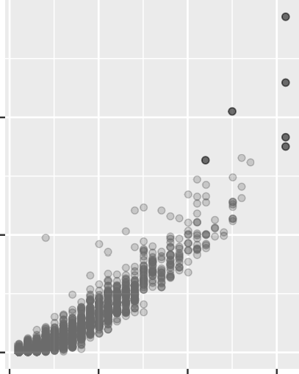1000

alpha

0.5

0

###### C

20000

totalcatch

10000

0 10 20 30

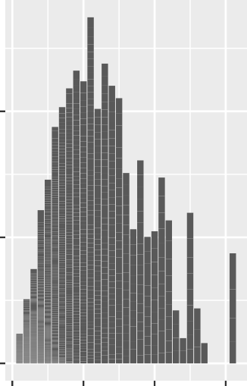TIP.8yr

n

1

0

0 10 20 30

TIP.8yr

###### D

90000

n

totalcatch

60000

1

30000

0

0 10 20 30

TIP.8yr

0

2 4 6 8

count_yr

Figure 5.2: Summary information on TIP indices relative to frequency of occurrence and catch. A) Frequency of TIP index; B) Relationship between TIP index and total catch (years pooled); C) Total catch by TIP Index (years pooled); D) Total catch by index of years fished (years pooled). Note: years fished is a count of the years when a given cell recorded more than the 5-minute effort threshold.

A 800 B 400

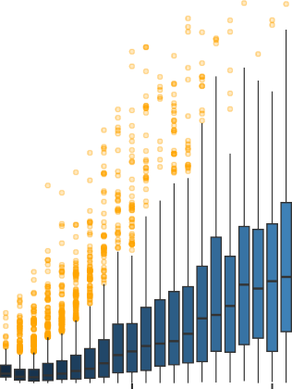

600 300

400 200

Catch (Kg)

Catch (Kg)

200 100

0

0 10 20 30

TIP.8yr

0

2 4 6 8

count_yr

Figure 5.3: A) Boxplot of annual catch by TIP Index. B) Boxplot of annual catch by years fished. Note: crude catch rate calculated from the ratio of catch/effort within each grid cell.

* + - 1. Differences in annual catch among TIP and year fished indices

When the relationship between catch and TIP index is considered by year, we see a similar pattern to that observed for the dataset with years pooled, though there is evidence of a shift in the relationship over time. The abalone fishery in the example SAU used here declined over the time period of 2012-19, and we see a gradual lowering of the annual catch achieved by high TIP cells (Figure 5.4). In 2012 and 2013, high TIP cells were achieving a median annual catch over 200kg, whereas by 2018 and 2019, high TIP cells were typically achieving a total annual catch of less than 200kg (Figure 5.4). The shift in median annual catch through time was less marked when we simply examine cells by the number of years they had been fished (Figure 5.5).

800

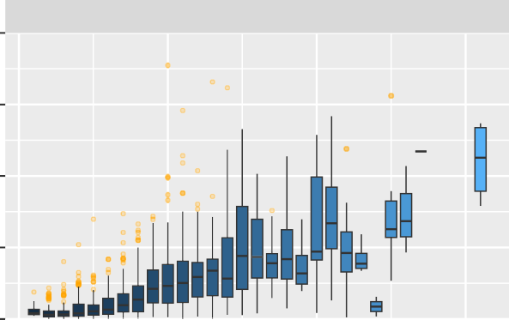

2012

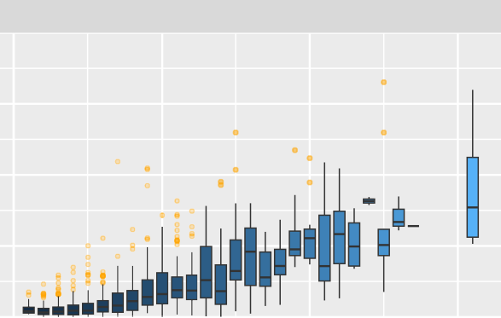

2013

600

400

200

0

800

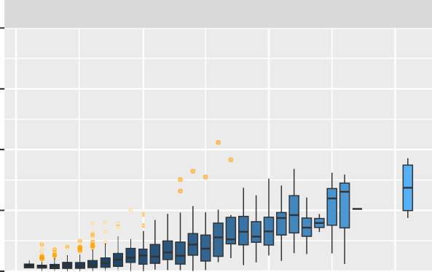

2014

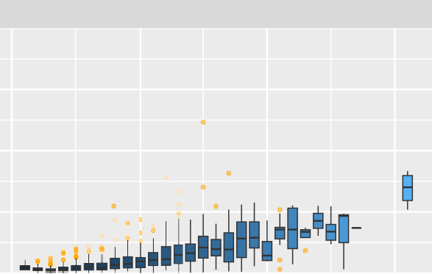

2015

600

400

200

0

Catch (Kg)

800

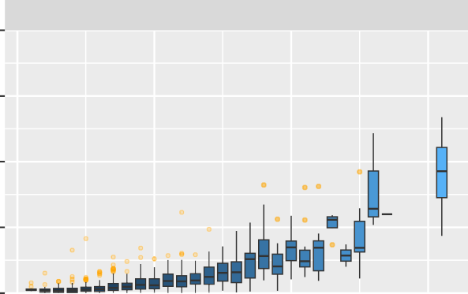

2016

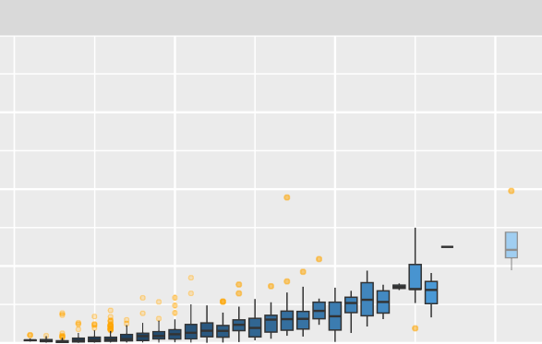

2017

600

400

200

0

800

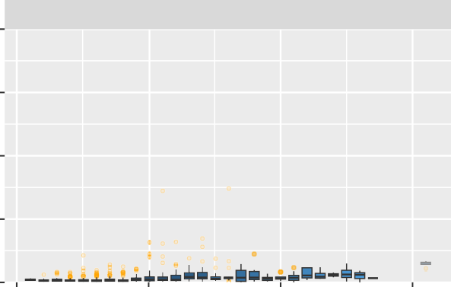

2018

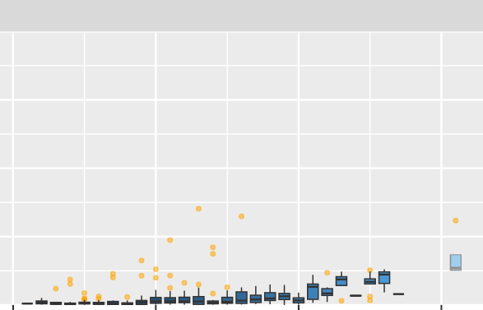

2019

600

400

200

0

0 10 20 30 0 10 20 30

TIP.8yr

Figure 5.4: Annual catch by TIP index in Block 6, Northern Zone, for each year in the time series (2012-19).

400

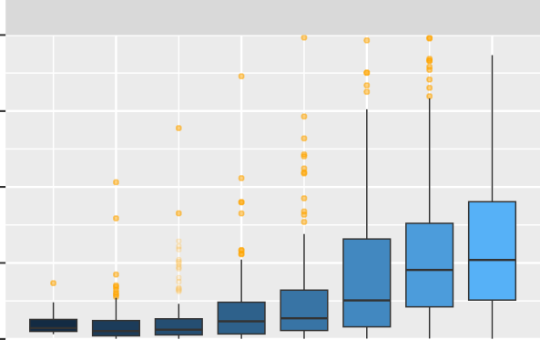

2012

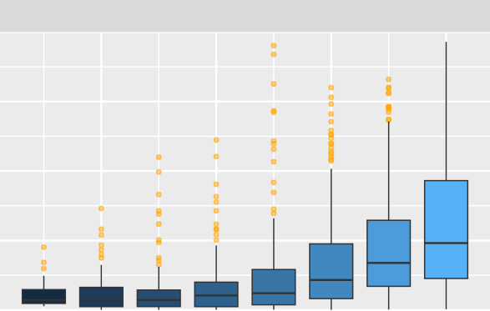

2013

300

200

100

0

400

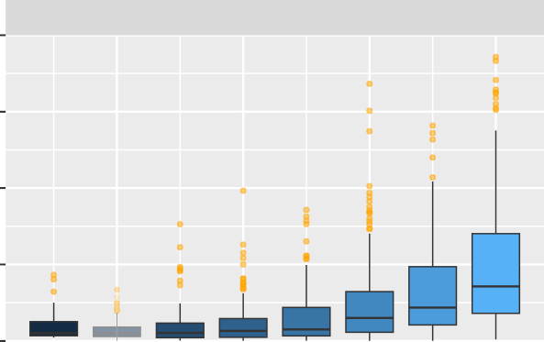

2014

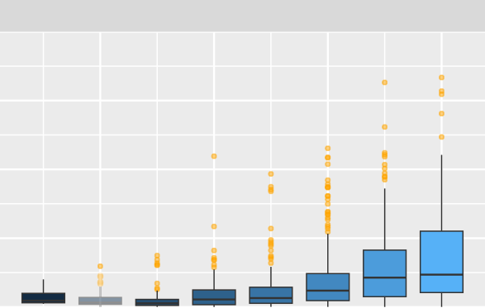

2015

300

200

100

0

Catch (Kg)

400

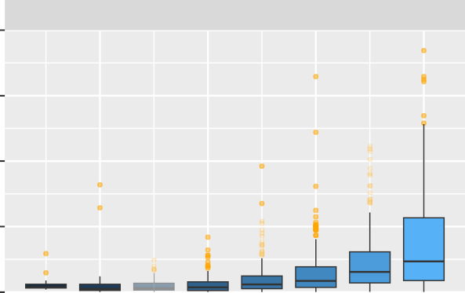

2016

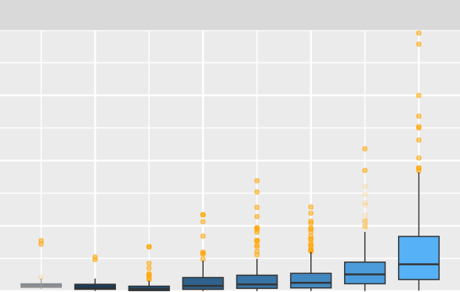

2017

300

200

100

0

400

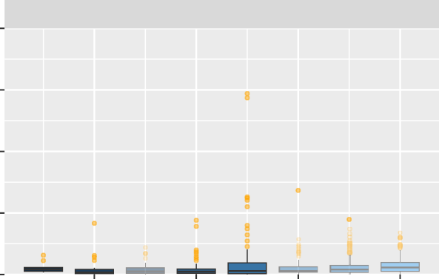

2018

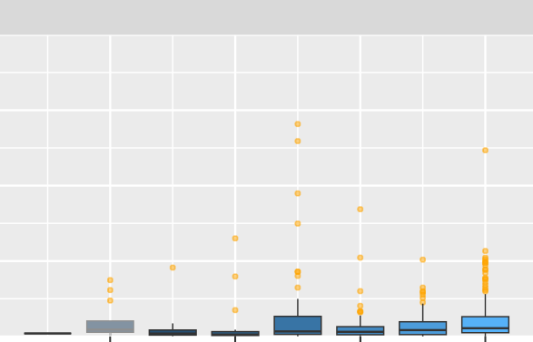

2019

300

200

100

0

2 4 6 8 2 4 6 8

count_yr

Figure 5.5: Annual catch by year index in Block 6, Northern Zone, for each year in the time series (2012-19).

* + - 1. Catch rate as a function of TIP and year fished indices

To simplify graphical presentations, the 32 level TIP index was categorised into 8 ordered classes, with TIP Class 1 containing TIP index scores of 1-4, Class 2 with 5-8, etc. A crude catch rate (CPUE) was calculated for each

class by the ratio of annual catch and effort observed for each cell. There was no consistent ordering of CPUE and TIP Class in the example SAU (Figure 5.6 A), and all TIP classes displayed a common inter-annual trend. The relationship between years fished index and CPUE was less consistent. In the first year (2012), cells fished in only 1 year had markedly higher CPUE, while cells that were fished every year had the second lowest CPUE (Figure 5.6 B). At the end of the time series cells that had been fished in most years (7 or 8) had low to moderate CPUE, and the cells that had been fished between three and four years had markedly higher CPUE (Figure 5.6 B), and the cells that had only been fished in 2019 had the highest CPUE.

A

100

TIP

Class

1

80 2

crudeCPUE

3

4

5

6

60 7

8

40

B

120

2012 2014 2016 2018

fishyear

100

80

crudeCPUE

60

Yrs fished

1

2

3

4

5

6

7

8

40

2012 2014 2016 2018

fishyear

Figure 5.6: A) Crude mean cell CPUE by TIP index categorised into a bin size of 4 (i.e. TIP class of 8 includes cells with TIP score of 29-32 inclusive); B) Crude mean cell CPUE by number of years fished. Note: crude catch rate calculated from the ratio of catch/effort within each grid cell.

* + 1. Spatial structure of TIP indices

The summaries above demonstrated that high TIP index cells were relatively uncommon, but supported relatively high annual catch, at a similar CPUE to moderate or low TIP cells. The spatial distribution of these high and low TIP index cells is also of interest. For example, do they occur as individual cells within the fishing grounds, or as small or large clusters of cells that might identify reefs with underlying characteristics. Local Indices of Spatial Autocorrelation (LISA) and Getis-Ord HotSpot analyses provide a mechanism for examining spatial structure in the TIP index.

The spatial lag of the TIP score is positively correlated with the TIP score (Figure 5.7), confirming that there is spatial autocorrelation in the dataset. A map of Local Morans I colour coded by LISA class (High-High, Low-Low, etc,). The majority of cells are classified as Not-significant (i.e. no local autocorrelation). However, cells classed as High-High are distributed through the fishing ground, either as individual cells are as small to large clusters of High-High cells (Figure 5.8). There were relatively few Low-Low cells in the example SAU. Most Low-Low cells were scattered across the fishing ground with only one cluster of any size evident (Figure 5.8). The Getis-Ord HotSpot analyses found a very similar pattern, particularly with the HotSpot cells, but provided a little more detail on ColdSpot cells than the LISA approach (Figure 5.9).

0.2

|  |  |  |  |  |  |  |  |  |  |  |  |  |
| --- | --- | --- | --- | --- | --- | --- | --- | --- | --- | --- | --- | --- |
|  |  |  |  |  |  |  |  |  |  |  |  |  |
|  |  |  |  |  |  |  |  |  |  |  |  |  |
|  |  |  |  |  |  |  |  |  |  |  |  |  |
|  |  |  |  |  |  |  |  |  |  |  |  |  |
|  |  |  |  |  |  |  |  |  |  |  |  |  |
|  |  |  |  |  |  |  |  |  |  |  |  |  |
|  |  |  |  |  |  |  |  |  |  |  |  |  |

0.1

Spatial lag of TIPS (z−score)

Cluster type

 High−high  Low−high  Low−low

 Not significant  NA

0.0

−1 0 1 2 3 4 5

TIPS (z−score)

Figure 5.7: Morans I: Spatial lag of TIP against Z score. Cells colour coded by the Local Indicator of Spatial Auotcorelation (LISA) index. The High-High class indicates the target cell has a high TIP index, and all neighbour cells also have a high TIP index (i.e. a ‘hotspot’). Low-Low indicates the inverse with both Target cells and neighbour cells having low TIP indicies (i.e. a ‘coldspot’).

N Local Moran's I

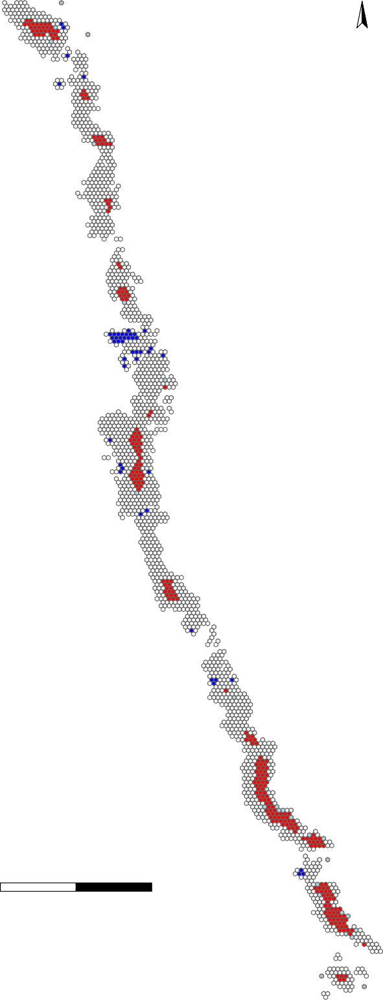

0

2

4 km

High−high Low−high Low−low

Not significant Missing

Figure 5.8: Spatial structure of Local Indicator of Spatial Autocorrelation (LISA) index. The High-High class indicates the target cell has a high TIP index, and all neighbour cells also have a high TIP index (i.e. a ‘hotspot’). Low-Low indicates the inverse with both Target cells and neighbour cells having low TIP indicies (i.e. a ‘coldspot’).

N Gi value

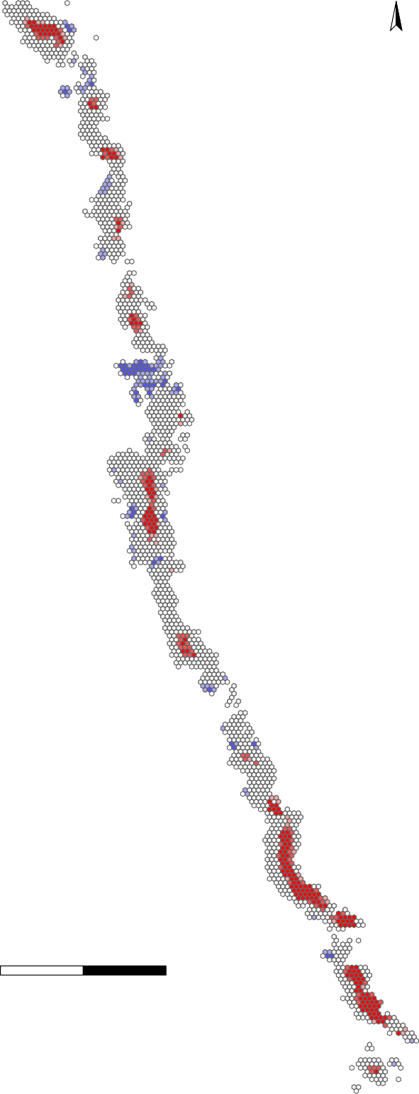

0

2

4 km

Cold spot 99%

Cold spot 95%

Cold spot 90% Not Significant Hot spot 90%

Hot spot 95%

Hot spot 99%

Figure 5.9: Getis-Ord G statistic for HotSpot analysis. When both Target and neighbour cells have high TIP indices, cells ae classified in three bands of ‘HotSpot’. When Target and Neighbour cells have low TIP indices, they are classified in three bands indicating a ‘ColdSpot’.

##### Discussion

The Time Integrated Productivity Index provides valuable insights on the spatial structure of productivity of fishing grounds. Total catch per cell was positively related to both the TIP index and years fished, although the overall contribution of these high TIP cells (or cells fished every year) to the SAU catch was relatively minor as these cells are relatively uncommon. Despite high TIP index cells supporting higher annual catch, there was no substantial difference in catch rates (crude CPUE) across TIP classes, or years fished.

High TIP index cells (hotspots) were not found to be clustered or grouped as a large block within the SAU fishing grounds used as an example in this study. Similarly low TIP index cells (coldspots) were distributed throughout the fishing ground, although the Getis-Ord HotSpot analysis identified an area of low-productivity in the central area of the case-study SAU (Figure 5.9). There was some evidence of a diminishing total annual catch from high TIP cells over time, but this likely to be a broader pattern of depletion across the SAU, as annual catch was simultaneously declining in low TIP index cells Figure 5.4.

The observation that individual areas of reef (identified here by one Hectare grid cells) show a temporal dynamic, highlights an important consideration for how we use grid cell data in a fishery assessment. Critical, is that we do not assume that the spatial structure observed in any given year is static. While we did find that some reef areas consistently contribute high catch to the total SAU catch, the majority of reef was temporally variable in its annual contribution to observed catch.

## Estimation of Total Fishable Area

##### Introduction

GPS logger equipment is required to be carried by all divers within the Tasmanian abalone fishery since 2012. This section will consider that GPS based data across the years 2012-19. Only the Western and Eastern zones will be considered, which avoids the complication of the mixed fishery for blacklip *Haliotis rubra*) and greenlip (*H. laevigata*) abalone that can occur in the Northern and Bass Strait zones. The GPS based data is much more spatially detailed than the more classical docket data and provides an opportunity to describe the empirical geographical extent of the fishery in each of the statistical blocks used in Tasmania in the fishery assessments. The docket data reports at a subblock area at its finest whereas the GPS data is reported every 10 seconds. This provides the possibility of characterizing the actual extent of fishable reef around Tasmania. The question to be addressed here is:

What is the total fishable area of reef within each statistical block or Statistical Assessment Unit (SAU) in the eastern and western zones?

Objective 2: **Develop methods for inclusion of fine-scale spatial data in CPUE standardisations.** Objective 3:

**Identify methods for detecting hyper-stability in CPUE.**

Objective 4: **Determine feasibility of spatial data based stock status determination in spatially structured fisheries**

##### Methods

* + 1. Identifying noise in the hexagon grid cell data

Mundy (2012) describes generating: “A hexagon grid cell network extending from the coast to a distance of two kilometres offshore was created for the entire coast of Tasmania and all offshore islands.” (Mundy (2012), p42). Using software to count the number of GPS data points in each of these cells (each point represents 10 seconds of effort), allows the areal extent and real-time usage of the reefs to be monitored. The use of depth loggers by the divers enables any GPS data points obtained while the divers are not underwater, or when travelling by vessel to be eliminated from the dataset. However, because of the uncertainty added through the location of the dive vessel not being an exact reflection of the location of the diver there will be some cells which only appear to contain effort data, which, in reality, are only noise due to vessel drift. Thus, estimating the extent of the fishable reef is not a case of simply summing the number of cells within which effort is recorded. The intent here is to estimate the intentional fishing of the reef and to find a method that facilitates the removal of false positive cell records.

Table 6.1: The data fields used in the TIP database for the years 2012-19, showing their general properties. ’coastdist is the distance in m of the centroid to the coast, divers is the number of unique divers that have visited a cell across years, exposure is an index of wave exposure, count_yr = occur, totE, totC, and maxE reflect cell values across all years.

|  |  |  |  |  |  |  |  |
| --- | --- | --- | --- | --- | --- | --- | --- |
| varname | Index | isNA | Unique | Class | Min | Max | Example |
| 1 cell | 1 | 0 | 60532 | integer | 3756 | 1673900 | 3756 |
| 2 zone | 2 | 0 | 4 | character | 0 | 0 | W |
| 3 block | 3 | 0 | 56 | integer | 1 | 57 | 12 |
| 4 subblock | 4 | 0 | 145 | character | 0 | 0 | 12C |
| 5 coastdist | 5 | 85 | 60482 | numeric | 7e-04 | 4989.223 | 1.851393 |
| 6 minutes | 6 | 0 | 3391 | numeric | 0.1667 | 1687.3333 | 7.5 |
| 7 catch | 7 | 0 | 212552 | numeric | 9e-04 | 3125.3839 | 26.75947 |
| 8 divers | 8 | 0 | 34 | integer | 1 | 34 | 1 |
| 9 year | 9 | 0 | 8 | numeric | 2012 | 2019 | 2016 |
| 10 exposure | 10 | 0 | 17234 | numeric | 0 | 817934.8539 | 385243.6 |
| 11 tipx | 11 | 0 | 32 | numeric | 1 | 32 | 2 |
| 12 count_yr | 12 | 0 | 8 | numeric | 1 | 8 | 1 |
| 13 TIP | 13 | 0 | 32 | numeric | 1 | 32 | 1 |
| 14 long | 14 | 0 | 60532 | numeric | 143.7896 | 148.5072 | 146.3741 |
| 15 lat | 15 | 0 | 60532 | numeric | <NA> | <NA> | -43.74261 |
| 16 occur | 16 | 0 | 8 | numeric | 1 | 8 | 1 |
| 17 totE | 17 | 0 | 7635 | numeric | 0.1667 | 9881.5 | 7.5 |
| 18 totC | 18 | 0 | 59096 | numeric | 0 | 11.2643 | 0.02675947 |
| 19 maxE | 19 | 0 | 2674 | numeric | 0.1667 | 1687.3333 | 7.5 |

In addition, of course, when a diver or set of divers fishes in a particular cell, they will only fish on rocky reefs that potentially hold abalone. The cells are just a grid arranged around the coast and will contain reef and sandy habitats to different degrees. What this means is, even if it is possible to find a way in which to exclude those cells that only accidentally contain effort records, any sum of the remaining 1 Ha cells will be biased high.

In this section the GPS logger data, summarized as 1 Ha cells, will be characterized and different approaches for selecting those cells that do not represent intentional abalone fishing will be compared to illustrate their effects. The objective is to identify the advantages and disadvantages of each approach and finally select the best compromise for identifying the total fishable area and subsequently for characterizing how the divers fish the reefs around Tasmania.

First the cell data will be characterized to illustrate the available information. The assumption is that there are two types of cell, those that experience true intentional fishing and false positives that only appear to experience fishing because of vessel movement. Those that experience true fishing will be defined as **true** cells and those that are only accidental will be referred to as **false** cells.

Within the GPS data from 2012-19 (see **(Table** **6.1****)**, for all blacklip abalone , without further filtering there are 220639 observations across a total of 0 separate 1 ha grid cells. These represent a total of 11021.899 tonnes of catch from 156340.2 hours of effort across the eight years.

The parts of **(Table** **6.2****)** that will be used are:

1. **minutes**, each cell sums up the number of GPS data points it contains. That number divided by 6 gives the number of minutes of effort.
2. **divers**, the number of separate dives that contribute to the effort in a cell is the number of divers it contains.
3. **catch** is obtained by dividing the reported catch for each dive by the number of 10 second GPS points in that dive and allocating that catch relative to the number of points in each cell visited. As the catch per dive (and per number of GPS points) differs between divers it is only the effort data that is invariant between divers.
4. **year** is the standard calendar year over which quotas are allocated.
5. **TIP** has been explained elsewhere. It is derived from the cumulative catch curve for the selected region of the fishery (in the cases considered here that is limited to statistical blocks), which is subdivided into four quartiles on the y-axis (25th, 50th and 75th). With eight years of data the maximum value possible is 32
6. **occur** is simply the number of years, across the eight available, in which effort is recorded in a cell.
7. **totE** is the total effort recorded within the same cell across the eight years.
8. **totC** is the total catch recorded within each cell across the eight years.
9. **maxE** is the maximum effort in any of the years for which effort is recorded within each cell.
   * 1. Example Blocks

Four example blocks will be used to illustrate how the cell summary data can be used to describe the spatial dynamics of fishing; only blacklip abalone data (*Haliotis rubra*) will be used. Analyses will be conducted on all four blocks but the results for some blocks may be relegated to an appendix to allow the text to progress more fluidly. The example blocks are:

1. Block 6 in the Northern Zone is an example of a block that has been heavily exploited and in 2008 had its Legal Minimum Size reduced from 136mm to 132mm following an industry driven initiative.
2. Block 11 from the Western Zone is an example of a highly productive west coast block whose catches were increased following zonation in 2000 and experienced a long decline in CPUE following that increase.
3. Block 13 in the Eastern Zone is the primary fishing block on the east coast of Tasmania. Its productivity is remarkable with catches averaging 250 t with rather large changes through time. The productivity is largely based around the Actaeon Islands in subblock 13E.
4. Block 21 in the Eastern Zone had a long history of catches of around 50 tonnes from 1992 - 2011, followed by lower catches of about 20 t.

##### Results

150

200

250

2012 2013 2014 2015 2016 2017 2018 2019

6

11

13

21

Annual Catch (t)

3000

4000

0

50

100

2012 2013 2014 2015 2016 2017 2018 2019

Hours Effort per Year

80 100 120

0

1000

2000

2012 2013 2014 2015 2016 2017 2018 2019

Ratio CPUE kg/hr per Year

0

20

40

60

Figure 6.1: The annual catch, hours of effort, and ratio cpue (total catch/total effort) in the GPS data logger data set for each of the four example blocks.

While the catch levels in block 13 east approximately match those in block 11 the effort is much greater, which explains the higher CPUE in block 11. The results for block 6 illustrate its slow depletion over the 8 years and for block 21 demonstrate its relative stability.

Table 6.2: Summary information for each block across all years. nobs is the number of observations or records, ncells is the number of unique cells reporting effort, hours is the total effort, catch is the total catch, catchKg/Hex is the average catch in Kg per cell per block, and the RatioCE is the ratio CPUE for the block averaged across years.

|  |  |  |  |  |  |  |
| --- | --- | --- | --- | --- | --- | --- |
|  | nobs | ncells | hours | catch t | catchKg/hex | RatioCE |
| 6 | 8918 | 0 | 5339.1 | 384.836 | Inf | 72.079 |
| 11 | 24730 | 5881 | 14942.6 | 1445.059 | 245.717 | 96.707 |
| 13 | 13615 | 0 | 26978.7 | 1509.916 | Inf | 55.967 |
| 21 | 4877 | 0 | 2844.4 | 178.727 | Inf | 62.834 |

Block 11 has more than double the apparent area of any other block but the averaged catch per cell in block 13 is more than double that in block 11. These differences become apparent once a strategy is implemented for removing false positive cells from consideration.

* + 1. Frequency of Occurrence of Records

By tabulating the frequency of occurrence of records for each combination of *occur* and TIP (Table 6.3) it becomes apparent that most cells are visited in fewer than eight years. For example, by considering only block 11 (18178 / 24730

= 0.735; 73.5% visited in only 1 - 7 years)

There are only 5881 unique cells with reported effort in block 11 across the years 2012-19. There are 24730 records because many cells occur in multiple years. An alternative view would be to determine the number of unique cells found in each combination of occur and TIP. Note in the column of occur = 8 it is possible to divide each value by 8 to determine the number of unique cells, and the values in occur = 1 already equal the number of unique cells. However, in all other combinations the number of unique cells would need to be determined individually. The equivalent analyses for the other example blocks can be found in the appendix.

Table 6.3: The frequency of occurrence of each combination of occur and TIP within the 24730 observations within block 11’s dataset.

1 2 3 4 5 6 7 8

1 1229 0 0 0 0 0 0 0

2 35 1365 0 0 0 0 0 0

3 6 122 1419 0 0 0 0 0

4 2 40 186 1468 0 0 0 0

5 0 16 108 360 1430 0 0 0

6 0 6 42 180 510 1356 0 0

7 0 2 24 100 270 660 1050 0

8 0 0 18 40 200 456 728 424

9 0 0 3 24 110 468 497 488

10 0 0 0 12 65 234 672 488

11 0 0 0 4 45 174 462 440

12 0 0 3 4 40 120 378 456

13 0 0 0 0 10 78 336 392

14 0 0 0 0 15 42 196 456

15 0 0 0 0 0 54 182 520

16 0 0 0 0 0 24 119 464

17 0 0 0 0 5 18 91 208

18 0 0 0 0 0 0 105 328

19 0 0 0 0 0 6 56 328

20 0 0 0 0 0 0 35 256

21 0 0 0 0 0 0 28 232

22 0 0 0 0 0 0 28 248

23 0 0 0 0 0 0 0 240

24 0 0 0 0 0 0 7 120

25 0 0 0 0 0 0 0 96

26 0 0 0 0 0 0 0 80

27 0 0 0 0 0 0 0 104

28 0 0 0 0 0 0 0 40

29 0 0 0 0 0 0 0 56

30 0 0 0 0 0 0 0 32

31 0 0 0 0 0 0 0 40

32 0 0 0 0 0 0 0 16

Table 6.4: The frequency of occurrence of unique cells in each combination of occur and TIP within the 5881 unique cells within block 11’s dataset.

1 2 3 4 5 6 7 8

1 1229 0 0 0 0 0 0 0

2 35 683 0 0 0 0 0 0

3 6 61 473 0 0 0 0 0

4 2 20 62 367 0 0 0 0

5 0 8 36 90 286 0 0 0

6 0 3 14 45 102 226 0 0

7 0 1 8 25 54 110 150 0

8 0 0 6 10 40 76 104 53

9 0 0 1 6 22 78 71 61

10 0 0 0 3 13 39 96 61

11 0 0 0 1 9 29 66 55

12 0 0 1 1 8 20 54 57

13 0 0 0 0 2 13 48 49

14 0 0 0 0 3 7 28 57

15 0 0 0 0 0 9 26 65

16 0 0 0 0 0 4 17 58

17 0 0 0 0 1 3 13 26

18 0 0 0 0 0 0 15 41

19 0 0 0 0 0 1 8 41

20 0 0 0 0 0 0 5 32

21 0 0 0 0 0 0 4 29

22 0 0 0 0 0 0 4 31

23 0 0 0 0 0 0 0 30

24 0 0 0 0 0 0 1 15

25 0 0 0 0 0 0 0 12

26 0 0 0 0 0 0 0 10

27 0 0 0 0 0 0 0 13

28 0 0 0 0 0 0 0 5

29 0 0 0 0 0 0 0 7

30 0 0 0 0 0 0 0 4

31 0 0 0 0 0 0 0 5

32 0 0 0 0 0 0 0 2

If the proportions in each *occur* column are determined, **(Table** **6.5****)**, the proportion of unique cells experiencing less than 8 years of fishing is up to 86%, and there are 21.6% that are only fishing in single years. If, however, the distribution of minutes of effort is considered (**Figure** **6.2**) it is clear that there are a large number of cells x year observations that contain only very small amounts of effort minutes. A value of less than around 3 minutes would not normally represent where a fisher has intentionally entered the water and then changed their minds and exit so as to fish elsewhere. The important point is whether the diver entered the water with the intention

of fishing, which assumes they would only enter the water where they would expect to find abalone. It may be the case that they then almost immediately exit the water to try elsewhere but at least they entered the water intentionally. A threshold of 3 minutes appears to be a minimum period that would be highly unlikely to represent an intentional water entry. Somewhere between 3 - 5 minutes would be required to assess an area to be worthwhile spending any time searching.

Table 6.5: The proportion of cells experiencing different numbers of years of fishing.

|  |  |  |  |  |  |  |  |  |
| --- | --- | --- | --- | --- | --- | --- | --- | --- |
|  | 1 | 2 | 3 | 4 | 5 | 6 | 7 | 8 |
| N | 1272 | 776 | 601 | 548 | 540 | 615 | 710 | 819 |
| Prop | 0.216 | 0.132 | 0.102 | 0.093 | 0.092 | 0.105 | 0.121 | 0.139 |
| CumProp | 0.216 | 0.348 | 0.450 | 0.544 | 0.635 | 0.740 | 0.861 | 1.000 |

0 100 200 300 400 500 600 700

Minutes

Frequency

Frequency

3000

0

5000

15000

0 10 20 30 40 50 60

Minutes (maximum at 100)

0

1000

Figure 6.2: The distribution of effort as minutes in each cell within block 11. The lower plot is identical to the upper plot except with an upper bound of 60 minutes and breaks at 3 minutes so as to expand the visibility of the smaller values.

* + 1. Catch by TIP Value

Now that the notion of TIP and occur have been introduced it is possible to plot out the frequency of records by TIP as well as the catch per TIP value.

1 3 5 7 9 12 15 18 21 24 27 30 1 3 5 7 9 12 15 18 21 24 27 30

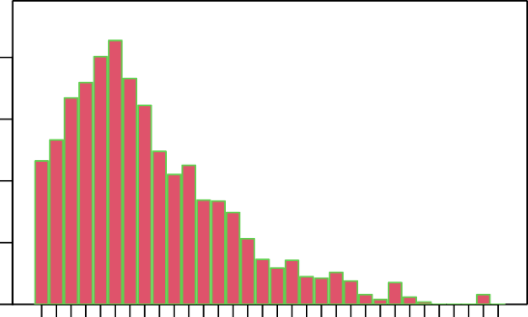

6

records 8918

cells 0

hours 5339

catch 384.836

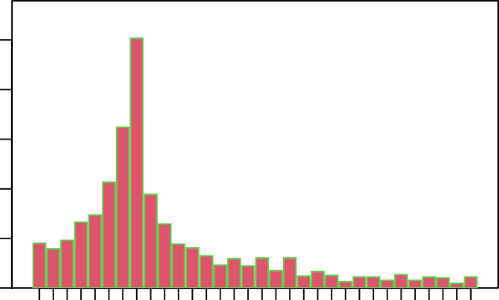

13

records 13615

cells 0

hours 26978

catch 1509.91

Number of Records

2000

0

200

400

600

800

400 500

0

500

1500

2500

1 3 5 7 9 12 15 18 21 24 27 30

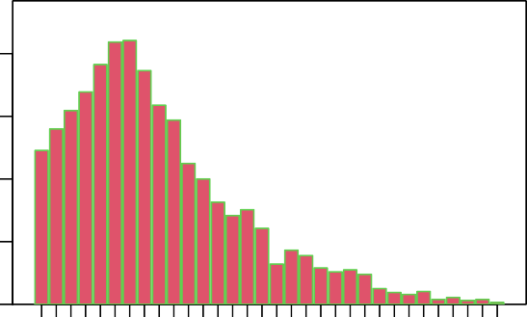

11

records 24730

cells 0

hours 14942

catch 1445.05

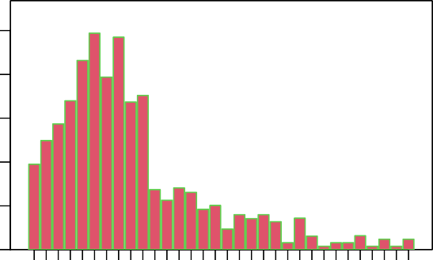

21

records 4877

cells 0

hours 2844

catch 178.727

0

500

1000

0

100 200 300

TIP value

1 3 5 7 9 12 15 18 21 24 27 30

Figure 6.3: The frequency distribution of the TIP index for each example statistical block, 6N, 11W, 13E, 21E.

20

25

30

80 100

1 3 5 7 9 12 15 18 21 24 27 30 1 3 5 7 9 12 15 18 21 24 27 30

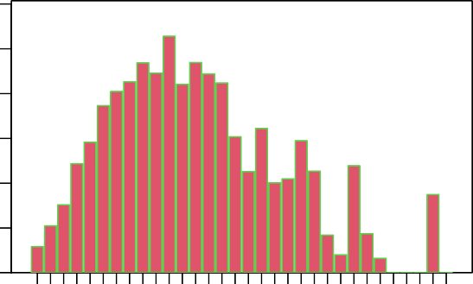

6

records 8918

cells 0

hours 5339

catch 384.836

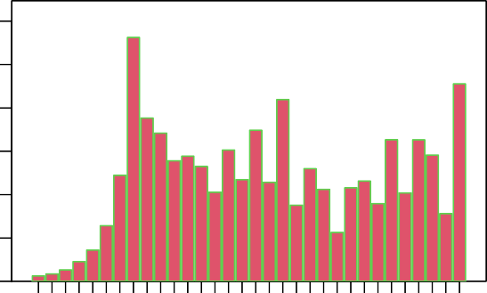

13

records 13615

cells 0

hours 26978

catch 1509.91

Catch (t) per TIP value

60

80

0

5

10

15

8 10 12

0

20

40

60

1 3 5 7 9 12 15 18 21 24 27 30

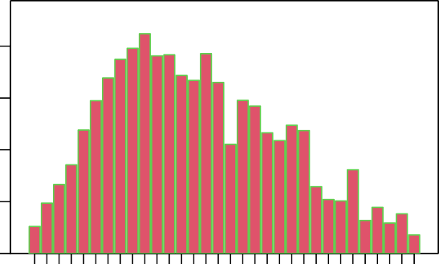

11

records 24730

cells 0

hours 14942

catch 1445.05

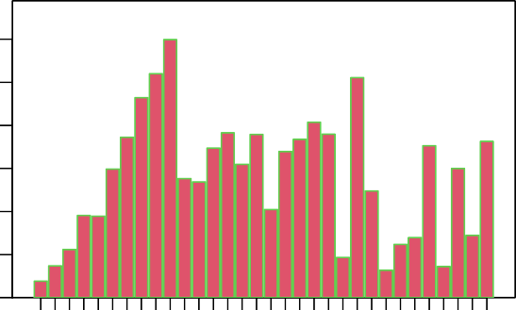

21

records 4877

cells 0

hours 2844

catch 178.727

0

20

40

0

2

4

6

TIP value

1 3 5 7 9 12 15 18 21 24 27 30

Figure 6.4: The distribution of catches for each TIP value for each example statistical block, 6N, 11W, 13E, 21E. The Eastern Zone blocks have more weight towards the higher TIP values.

250

300

800

0 5 10 15 20 25 30 0 5 10 15 20 25 30

records 8918

cells 0

hours 5339

catch 384.836

6

records 13615 13

cells 0

hours 26978

catch 1509.916

Mean Catch (kg) per TIP value

300

400

500

0

50

100

150

200

300

400

0

200

400

600

0 5 10 15 20 25 30 0 5 10 15 20 25 30

records 24730

cells 0

hours 14942

catch 1445.059

11

records 4877

cells 0

hours 2844

catch 178.727

21

0

100

200

0

100

200

TIP value

Figure 6.5: The mean catch per TIP value with 99% Normal CI for each example statistical block, 6N, 11W, 13E, 21E. The number of observations for each TIP value are so large that the CI are all small except for the TIP values with low representation.

0 5 10 15 20 25 30 0 5 10 15 20 25 30

records 1266

cells 1266

hours 1017.728

catch 103.982

2012

records 1171

cells 1171

hours 654.297

catch 38.498

2016

300

500

0

100

300

500

250

0

100

200 300

400

0 5 10 15 20 25 30 0 5 10 15 20 25 30

records 1375

cells 1375

hours 1008.472

catch 87.195

2013

records 1246

cells 1246

hours 667.864

catch 32.197

2017

Mean Catch (kg) per TIP value

250

350

0

100

50

0

50

150

0 5 10 15 20 25 30 0 5 10 15 20 25 30

records 1394

cells 1394

hours 872.2

catch 58.959

2014

records 720

cells 720

hours 181.761

catch 8.795

2018

250

0

50

150

100

150

0

10

30

0 5 10 15 20 25 30 0 5 10 15 20 25 30

records 1290

cells 1290

hours 779.511

catch 46.551

2015

records 456

cells 456

hours 157.281

catch 8.658

2019

0

50

150

0

50

TIP value

Figure 6.6: The mean catch per TIP value by year with 99% Normal CI for example statistical block 6N.

##### Alternative Approaches to Select for Effort

There are at least three different ways that one could select some chosen minimum level of effort:

1. Select X minutes from the **$minutes** field in the dataset.
2. Select Y minutes from the **$totE** field in the dataset.
3. Select Z minutes from the **$maxE** field in the dataset.

The use of X, Y, and Z minutes in the different approaches is merely to represent that because they are different

approaches, different levels of effort might be required to gain the desired effect. While there are these alternatives there are some good reasons to exclude two of the options.

If one were to select against, for example, every cell by year combination where **$minutes** <= X minutes, this would certainly remove every instance of cells where only small amounts of effort were expressed. However, this only removes the individual records in each year in which such records occur. This does not appear to be what is needed when attempting to estimate the total fishable areas of reefs where intentional fishing occurs. While this approach would find all cells in each year that have <= 5 minutes, many of those may have much more effort in other years and so really contribute to the total fishable area (they are just not used in every year). This can be illustrated by selecting the unique cells that have at least one year where <= 3 minutes of effort are expressed. If all effort levels for those cells are plotted then much great levels of effort are present in at least some of them in other years (**Figure** **6.7**).

15000

0 100 200 300 400 500 600

Minutes

Frequency

Frequency

6000

0 5000

0 10 20 30 40 50 60

Minutes (maximum at 100)

0 2000

Figure 6.7: The distribution of effort as minutes in each unique cell within block 11 that has at least one year where effort was <= 3 minutes. The lower plot is identical to the upper plot except with an upper bound of 50 minutes so as to expand the visibility of the smaller values.

Using a selection criterion with the *totE* field has different but related problems. The range of effort expended within each cell can vary markedly between years and by using the total effort across years even if one were to use some low value, such as 5 minutes, this might arise from a series of seven very low values and one large value.

Following this train of thought it appears that the optimum approach would be to select some level of the maximum effort that occurs across all years. If a maximum effort (*maxE*) of 3 minutes or less is selected this ensures that there are no unexpectedly high years hidden within the selection and that the cells selected will be removed from all years. The question remains of what level of maximum effort across all years should be used to select against false positive cell records. By plotting up the effect of selecting for a range of different *maxE* values any discontinuities in the observed data can be made apparent. If there are no discontinuities then some value that would represent the time that would exclude any intentional fishing should be selected.

0.3

0.4

0.5

5 10 15 20

6

11

13

21

Proportion Hexagons <= X value

0.0

0.1

0.2

maxE Value

6

11

13

21

Proportion of Total Block Catch

0.03

0.04

5 10 15 20

maxE Value

0.00

0.01

0.02

Figure 6.8: The proportion of the unique cells reported in each example block selected by different values of the maximum effort across years value (maxE). There are no obvious inflection points in any block and the vertical red line at 3 minutes is the nominally selected value of maxE that will be used leading to percentages of cells excluded of 14.3, 13.7, 11.4 and 17.1 in blocks 6, 11, 13, and 21, respectively.

6.4.0.1 Update Fishable Area

Table 6.6: Summary information for each block across year. ncells is the total number of unique cells identified in the observations for each block, area* is the number of cells selected with maximum effort levels of <= 3 minutes, and fishable Ha is the estimated fishable reef area in hectares after the false positive cells are removed.

|  |  |  |  |  |  |  |
| --- | --- | --- | --- | --- | --- | --- |
|  | nobs | hours | catch t | ncells | area* | fishable Ha |
| 6 | 8918 | 5339.1 | 384.836 | 0 | 0 | 0 |
| 11 | 24730 | 14942.6 | 1445.059 | 0 | 0 | 0 |
| 13 | 13615 | 26978.7 | 1509.916 | 0 | 0 | 0 |

Table 6.6: Summary information for each block across year. ncells is the total number of unique cells identified in the observations for each block, area* is the number of cells selected with maximum effort levels of <= 3 minutes, and fishable Ha is the estimated fishable reef area in hectares after the false positive cells are removed.

nobs hours catch t ncells area* fishable Ha

21 4877 2844.4 178.727 0 0 0

##### Discussion and Implications

The proportion of false positive cells is surprisingly high although most occur in the TIP = 1 by occur = 1 combination (i.e. the cell occurs in only one year, and is in the lowest quartile of catch for that year). There were no occurrences of low maxE values in TIP values greater than 8.

Table 6.7: The count of cells in block 6 having a maxE value <= 3 in each combination of TIP and occur (see appendix for the other block results.

1 2 3 4 5 6 7 8

1 244 0 0 0 0 0 0 0

2 0 50 0 0 0 0 0 0

3 0 0 19 0 0 0 0 0

4 0 0 0 3 0 0 0 0

5 0 0 0 0 1 0 0 0

6 0 0 0 0 0 1 0 0

7 0 0 0 0 0 0 0 0

8 0 0 0 0 0 0 0 0

The proportion of cells in each block with maxE values <= 3 minutes was always greater than 10%, but the proportion of catch lost in this manner was always less than 0.2% of the total, and in the case of block 13 was only 0.026%.

Table 6.8: A summary across blocks of the result of selecting on maxE <= 3 minutes.

|  |  |  |  |  |  |  |  |
| --- | --- | --- | --- | --- | --- | --- | --- |
|  | maxE | ncell | select | prop | catch | propcatch | totalcatch |
| 6 | 3 | 2226 | 318 | 0.1429 | 548.203 | 0.00142 | 384835.6 |
| 11 | 3 | 5881 | 806 | 0.1371 | 1752.345 | 0.00121 | 1445059.5 |
| 13 | 3 | 2573 | 294 | 0.1143 | 395.136 | 0.00026 | 1509915.9 |
| 21 | 3 | 1073 | 183 | 0.1705 | 352.700 | 0.00197 | 178726.5 |

Despite the misplaced catch being such a small proportion of the total this selection against false positive cells implies that, in order to obtain accurate summary statistics relating to catch rates and related matters, the missing catches will need to be redistributed back into the cells in which most of the fishing from such events

occurred. Given the relatively high number of individual cells affected in each block (**Table** **6.8**), this is not a rapid or simple task. At a minimum the analyses should be restricted to those cells assumed to represent the true fishable reef area. This would entail removing those cell identified are false positives.

For example, if we consider one of the example blocks, we shall use block 13, the total number of unique cells used across the eight years is known. The number of cells visited in any single year is known (labelled ‘records’). It is also possible to identify how many of the total unique cells were visited for the first time in each year (labelled ‘new’). Similarly, how many of the cells visited in a year had been visited in the previous year (‘prevyr’). By knowing the total unique cells it is also possible to tabulate how many of the total were not visited in a given year (‘missed’). The catch and effort per year can also be added as can the proportion of the total known area that was used (**Table** **6.9**).

Table 6.9: A summary of the grid cell use across years for block 6.

|  |  |  |  |  |  |  |  |  |
| --- | --- | --- | --- | --- | --- | --- | --- | --- |
|  | records | new | cumul | prevyr | missed | catch | hrs | propused |
| 2012 | 1266 | 1266 | 1266 | 0 | 960 | 103.982 | 1017.728 | 0.569 |
| 2013 | 1375 | 400 | 1666 | 975 | 851 | 87.195 | 1008.472 | 0.618 |
| 2014 | 1394 | 250 | 1916 | 1016 | 832 | 58.959 | 872.200 | 0.626 |
| 2015 | 1290 | 126 | 2042 | 961 | 936 | 46.551 | 779.511 | 0.580 |
| 2016 | 1171 | 68 | 2110 | 845 | 1055 | 38.498 | 654.297 | 0.526 |
| 2017 | 1246 | 65 | 2175 | 847 | 980 | 32.197 | 667.864 | 0.560 |
| 2018 | 720 | 45 | 2220 | 539 | 1506 | 8.795 | 181.761 | 0.323 |
| 2019 | 456 | 6 | 2226 | 254 | 1770 | 8.658 | 157.281 | 0.205 |

But this outcome (**Table** **6.9**) uses all known cells including those that we now assume are false positives. If those are removed by excluding all cells with maxE <= 3 minutes, rather different results are forthcoming.

Table 6.10: A summary of the grid cell use across years for block 6 after all cells with maximum effort levels <= 3 minutes are excluded. The final column ‘propused’ refers to the proportion of cells used in that year.

|  |  |  |  |  |  |  |  |  |
| --- | --- | --- | --- | --- | --- | --- | --- | --- |
|  | records | new | cumul | prevyr | missed | catch | hrs | propused |
| 2012 | 1213 | 1213 | 1213 | 0 | 695 | 103.881 | 1016.675 | 0.636 |
| 2013 | 1308 | 345 | 1558 | 963 | 600 | 87.069 | 1006.947 | 0.686 |
| 2014 | 1301 | 173 | 1731 | 1009 | 607 | 58.827 | 870.250 | 0.682 |
| 2015 | 1228 | 80 | 1811 | 953 | 680 | 46.499 | 778.547 | 0.644 |
| 2016 | 1120 | 37 | 1848 | 842 | 788 | 38.441 | 653.358 | 0.587 |
| 2017 | 1199 | 41 | 1889 | 841 | 709 | 32.159 | 667.039 | 0.628 |
| 2018 | 678 | 18 | 1907 | 535 | 1230 | 8.762 | 181.161 | 0.355 |
| 2019 | 447 | 1 | 1908 | 253 | 1461 | 8.649 | 157.108 | 0.234 |

Comparing the two tables **Table** **6.9**and **Table** **6.10**the cumulative number of unique cells (‘cumul’) differs in 2019 by 318 (as predicted by **Table** **6.8**). The ‘known’ area of reef has been empirically defined as those cells with intentional fishing. The effect or removing the false positive cells is to increase the proportion of the total

used each year. However, even with this increase it is clear that the proportion of the known reef used in any single year can be only a fraction of the total.

In block 6, the proportion used in the last two years was unusually low, which reflected the very low catches. In the other years, however, the proportion of the known area used varied from 0.587 - 0.682 with an average of 0.643. Block 11 (see appendix) was similar varying from 0.51 - 0.658. The blocks from the east coast used a somewhat higher proportion with block 13 varying from 0.601 - 0.808, while block 21 varied between 0.542 - 0.766.

Table 6.11: The range of the total known reef area used across years for all blocks after all cells with effort levels <= 3 minutes are excluded. Block 6 should really not include the last two years as they were exceptionally low. The final column ‘propused’ refers to the proportion of cells used in that year.

|  |  |  |  |  |
| --- | --- | --- | --- | --- |
|  | ReefArea | minimum | maximum | average |
| 6 | 1908 | 0.234 | 0.686 | 0.556 |
| 11 | 5075 | 0.510 | 0.658 | 0.584 |
| 13 | 2279 | 0.601 | 0.808 | 0.726 |
| 21 | 890 | 0.542 | 0.766 | 0.646 |

##### Appendix - Analyses of Blocks not Included in Text

* + 1. Frequency of Occurrence of Records
       1. Block 6

Table 6.12: The frequency of occurrence of each combination of occur and TIP within block 6’s dataset.

1 2 3 4 5 6 7 8

1 465 0 0 0 0 0 0 0

2 7 526 0 0 0 0 0 0

3 3 36 630 0 0 0 0 0

4 1 14 72 632 0 0 0 0

5 0 6 27 180 590 0 0 0

6 0 0 12 48 285 510 0 0

7 0 0 6 32 125 324 245 0

8 0 0 3 8 75 264 175 120

9 0 0 0 28 40 192 196 40

10 0 0 0 12 50 132 147 80

11 0 0 0 0 50 114 175 112

12 0 0 0 0 5 96 133 104

13 0 0 0 0 15 42 182 96

14 0 0 0 0 15 42 105 136

15 0 0 0 0 10 48 91 64

Table 6.12: The frequency of occurrence of each combination of occur and TIP within block 6’s dataset.

|  |  |  |  |  |  |  |  |  |
| --- | --- | --- | --- | --- | --- | --- | --- | --- |
|  | 1 | 2 | 3 | 4 | 5 | 6 | 7 | 8 |
| 16 | 0 | 0 | 0 | 0 | 5 | 12 | 105 | 24 |
| 17 | 0 | 0 | 0 | 0 | 0 | 12 | 42 | 64 |
| 18 | 0 | 0 | 0 | 0 | 0 | 12 | 91 | 40 |
| 19 | 0 | 0 | 0 | 0 | 0 | 6 | 28 | 56 |
| 20 | 0 | 0 | 0 | 0 | 0 | 0 | 21 | 64 |
| 21 | 0 | 0 | 0 | 0 | 0 | 6 | 42 | 56 |
| 22 | 0 | 0 | 0 | 0 | 0 | 6 | 14 | 56 |
| 23 | 0 | 0 | 0 | 0 | 0 | 0 | 0 | 32 |
| 24 | 0 | 0 | 0 | 0 | 0 | 0 | 0 | 16 |
| 25 | 0 | 0 | 0 | 0 | 0 | 0 | 7 | 64 |
| 26 | 0 | 0 | 0 | 0 | 0 | 0 | 0 | 24 |
| 27 | 0 | 0 | 0 | 0 | 0 | 0 | 0 | 8 |
| 31 | 0 | 0 | 0 | 0 | 0 | 0 | 0 | 32 |

Table 6.13: The frequency of occurrence of unique hexagons in each combination of occur and TIP within block 6’s dataset.

1 2 3 4 5 6 7 8

1 465 0 0 0 0 0 0 0

2 7 263 0 0 0 0 0 0

3 3 18 210 0 0 0 0 0

4 1 7 24 158 0 0 0 0

5 0 3 9 45 118 0 0 0

6 0 0 4 12 57 85 0 0

7 0 0 2 8 25 54 35 0

8 0 0 1 2 15 44 25 15

9 0 0 0 7 8 32 28 5

10 0 0 0 3 10 22 21 10

11 0 0 0 0 10 19 25 14

12 0 0 0 0 1 16 19 13

13 0 0 0 0 3 7 26 12

14 0 0 0 0 3 7 15 17

15 0 0 0 0 2 8 13 8

16 0 0 0 0 1 2 15 3

17 0 0 0 0 0 2 6 8

18 0 0 0 0 0 2 13 5

19 0 0 0 0 0 1 4 7

20 0 0 0 0 0 0 3 8

21 0 0 0 0 0 1 6 7

Table 6.13: The frequency of occurrence of unique hexagons in each combination of occur and TIP within block 6’s dataset.

|  |  |  |  |  |  |  |  |  |
| --- | --- | --- | --- | --- | --- | --- | --- | --- |
|  | 1 | 2 | 3 | 4 | 5 | 6 | 7 | 8 |
| 22 | 0 | 0 | 0 | 0 | 0 | 1 | 2 | 7 |
| 23 | 0 | 0 | 0 | 0 | 0 | 0 | 0 | 4 |
| 24 | 0 | 0 | 0 | 0 | 0 | 0 | 0 | 2 |
| 25 | 0 | 0 | 0 | 0 | 0 | 0 | 1 | 8 |
| 26 | 0 | 0 | 0 | 0 | 0 | 0 | 0 | 3 |
| 27 | 0 | 0 | 0 | 0 | 0 | 0 | 0 | 1 |
| 28 | 0 | 0 | 0 | 0 | 0 | 0 | 0 | 0 |
| 29 | 0 | 0 | 0 | 0 | 0 | 0 | 0 | 0 |
| 30 | 0 | 0 | 0 | 0 | 0 | 0 | 0 | 0 |
| 31 | 0 | 0 | 0 | 0 | 0 | 0 | 0 | 4 |
| 32 | 0 | 0 | 0 | 0 | 0 | 0 | 0 | 0 |

* + - 1. Block 13

Table 6.14: The frequency of occurrence of each combination of occur and TIP within block 13’s dataset.

1 2 3 4 5 6 7 8

1 452 0 0 0 0 0 0 0

2 1 394 0 0 0 0 0 0

3 0 0 483 0 0 0 0 0

4 0 0 0 664 0 0 0 0

5 0 0 0 20 715 0 0 0

6 0 0 0 0 35 1032 0 0

7 0 0 0 0 5 84 1533 0

8 0 0 0 0 0 48 245 2224

9 0 0 0 0 0 0 105 840

10 0 0 0 0 0 0 63 584

11 0 0 0 0 0 0 28 416

12 0 0 0 0 0 0 14 392

13 0 0 0 0 0 0 14 312

14 0 0 0 0 0 0 0 232

15 0 0 0 0 0 0 0 296

16 0 0 0 0 0 0 0 224

17 0 0 0 0 0 0 0 304

18 0 0 0 0 0 0 0 176

19 0 0 0 0 0 0 0 304

20 0 0 0 0 0 0 0 120

21 0 0 0 0 0 0 0 168

Table 6.14: The frequency of occurrence of each combination of occur and TIP within block 13’s dataset.

|  |  |  |  |  |  |  |  |  |
| --- | --- | --- | --- | --- | --- | --- | --- | --- |
|  | 1 | 2 | 3 | 4 | 5 | 6 | 7 | 8 |
| 22 | 0 | 0 | 0 | 0 | 0 | 0 | 0 | 128 |
| 23 | 0 | 0 | 0 | 0 | 0 | 0 | 0 | 64 |
| 24 | 0 | 0 | 0 | 0 | 0 | 0 | 0 | 112 |
| 25 | 0 | 0 | 0 | 0 | 0 | 0 | 0 | 112 |
| 26 | 0 | 0 | 0 | 0 | 0 | 0 | 0 | 80 |
| 27 | 0 | 0 | 0 | 0 | 0 | 0 | 0 | 136 |
| 28 | 0 | 0 | 0 | 0 | 0 | 0 | 0 | 80 |
| 29 | 0 | 0 | 0 | 0 | 0 | 0 | 0 | 112 |
| 30 | 0 | 0 | 0 | 0 | 0 | 0 | 0 | 104 |
| 31 | 0 | 0 | 0 | 0 | 0 | 0 | 0 | 48 |
| 32 | 0 | 0 | 0 | 0 | 0 | 0 | 0 | 112 |

Table 6.15: The frequency of occurrence of unique hexagons in each combination of occur and TIP within block 13’s dataset.

1 2 3 4 5 6 7 8

1 452 0 0 0 0 0 0 0

2 1 197 0 0 0 0 0 0

3 0 0 161 0 0 0 0 0

4 0 0 0 166 0 0 0 0

5 0 0 0 5 143 0 0 0

6 0 0 0 0 7 172 0 0

7 0 0 0 0 1 14 219 0

8 0 0 0 0 0 8 35 278

9 0 0 0 0 0 0 15 105

10 0 0 0 0 0 0 9 73

11 0 0 0 0 0 0 4 52

12 0 0 0 0 0 0 2 49

13 0 0 0 0 0 0 2 39

14 0 0 0 0 0 0 0 29

15 0 0 0 0 0 0 0 37

16 0 0 0 0 0 0 0 28

17 0 0 0 0 0 0 0 38

18 0 0 0 0 0 0 0 22

19 0 0 0 0 0 0 0 38

20 0 0 0 0 0 0 0 15

21 0 0 0 0 0 0 0 21

22 0 0 0 0 0 0 0 16

23 0 0 0 0 0 0 0 8

Table 6.15: The frequency of occurrence of unique hexagons in each combination of occur and TIP within block 13’s dataset.

|  |  |  |  |  |  |  |  |  |
| --- | --- | --- | --- | --- | --- | --- | --- | --- |
|  | 1 | 2 | 3 | 4 | 5 | 6 | 7 | 8 |
| 24 | 0 | 0 | 0 | 0 | 0 | 0 | 0 | 14 |
| 25 | 0 | 0 | 0 | 0 | 0 | 0 | 0 | 14 |
| 26 | 0 | 0 | 0 | 0 | 0 | 0 | 0 | 10 |
| 27 | 0 | 0 | 0 | 0 | 0 | 0 | 0 | 17 |
| 28 | 0 | 0 | 0 | 0 | 0 | 0 | 0 | 10 |
| 29 | 0 | 0 | 0 | 0 | 0 | 0 | 0 | 14 |
| 30 | 0 | 0 | 0 | 0 | 0 | 0 | 0 | 13 |
| 31 | 0 | 0 | 0 | 0 | 0 | 0 | 0 | 6 |
| 32 | 0 | 0 | 0 | 0 | 0 | 0 | 0 | 14 |

* + - 1. Block 21

Table 6.16: The frequency of occurrence of each combination of occur and TIP within block 21’s dataset.

1 2 3 4 5 6 7 8

1 195 0 0 0 0 0 0 0

2 1 248 0 0 0 0 0 0

3 0 14 273 0 0 0 0 0

4 0 2 30 308 0 0 0 0

5 0 0 0 32 400 0 0 0

6 0 0 3 4 85 402 0 0

7 0 0 0 4 40 126 224 0

8 0 0 0 0 5 66 182 232

9 0 0 0 8 5 60 112 152

10 0 0 0 0 5 18 105 224

11 0 0 0 0 0 24 49 64

12 0 0 0 0 0 6 35 72

13 0 0 0 0 0 0 21 120

14 0 0 0 0 0 6 21 104

15 0 0 0 0 0 6 14 72

16 0 0 0 0 0 0 21 80

17 0 0 0 0 0 0 7 40

18 0 0 0 0 0 0 0 80

19 0 0 0 0 0 0 7 64

20 0 0 0 0 0 0 0 80

21 0 0 0 0 0 0 0 64

22 0 0 0 0 0 0 0 16

23 0 0 0 0 0 0 0 72

Table 6.16: The frequency of occurrence of each combination of occur and TIP within block 21’s dataset.

|  |  |  |  |  |  |  |  |  |
| --- | --- | --- | --- | --- | --- | --- | --- | --- |
|  | 1 | 2 | 3 | 4 | 5 | 6 | 7 | 8 |
| 24 | 0 | 0 | 0 | 0 | 0 | 0 | 7 | 24 |
| 25 | 0 | 0 | 0 | 0 | 0 | 0 | 0 | 8 |
| 26 | 0 | 0 | 0 | 0 | 0 | 0 | 0 | 16 |
| 27 | 0 | 0 | 0 | 0 | 0 | 0 | 0 | 16 |
| 28 | 0 | 0 | 0 | 0 | 0 | 0 | 0 | 32 |
| 29 | 0 | 0 | 0 | 0 | 0 | 0 | 0 | 8 |
| 30 | 0 | 0 | 0 | 0 | 0 | 0 | 0 | 24 |
| 31 | 0 | 0 | 0 | 0 | 0 | 0 | 0 | 8 |
| 32 | 0 | 0 | 0 | 0 | 0 | 0 | 0 | 24 |

Table 6.17: The frequency of occurrence of unique hexagons in each combination of occur and TIP within block 21’s dataset.

1 2 3 4 5 6 7 8

1 195 0 0 0 0 0 0 0

2 1 124 0 0 0 0 0 0

3 0 7 91 0 0 0 0 0

4 0 1 10 77 0 0 0 0

5 0 0 0 8 80 0 0 0

6 0 0 1 1 17 67 0 0

7 0 0 0 1 8 21 32 0

8 0 0 0 0 1 11 26 29

9 0 0 0 2 1 10 16 19

10 0 0 0 0 1 3 15 28

11 0 0 0 0 0 4 7 8

12 0 0 0 0 0 1 5 9

13 0 0 0 0 0 0 3 15

14 0 0 0 0 0 1 3 13

15 0 0 0 0 0 1 2 9

16 0 0 0 0 0 0 3 10

17 0 0 0 0 0 0 1 5

18 0 0 0 0 0 0 0 10

19 0 0 0 0 0 0 1 8

20 0 0 0 0 0 0 0 10

21 0 0 0 0 0 0 0 8

22 0 0 0 0 0 0 0 2

23 0 0 0 0 0 0 0 9

24 0 0 0 0 0 0 1 3

25 0 0 0 0 0 0 0 1

Table 6.17: The frequency of occurrence of unique hexagons in each combination of occur and TIP within block 21’s dataset.

|  |  |  |  |  |  |  |  |  |
| --- | --- | --- | --- | --- | --- | --- | --- | --- |
|  | 1 | 2 | 3 | 4 | 5 | 6 | 7 | 8 |
| 26 | 0 | 0 | 0 | 0 | 0 | 0 | 0 | 2 |
| 27 | 0 | 0 | 0 | 0 | 0 | 0 | 0 | 2 |
| 28 | 0 | 0 | 0 | 0 | 0 | 0 | 0 | 4 |
| 29 | 0 | 0 | 0 | 0 | 0 | 0 | 0 | 1 |
| 30 | 0 | 0 | 0 | 0 | 0 | 0 | 0 | 3 |
| 31 | 0 | 0 | 0 | 0 | 0 | 0 | 0 | 1 |
| 32 | 0 | 0 | 0 | 0 | 0 | 0 | 0 | 3 |

* + 1. Catch by TIP Value
       1. Block 11

500

200 300 400

0 5 10 15 20 25 30 0 5 10 15 20 25 30

records 2680

cells 2680

hours 1600.456

catch 194.175

2012

records 3096

cells 3096

hours 1620.986

catch 149.317

2016

800

1200

0

100

300

400

600

0

100

0 5 10 15 20 25 30 0 5 10 15 20 25 30

records 3393

cells 3393

hours 2346.442

catch 245.436

2013

records 2838

cells 2838

hours 1758.403

catch 163.907

2017

Mean Catch (kg) per TIP value

300

400

0

400

400 600 800

0

200

0 5 10 15 20 25 30 0 5 10 15 20 25 30

records 3263

cells 3263

hours 2060.322

catch 191.235

2014

records 3012

cells 3012

hours 1584.428

catch 148.732

2018

500

0

100

200

300

500

0

200

0 5 10 15 20 25 30 0 5 10 15 20 25 30

records 3487

cells 3487

hours 2355.167

catch 203.408

2015

records 2961

cells 2961

hours 1616.428

catch 148.85

2019

0

100

300

0

100

TIP value

Figure 6.9: The mean catch per TIP value by year with 99% Normal CI for example statistical block 11.

* + - 1. Block 13

600

800

1000

0 5 10 15 20 25 30 0 5 10 15 20 25 30

records 1726

cells 1726

hours 4335.653

catch 246.734

2012

records 1843

cells 1843

hours 3916.839

catch 218.408

2016

600

800

0

200

400

600

1000

0

200

600

0 5 10 15 20 25 30 0 5 10 15 20 25 30

records 1662

cells 1662

hours 3322.661

catch 178.816

2013

records 1915

cells 1915

hours 4065.383

catch 239.913

2017

Mean Catch (kg) per TIP value

600

800

0

200

400

400 600 800

0

200

0 5 10 15 20 25 30 0 5 10 15 20 25 30

records 1672

cells 1672

hours 3009.564

catch 151.783

2014

records 1614

cells 1614

hours 2657.342

catch 154.857

2018

600

800

0

200

400

400

600

0

200

0 5 10 15 20 25 30 0 5 10 15 20 25 30

records 1799

cells 1799

hours 3726.703

catch 199.882

2015

records 1384

cells 1384

hours 1944.525

catch 119.523

2019

0

200

400

0

200

TIP value

Figure 6.10: The mean catch per TIP value by year with 99% Normal CI for example statistical block 13.

* + - 1. Block 21

250

300

0 5 10 15 20 25 30 0 5 10 15 20 25 30

records 732

cells 732

hours 341.619

catch 22.036

2012

records 642

cells 642

hours 355.942

catch 15.691

2016

300

400

0

50

150

250

0

100

200

0 5 10 15 20 25 30 0 5 10 15 20 25 30

records 635

cells 635

hours 360.956

catch 24.65

2013

records 518

cells 518

hours 301.042

catch 15.667

2017

Mean Catch (kg) per TIP value

300

500

0

100

200

250

0

50

150

0 5 10 15 20 25 30 0 5 10 15 20 25 30

records 589

cells 589

hours 444.169

catch 28.764

2014

records 505

cells 505

hours 259.425

catch 15.812

2018

400

600

0

100

200

0

50

150

0 5 10 15 20 25 30 0 5 10 15 20 25 30

records 724

cells 724

hours 554.697

catch 39.837

2015

records 532

cells 532

hours 226.564

catch 16.268

2019

0

200

0

50 100

TIP value

Figure 6.11: TThe mean catch per TIP value by year with 99% Normal CI for example statistical block 21.

* + 1. Update Fishable Area

Most hexagons exhibiting maxE values <= 3 minutes occur in the occur = 1 and TIP = 1 combination. There were no occurrences of such hexagons in TIP values greater than 8.

Table 6.18: The count of hexagons in block 11 having a maxE value <= 3 in each combination of TIP and occur (see appendix for the other block results.

1 2 3 4 5 6 7 8

1 638 0 0 0 0 0 0 0

2 0 120 0 0 0 0 0 0

3 0 0 38 0 0 0 0 0

4 0 0 0 6 0 0 0 0

5 0 0 0 0 3 0 0 0

6 0 0 0 0 0 0 0 0

7 0 0 0 0 0 0 0 0

8 0 0 0 0 0 0 0 1

Table 6.19: The count of hexagons in block 13 having a maxE value <= 3 in each combination of TIP and occur (see appendix for the other block results.

1 2 3 4 5 6 7 8

1 238 0 0 0 0 0 0 0

2 0 34 0 0 0 0 0 0

3 0 0 12 0 0 0 0 0

4 0 0 0 8 0 0 0 0

5 0 0 0 0 2 0 0 0

6 0 0 0 0 0 0 0 0

7 0 0 0 0 0 0 0 0

8 0 0 0 0 0 0 0 0

Table 6.20: The count of hexagons in block 21 having a maxE value <= 3 in each combination of TIP and occur (see appendix for the other block results.

1 2 3 4 5 6 7 8

1 127 0 0 0 0 0 0 0

2 0 32 0 0 0 0 0 0

3 0 0 15 0 0 0 0 0

4 0 0 0 2 0 0 0 0

5 0 0 0 0 5 0 0 0

6 0 0 0 0 0 2 0 0

7 0 0 0 0 0 0 0 0

8 0 0 0 0 0 0 0 0

* + 1. Implications

Table 6.21: A summary of the hexagon use across years for block 11.

|  |  |  |  |  |  |  |  |  |
| --- | --- | --- | --- | --- | --- | --- | --- | --- |
|  | records | new | cumul | prevyr | missed | catch | hrs | propused |
| 2012 | 2680 | 2680 | 2680 | 0 | 3201 | 194.175 | 1600.456 | 0.456 |
| 2013 | 3393 | 1284 | 3964 | 2109 | 2488 | 245.436 | 2346.442 | 0.577 |
| 2014 | 3263 | 600 | 4564 | 2382 | 2618 | 191.235 | 2060.322 | 0.555 |
| 2015 | 3487 | 464 | 5028 | 2423 | 2394 | 203.408 | 2355.167 | 0.593 |
| 2016 | 3096 | 277 | 5305 | 2270 | 2785 | 149.317 | 1620.986 | 0.526 |
| 2017 | 2838 | 147 | 5452 | 1931 | 3043 | 163.907 | 1758.403 | 0.483 |
| 2018 | 3012 | 217 | 5669 | 1910 | 2869 | 148.732 | 1584.428 | 0.512 |
| 2019 | 2961 | 212 | 5881 | 1938 | 2920 | 148.850 | 1616.428 | 0.503 |

Table 6.22: A summary of the hexagon use across years for block 11 after all hexagons with effort levels <= 3 minutes are excluded.

|  |  |  |  |  |  |  |  |  |
| --- | --- | --- | --- | --- | --- | --- | --- | --- |
|  | records | new | cumul | prevyr | missed | catch | hrs | propused |
| 2012 | 2587 | 2587 | 2587 | 0 | 2488 | 193.935 | 1598.536 | 0.510 |
| 2013 | 3237 | 1146 | 3733 | 2091 | 1838 | 245.119 | 2343.500 | 0.638 |
| 2014 | 3152 | 514 | 4247 | 2363 | 1923 | 191.003 | 2057.856 | 0.621 |
| 2015 | 3339 | 351 | 4598 | 2413 | 1736 | 203.168 | 2352.314 | 0.658 |
| 2016 | 2982 | 201 | 4799 | 2262 | 2093 | 149.114 | 1618.689 | 0.588 |
| 2017 | 2746 | 91 | 4890 | 1926 | 2329 | 163.770 | 1756.883 | 0.541 |
| 2018 | 2860 | 110 | 5000 | 1902 | 2215 | 148.530 | 1582.300 | 0.564 |
| 2019 | 2788 | 75 | 5075 | 1927 | 2287 | 148.669 | 1614.508 | 0.549 |

Table 6.23: A summary of the hexagon use across years for block 13.

|  |  |  |  |  |  |  |  |  |
| --- | --- | --- | --- | --- | --- | --- | --- | --- |
|  | records | new | cumul | prevyr | missed | catch | hrs | propused |
| 2012 | 1726 | 1726 | 1726 | 0 | 847 | 246.734 | 4335.653 | 0.671 |
| 2013 | 1662 | 204 | 1930 | 1458 | 911 | 178.816 | 3322.661 | 0.646 |
| 2014 | 1672 | 163 | 2093 | 1380 | 901 | 151.783 | 3009.564 | 0.650 |
| 2015 | 1799 | 158 | 2251 | 1444 | 774 | 199.882 | 3726.703 | 0.699 |
| 2016 | 1843 | 112 | 2363 | 1526 | 730 | 218.408 | 3916.839 | 0.716 |
| 2017 | 1915 | 128 | 2491 | 1595 | 658 | 239.913 | 4065.383 | 0.744 |
| 2018 | 1614 | 69 | 2560 | 1434 | 959 | 154.857 | 2657.342 | 0.627 |
| 2019 | 1384 | 13 | 2573 | 1205 | 1189 | 119.523 | 1944.525 | 0.538 |

Table 6.24: A summary of the hexagon use across years for block 13 after all hexagons with effort levels <= 3 minutes are excluded.

|  |  |  |  |  |  |  |  |  |
| --- | --- | --- | --- | --- | --- | --- | --- | --- |
|  | records | new | cumul | prevyr | missed | catch | hrs | propused |
| 2012 | 1681 | 1681 | 1681 | 0 | 598 | 246.689 | 4334.856 | 0.738 |
| 2013 | 1619 | 170 | 1851 | 1449 | 660 | 178.772 | 3321.847 | 0.710 |
| 2014 | 1621 | 123 | 1974 | 1372 | 658 | 151.731 | 3008.697 | 0.711 |
| 2015 | 1732 | 105 | 2079 | 1440 | 547 | 199.820 | 3725.511 | 0.760 |
| 2016 | 1798 | 82 | 2161 | 1521 | 481 | 218.345 | 3915.822 | 0.789 |
| 2017 | 1842 | 77 | 2238 | 1587 | 437 | 239.840 | 4064.136 | 0.808 |
| 2018 | 1568 | 36 | 2274 | 1430 | 711 | 154.812 | 2656.603 | 0.688 |
| 2019 | 1370 | 5 | 2279 | 1202 | 909 | 119.511 | 1944.319 | 0.601 |

Table 6.25: A summary of the hexagon use across years for block 21.

|  |  |  |  |  |  |  |  |  |
| --- | --- | --- | --- | --- | --- | --- | --- | --- |
|  | records | new | cumul | prevyr | missed | catch | hrs | propused |
| 2012 | 732 | 732 | 732 | 0 | 341 | 22.036 | 341.619 | 0.682 |
| 2013 | 635 | 135 | 867 | 500 | 438 | 24.650 | 360.956 | 0.592 |
| 2014 | 589 | 58 | 925 | 438 | 484 | 28.764 | 444.169 | 0.549 |
| 2015 | 724 | 68 | 993 | 496 | 349 | 39.837 | 554.697 | 0.675 |
| 2016 | 642 | 27 | 1020 | 539 | 431 | 15.691 | 355.942 | 0.598 |
| 2017 | 518 | 21 | 1041 | 408 | 555 | 15.667 | 301.042 | 0.483 |
| 2018 | 505 | 20 | 1061 | 353 | 568 | 15.812 | 259.425 | 0.471 |
| 2019 | 532 | 12 | 1073 | 349 | 541 | 16.268 | 226.564 | 0.496 |

Table 6.26: A summary of the hexagon use across years for block 21 after all hexagons with effort levels <= 3 minutes are excluded.

|  |  |  |  |  |  |  |  |  |
| --- | --- | --- | --- | --- | --- | --- | --- | --- |
|  | records | new | cumul | prevyr | missed | catch | hrs | propused |
| 2012 | 676 | 676 | 676 | 0 | 214 | 21.966 | 340.519 | 0.760 |
| 2013 | 589 | 99 | 775 | 490 | 301 | 24.582 | 359.997 | 0.662 |
| 2014 | 557 | 39 | 814 | 431 | 333 | 28.715 | 443.453 | 0.626 |
| 2015 | 682 | 43 | 857 | 490 | 208 | 39.782 | 554.000 | 0.766 |
| 2016 | 611 | 11 | 868 | 533 | 279 | 15.667 | 355.400 | 0.687 |
| 2017 | 495 | 11 | 879 | 404 | 395 | 15.648 | 300.622 | 0.556 |
| 2018 | 482 | 8 | 887 | 351 | 408 | 15.788 | 258.972 | 0.542 |
| 2019 | 504 | 3 | 890 | 345 | 386 | 16.226 | 226.019 | 0.566 |

## Grid turnover: temporal dynamics of reef use

##### Introduction

When preparing and interpreting fishery data (catch, catch rates), there is no consideration given to whether fishers utilise all or part of the known productive reef each year. This is fundamentally because very few fisheries have sufficient spatial data across the fleet to determine what proportion of the fishing grounds have been accessed in a given year. Without knowledge of what proportion of the fishers have accessed in a given year, there arises an implicit assumption that either a) it doesn’t matter, or b) most of the reef is utilised and therefore it doesn’t matter.

Of specific interest were the following categories:

* *This Year* = total number of cells fished this year
* *new* = new cells this year
* *Last year and this* = cells fished in two consecutive years (this year and the preceding year)
* *New this year* = cells fished this year, but not last year
* *Not this year, but last* = cells fished last year and not visited in the current year
* *Cumulative* = total known cells in the fishery

This work relates to two objectives:

Objective 2: **Develop methods for inclusion of fine-scale spatial data in CPUE standardisations.** Objective 3:

**Identify methods for detecting hyper-stability in CPUE.**

Objective 4: **Determine feasibility of spatial data based stock status determination in spatially structured fisheries**

* + 1. Statewide patterns of grid cell turnover

A state-wide summary of the grid dynamics indicates that in the eight years of this time-series, areas are being utilised that haven’t been utilised in the previous seven years (Figure 7.1). This approach to examining the dynamics of reef utilisation indicates that the total number of cells utilised annually declined from 2016 to 2019, which is consistent with wide-ranging TACC reductions in those years. In the final year of this time-series however, there will still almost 1000 new cells visited across the fishery (Table 7.1, Figure 7.1). By the end of the time-series, there were over 47,500 1Ha Hexagonal cells visited between 2012 and 2019.

Table 7.1: Annual turnover of grid cells across the Tasmanian abalone fishery, excluding cells with less than 5 minutes of fishing effort. Explanation of legend: This Year - total number number of cells fished this year; Last year and this - cells fished in two consecutive years (this year and preceding year); New this year - cells not previously fished; Not this year, but last - cells fished last year and not visited in the current year; Cumulative - total known cells in the fishery

|  |  |  |  |  |  |  |  |  |
| --- | --- | --- | --- | --- | --- | --- | --- | --- |
|  | 2012 | 2013 | 2014 | 2015 | 2016 | 2017 | 2018 | 2019 |
| years | 21937 | 23345 | 24260 | 24048 | 22603 | 20216 | 17611 | 15905 |
| new | 21937 | 8953 | 5608 | 3819 | 2966 | 2025 | 1457 | 928 |
| both_years | 0 | 14392 | 15570 | 15820 | 14857 | 13317 | 11292 | 10112 |
| this_year | 0 | 8953 | 8690 | 8228 | 7746 | 6899 | 6319 | 5793 |
| last_year | 0 | 7545 | 7775 | 8440 | 9191 | 9286 | 8924 | 7499 |
| all_years | 21937 | 30890 | 36498 | 40317 | 43283 | 45308 | 46765 | 47693 |

**Annual Grid Turnover**

40000

This year new

Last year and this Not last year, but this Not this year, but last Cumulative, by year

30000

20000

10000

0

2012 2013 2014 2015 2016 2017 2018 2019

Figure 7.1: Dynamics of fishing. Annual turnover of grid cells across the Tasmanian abalone fishery, excluding cells with less than 5 minutes of fishing effort. Explanation of legend: This Year - total number of cells fished this year; Last year and this - cells fished in two consecutive years (this year and preceding year); New this year - cells not previously fished; Not this year, but last - cells fished last year and not visited in the current year; Cumulative - total known cells in the fishery

Table 7.2: Dynamics of fishing in Block 6. Annual turnover of grid cells, excluding cells with less than 5 minutes of fishing effort. Explanation of legend: years - total number of cells fished this year; New this year - cells not previously fished; both_years - cells fished in two consecutive years (this year and preceding year); this_year - cells fished this year and not visited in the previous year; last_year - cells fished last year and not visited in the current year; all_years - total known cells in the fishery

|  |  |  |  |  |  |  |  |  |  |  |  |  |
| --- | --- | --- | --- | --- | --- | --- | --- | --- | --- | --- | --- | --- |
|  | 2012 | 2013 | 2014 | 2015 |  | 2016 |  | 2017 |  | 2018 |  | 2019 |
| years | 983 | 1064 | 1040 | 961 |  | 831 |  | 917 |  | 418 |  | 297 |
| new | 983 | 353 | 182 | 95 |  | 47 |  | 58 |  | 18 |  | 5 |
| both_years | 0 | 711 | 745 | 689 |  | 583 |  | 575 |  | 320 |  | 139 |
| this_year | 0 | 353 | 295 | 272 |  | 248 |  | 342 |  | 98 |  | 158 |
| last_year | 0 | 272 | 319 | 351 |  | 378 |  | 256 |  | 597 |  | 279 |
| all_years | 983 | 1336 | 1518 | 1613 |  | 1660 |  | 1718 |  | 1736 |  | 1741 |

Table 7.3: Dynamics of fishing in Block 21. Annual turnover of grid cells, excluding cells with less than 5 minutes of fishing effort. Explanation of legend: years - total number of cells fished this year; New this year - cells not previously fished; both_years - cells fished in two consecutive years (this year and preceding year); this_year - cells fished this year and not visited in the previous year; last_year - cells fished last year and not visited in the current year; all_years - total known cells in the fishery

|  |  |  |  |  |  |  |  |  |  |  |  |
| --- | --- | --- | --- | --- | --- | --- | --- | --- | --- | --- | --- |
|  | 2012 | 2013 | 2014 | 2015 | 2016 |  | 2017 |  | 2018 |  | 2019 |
| years | 485 | 444 | 447 | 557 | 438 |  | 368 |  | 344 |  | 362 |
| new | 485 | 117 | 57 | 78 | 19 |  | 22 |  | 15 |  | 12 |
| both_years | 0 | 327 | 321 | 379 | 370 |  | 275 |  | 243 |  | 230 |
| this_year | 0 | 117 | 126 | 178 | 68 |  | 93 |  | 101 |  | 132 |
| last_year | 0 | 158 | 123 | 68 | 187 |  | 163 |  | 125 |  | 114 |
| all_years | 485 | 602 | 659 | 737 | 756 |  | 778 |  | 793 |  | 805 |

* + 1. Block level dynamics of grid cell activity

At a smaller scale, the grid turnover metrics confirm that reef area accessed to harvest abalone is not common among years, and, there may be as little as 50% overlap in reef utilised among consecutive years (Table 7.2, Table 7.3). In the depleting fishery (Block 6), the mean fishing grounds in common among consecutive years was 0.58 (Table 7.2; Years vs both_years), except for 2019, where there was only 0.47 reef used in common. A similar pattern was observed for the rebuilding Block 21, with the mean fishing grounds in common among consecutive years marginally higher at 0.63 (Table 7.2; Years vs both_years).

In overall terms, the proportion of the total known fishery utilised in anyone year averaged 0.47 in Block 6, and

0.53 in Block 21. In the final three years in Block 6 that fraction reduced to an average of 0.31, whereas in the rebuilding Block 21, that fraction was 0.44, and closer to the annual average.

##### Discussion

In the absence of spatially explicit fisheries data we are forced to ignore any underlying spatio-temporal dynamics within an SAU. The alternative is to make explicit assumptions about how we believe the fishery operates. In terms of reef area utilised to achieve a harvest in a fishing year, and whether the amount of reef area changes

through time, or, all fishing grounds are used every year is a major gap in our understanding of our abalone fisheries. In this chapter we have demonstrated that around two-thirds of the reef area utilised is common among consecutive years, with only half of the known fishing grounds utilised each year. Interestingly, we observed a decline in the average fraction of the total known reef area in the final three years of the eight-year time-series. For the depleted Block 6, this is likely to reflect that fishers have targeted the few remaining productive fishing grounds in the fishery. Whereas for the rebuilding Block 21, with high catch rates and constraints on catch, the fishers will be able to obtain allocated catch from a smaller proportion of the total fishing grounds. Thus, two different explanations underpin a similar result - in Block the small level of reef used is a function of stock dynamics, whereas in Block 21 it is a management induced response.

Given that the level of reef use in common among consecutive years is around two-thirds, we might conclude that fishers are not fishing at random each year, and experience in the previous year might encourage them to return if fishing was good, or find a new location if fishing was poor. This metric provides some insight into the fleet preference of where to fish each year, though does not account for changes in where individual divers may choose to fish across years. It is unlikely this new understanding of how fishers utilise reef areas will change existing data treatment of docket book, or even spatial data. It should however, influence how we think about recovery and depletion of fisheries, whether management actions might be inducing trends in spatial utilisation of fishing grounds. As most of the Tasmanian abalone fishery has been either in a depleting phase or rebuilding phase over the period of this study, it is unclear whether the patterns we see are a subset or modified form of natural cycles of exploitation of fishing grounds (within and among years). By focusing on the most productive grounds that presumably recover the fastest, such spatial changes in fishing practices may lead to an appreance of recovery occurring faster than it is across the whole SAU.

A question frequently asked in abalone fisheries is whether our fisheries are undergoing spatial contraction. This question can only be answered with geo-referenced fishery-dependent data, although the analysis is not necessarily as simple as looking at which grid cells are not being utilised. Declining TACC levels also trigger a reduction in total effort, with corresponding reduction in spatial area utilised, unless abundance is declining rapidly and effort and area used increases inversely to catch. Fishers also rotate through their known patches, which may create a signal in how the entire reef is used. This will be especially prevalent in SAUs which support small amounts of catch, and are visited by relatively few fishers often who have good local knowledge of that SAU. In this chapter we looked at cells that were fished last year, but not this year. This approach could be modified to examine those cells that have not been fished for a period of time after a particular year. For example, how many cells fished in 2012, were not fished again within the next five years, or indeed the entire remainder of the time series.

The level of annual turnover in fishing grounds identified here suggests there would be limited success in utilising the grid-based datasets for the purpose of predicting future yield. Previous attempts to utilise the same dataset explored in this chapter (hexagonal grid dataset) to predict future catch as a function of recent catch history was very poor for the Tasmanian Western Zone (Mundy, Jones, and Worthington 2018, chap. 8, Table 8). However, that finding may have been a result of the lack of a high level of overlap among consecutive years.

Part IV

# Interpretation and implications

## Can spatial fisheries data improve assessment of stock status?

The Tasmanian high-resolution spatial fisheries data collection program is highly cost-effective given the scope and scale of the information the program delivers. Spatial fisheries data derived from GPS logger programs provide multiple benefits for determining stock status in spatially structured abalone fisheries:

1. provision of a more responsive measure of effort in the form of dive polygon area,
2. identification of discrete reef systems as an improvement on within Spatial Assessment Unit spatial structure,
3. through a temporal index of productivity (reported in an earlier milestone), and,
4. provision of capacity to quantify the extent of reef used each year, and among consecutive years.

##### Space is a better measure of effort than time

Area as a measure of effort in diver fisheries appears to offer greater sensitivity to stock changes and is less affected by hyperstability than time as a measure of effort. Passive GPS and Depth data logging technology capture dive time and dive area with greater precision than estimated daily dive effort by divers. Even when we have greater precision in capturing fishing effort in the form of dive time with depth data loggers, area however appears to be a better measure of effort to assess performance of the fishery, and therefore stock status. In essence, using both Area and Time as measure of effort, we are able to see the cross-over from when search time dominates the dive to when handling time is the limiting factor and search time is minimal.

The findings that catch rates based on diving time are subject to hyperstability are not evidence that CPUE (effort as *Time*) is an inaccurate measure of fishery performance as many would argue. This project merely confirms hyperstability is present at both high and low stock levels. Where *Time* is the only measure of effort available, Harvest Strategies can still effectively utilise CPUE as a performance measure, with simple adjustments such that as CPUE deviates from historical median catch rates, outcomes should be increasingly conservative, and when CPUE approaches historic high levels, outcomes can be more optimistic. However, it appears that the level of hyperstability is not entirely symmetrical, thus caution is advised when adjusting HS outcomes at the very high end of the scale.

##### Explicit inclusion of dive location in catch rate standardisation

Abalone fisheries are well known for being highly variable, both in terms of fishery dynamics, biology, produc- tivity, and yields, at local scales. Largely this comes from ‘Fisher Ecological Knowledge’ or ‘Local Knowledge’ (Anuchiracheeva et al. 2003; Hall and Close 2007; Hall et al. 2009; Nguyen et al. 2019), and has rarely been quantified through a data collection and analysis process. In Chapter 3 we illustrated that daily catch rates, can be highly variable, either as mean daily catch rates, or smoothed with a moving window average of 5, 20, or 30 days. As most catch rate standardisations account for season and fisher identity, one remaining predictor that had not been previously examined was the dive location as a primary driver of high variation in mean daily catch rate within a reporting area. Inclusion of spatial location as a term in the catch rate standardisations however, had negligible impact on predicted mean annual catch rate. This seems likely to reflect the highly variable catch-rates that occur at small spatial and temporal scales in this abalone fishery. Comparisons of models with and without spatial terms are rather difficult to compare directly through common methods such as R^2 or AIC. The tools for spatial mixed effect models are still under rapid development, as are the diagnostic procedures and methods for comparison with non-spatial models. This project has touched on these methods, and is an area for future activity, although largely that will be to determine the extent of the *noise* captured by the model, but also in terms of spatial predictions to visualise usage of reef systems over times.

As abalone stocks decline, and eventually rebuild, fleet movement and individual diver choices on where to fish will signal important information in the depletion and recovery process. With hard copy logbook reporting, we are unable to determine whether a stock declines or stock recovery is homogeneous across an SAU, or whether there is significant spatial structure in changes that occur. This is particularly important where once important fishing grounds fail to recover or recover more slowly. Traditionally information on this question is provided by fishers, although fishers rarely fish everywhere and may not always be aware of all activity in a particular area, and are thus prone to gaps in knowledge (although that may not always be acknowledged). The GPS data logger program provides critical detail on where and to what extent components of a fishery change, and the rate at which they change. The investigation of fleet dynamics is an important new direction to better inform managers on the spatial structure of recovery (O’Farrell et al. 2017).

##### Feasibility of spatial data for stock status

Tasmania now has a 12-year time-series of GPS and Depth logger data, covering on average around ~90% of fishing activity in the Tasmanian abalone fishery. For states with a shorter or fractured time-series, area-based metrics can still provide valuable insights on the trend of fishery performance by examining relative change from the time-series start-year, as deviations from time-based trends are evident after three to four years. data investigations (not included in this report) also suggests that the dive polygon based spatial performance measures can be informative at lower levels of fishery coverage. While an adequate time-series is being acquired from which to directly determine reference points for area-based catch rates, an interim measure could be to fit a model between time and area, and predicted area based TRPs and LRPs from the more extensive time-based catch rate data set.

Scales at which abalone fisheries are managed, are necessarily larger than the scale at which the fishery might be assessed. Total Allowable Commercial Catch (TACC) is often set at larger geographical scales such as fishery Zones, with effort management undertaken at within-zone scale in Spatial Assessment Units (Spatial

Management Units, Fishery Areas). At still smaller scales, catch (but not necessarily catch rates) can vary widely. Of concern during a declining phase of a fishery is that smaller sections of coastline are abandoned, and there may be delays before those areas are re-integrated to the fishery (e.g. Figure 3.13). Thus catch rates at an SAU level may only represent the more productive and resilient sections of the coastline, and without access to the spatial detail of the fishery provided by GPS logger programs, the assumption will (incorrectly) be that the entire SAU is displaying the same trend. Most abalone fishery assessment processes as well as the Status of Australian Fish Stocks (SAFS) program are victim to the complications of Dynamic Pool assumptions (Mundy, Haddon, and McAllister 2023). Many of the Dynamic Pool assumptions required by integrated assessment models are equally applicable to the calculation of mean annual catch rates and their interpretation. Regardless of whether catch rates utilise area or time as a measure of effort, catch rates are an index of local abundance at the time of fishing. Further, they are an index of what was taken and not what remains and are not representative of the entire stock. Access to spatial fisheries data partially solves this problem by providing the ability to examine fishing effort at relevant scales, either by inclusion of within SAU terms in catch rate standardisations (Chapter 3), or by examining the dynamic of fishing activity in the 1 Hectare hexagon grid layers (Chapter 5, Chapter 6, Chapter 7).

##### Utility of logbook catch rate data for stock status

Docket or Logbook based catch and effort data remain valuable to the determination of stock status of abalone fisheries. This is with the caveat that fishing time reported in mandatory Docket book systems is reported accurately, as found for the Tasmanian abalone fishery (Chapter 1). Docket book data is already part of the fishery, and there is a long time-series of data available for all abalone fisheries. Providing that harvest strategies include appropriate precautionary settings when relying on Docket book catch rate data, there is no reason to stop relying on this valuable data source. The Tasmanian abalone Empirical Harvest Strategy achieves this by using an asymmetric control rule, which is more conservative as a fishery declines below the catch rate Target Reference Point compared to a rebuilding fishery which is above the TRP.

##### Further work

The investigation of spatial mixed effect models in this study was limited and focused on the impact of including location on the annual mean catch rate. Further work is required to better understand the mechanics of these random spatial terms, and how best to utilise these tools to examine the spatio-temporal dynamic in our dive fishery. More work is required in this space to better understand to what extent mixed effect spatial linear models are capturing the variability in mean daily catch rates (Chapter 3), and, whether they assist by providing greater confidence in the mean estimates provided.

Documenting and quantifying fleet dynamics remains a relatively untouched challenge. Tasmania Divers are paid a dive rate per Kilogram of abalone caught, and not by time. Unless other economic or weather factors come into play, there is a strong incentive for them to move on from areas where catch achieved by hour of effort declines below the individual’s threshold. This may manifest in divers moving multiple times during a day, or, not returning to that fishing ground in the near future. It is this latter behaviour that will provide much greater insight to the status of stocks at appropriate spatial scales, and at scales smaller than SAUs.

##### Recommendations

1. Catch per Unit Area (CPUA) to be included as part of the catch rate analysis in the Tasmanian Fishery Assessment.

## Extension and Adoption

It is expected that there will be general interest in the approaches used in this study, and the findings in each of the sections. The capacity for other groups or fisheries to utilise the work presented here will be limited to those fisheries a time-series of geo-referenced fishery-dependent data. Some of the methods for exploring spatio-temporal dynamics may be of use to fisheries with access to VMS data, where fishing activity is summarised with a similar grid over the known fishing grounds.

##### Extension

Outcomes of this project have been presented in multiple research, management and industry forums. The work on hyperstable catch rates and the effect of environmental variables (temperature and wave power) was presented at the 11th International Abalone Symposium in Auckland March 2023. The concept of switching from a time-based effort (CPUE) to area-based effort (CPUA) for calculating catch rates has been presented to Tasmanian port meetings, and feedback sought on whether CPUA better reflects their experiences in parts of the fishery they know well. The importance of scale work was presented at the recent Australasian Abalone mini-Research Symposium held in Hobart September 2024.

The new approach to standardisation and the inclusion of Catch per Unit Area (CPUA) in the Harvest Strategy has been added to the drat Revised Tasmanian Abalone harvest Strategy. The revised Harvest Strategy document is currently undergoing a mandatory public consultation process. Code developed for the hyperstability component has been provided to SARDI and used to examine hyperstability in some of their jurisdictions that have access to geo-referenced fishery dependent data.

##### Adoption

Inclusion of spatial information in fishery assessments

The use of CPUA as an index of abundance has been proposed for inclusion as part of the standard metrics for assessment in the draft Revised Abalone Harvest Strategy. It is expected that this change will be approved following the mandatory consultation process currently under way.

Strategy for catch and effort standardisation

Within this project we explored generic approaches for statistical standardisation of catch and effort data, regardless of whether the data origins where electronic from data logger equipment or fisher reported docket- book returns. This generic model has also been proposed as a replacement for the current standardisation strategy in the draft Revised Harvest Strategy document. As for the inclusion of spatial metrics, it is expected this will also be approved following the consultation process.